Lewis Structures and the Shapes of Molecules

Pre-Lab Assignments:

To be assigned by your lab instructor.

Student Learning Outcomes:

- Learn how to draw Lewis structures.
- Learn how to draw Lewis structures for atoms which violate the octet rule.
- Learn how to use Lewis structures and VSEPR and to predict the shapes of molecules.
- Learn how to use the shape of a molecule to predict whether or not it is polar.

Experimental Goals:

The purpose of this lab is to learn how to draw Lewis structures for molecules, and, from those structures, to predict the shape of those molecules, and whether or not the molecules are polar.

Introduction:

A. Covalent Bonds and Lewis Structures

When elements combine, there are two types of bonds that may form between them:

- Ionic bonds result from a transfer of electrons from one species (usually a metal) to another (usually a nonmetal or polyatomic ion).
- Covalent bonds result from a sharing of electrons by two or more atoms (usually nonmetals).

Lewis theory (Gilbert Newton Lewis, 1875-1946) focuses on the valence electrons, since the outermost electrons are the ones that are highest in energy and farthest from the nucleus, and are therefore the ones that are most exposed to other atoms when bonds form.

Lewis dot diagrams for elements are a handy way of picturing valence electrons, and especially, what electrons are available to be shared in covalent bonds. The valence electrons are written as dots surrounding the symbol for the element: one dot is place on each side first, and when all four positions are filled, the remaining dots are paired with one of the first set of dots, with a maximum of two dots placed on each side. Lewis-dot diagrams of the atoms in rows 1 and 2 of the periodic table are shown below:

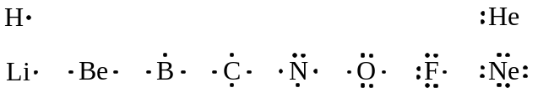
Unpaired electrons represent places where electrons can be gained in ionic compounds, or electrons that can be shared to form molecular compounds. (The valence electrons of helium are better represented by two paired dots, since in all of the noble gases, the valence electrons are in filled shells, and are unavailable for bonding.)

Covalent bonds generally form when a nonmetal combines with another nonmetal. Both elements in the bond are attracted to the unpaired valence electrons so strongly that neither can take the electron away from the other (unlike the case with ionic bonds), so the unpaired valence electrons are shared by the two atoms, forming a covalent bond:

The shared electrons act like they belong to both atoms in the bond, and they bind the two atoms together into a molecule. The shared electrons are usually represented as a line (—) between the bonded atoms. (In Lewis structures, a line represents two electrons.)

Atoms tend to form covalent bonds in such a way as to satisfy the octet rule, with every atom surrounded by eight electrons. (Hydrogen is an exception, since it is in row 1 of the periodic table, and only has the 1s orbital available in the ground state, which can only hold two electrons.)

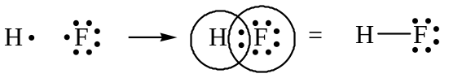
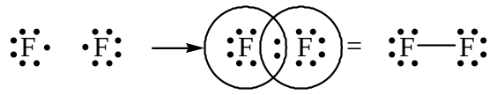
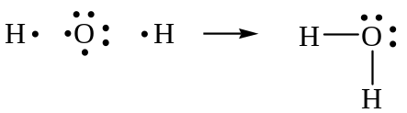
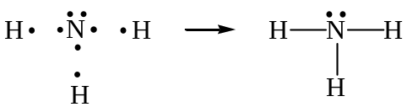
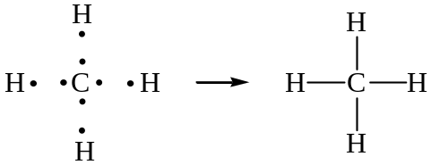

The shared pairs of electrons are bonding pairs (represented by lines in the drawings above). The unshared pairs of electrons are lone pairs or nonbonding pairs.
All of the bonds shown so far have been single bonds, in which one pair of electrons is being shared. It is also possible to have double bonds, in which two pairs of electrons are shared, and triple bonds, in which three pairs of electrons are shared:

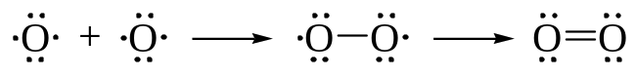

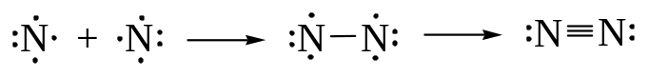

Multiple bonds are shorter and stronger than their corresponding single bond counterparts.

B. Writing Lewis Structures for Molecules

1. Count the total number of valence electrons in the molecule or polyatomic ion. (For example, H₂O has 2×1 + 6 = 8 valence electrons, CCl₄ has 4 + 4×7 = 32 valence electrons.) For anions, add one valence electron for each unit of negative charge; for cations, subtract one electron for each unit of positive charge. (For example, NO₃⁻ has 5 + 3×6 + 1 = 24 valence electrons; NH₄⁺ has 5 + 4×1 – 1 = 8 valence electrons.)

2. Place the atoms relative to each other. For molecules of the formula AX_{n}, place the atom with the lower group number in the center. If A and X are in the same group, place the atom with the higher period number in the center. (This places the least electronegative atom in the center — see section G.) H is NEVER UNDER ANY CIRCUMSTANCES a central atom.

3. Draw a single bond from each terminal atom to each connected atom. Each bond uses two valence electrons.

4. Distribute the remaining valence electrons in pairs so that each atom obtains eight electrons (or 2 for H). Place the lone pairs on the terminal atoms first , and place any remaining valence electrons on the central atom. The number of electrons in the final structure must equal the number of valence electrons from Step 1.

5. If an atom still does not have an octet, move a lone pair from an adjacent atom in between the atoms to make a double or triple bond. Use the formal charge as a guideline for placing multiple bonds:

Formal charge = valence – (½ bonding e-) – (lone pair e-)

The formal charge is the charge an atom would have if the bonding electrons were shared equally.
  - The sum of the formal charges must equal the charge on the species.
  - Smaller formal charges are better (more stable) than larger ones.
  - The number of atoms having formal charges should be minimized.
  - Like charges on adjacent atoms are not desirable.
  - A more negative formal charge should reside on a more electronegative atom.

Examples:

1. CH₄
8 valence electrons (4 + 4×1)
Place the C in the center, and connect the four H’s to it:
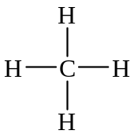
This uses up all of the valence electrons. The octet rule is satisfied everywhere, and all of the atoms have formal charges of zero.

2. NH₃
8 valence electrons (5 + 3×1)
Place the N in the center, and connect the three H’s to it:
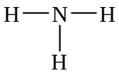
This uses up six of the eight valence electrons. The last two electrons cannot go on the H’s (that would violate the octet rule for H), so they must go on the N:
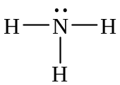
All of the valence electrons have now been used up, the octet rule is satisfied everywhere, and all of the atoms have formal charges of zero.

3. H₂O
8 valence electrons (2×1 + 6)
Place the O in the center, and connect the two H’s to it:
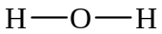
This uses up four of the valence electrons. The remaining four valence electrons cannot go on the H’s, so they must go on the O, in two pairs:
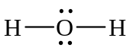
All of the valence electrons have now been used up, the octet rule is satisfied everywhere, and all of the atoms have formal charges of zero.
4. H₃O⁺
8 valence electrons (3×1 + 6 – 1)
Place the O in the center, and connect the three H’s to it:
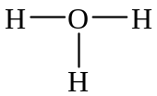
This uses up six of the valence electrons. The remaining two valence electrons must go on the oxygen:
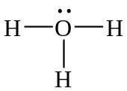
All of the valence electrons have been used up, and the octet rule is satisfied everywhere. The formal charge on the oxygen atom is 1+ (8 – ½ 6 – 2):
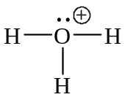

5. HCN
10 valence electrons (1 + 4 + 5)
Place the C in the center, and connect the H and N to it:
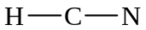
This uses up four of the valence electrons. The remaining six valence electrons start out on the N:
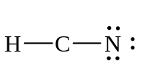
In the structure as shown, the octet rule is not satisfied on the C, and there is a 2+ formal charge on the C (4 – ½ 4 – 0) and a 2- formal charge on the N (5 – ½ 2 – 6):
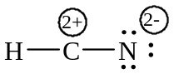
The octet rule can be satisfied if we move two pairs of electrons from the N in between the C and the N, making a triple bond:
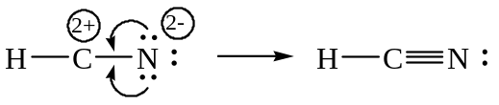
The octet rule is now satisfied, and the formal charges are zero.

6. CO₂
16 valence electrons (4 + 2×6)
Place the C in the center, connect the two O’s to it, and place the remaining valence electrons on the O’s:
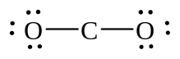
This uses up the sixteen valence electrons The octet rule is not satisfied on the C, and there are lots of formal charges in the structure:
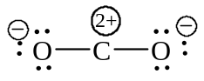
The octet rule can be satisfied, and the formal charges diminished if we move a pair of electrons from each oxygen atom in between the carbon and oxygen atoms:
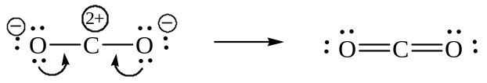
The octet rule is satisfied everywhere, and all of the atoms have formal charges of zero.

7. CCl₄
32 valence electrons (4 + 4×7)
Place the C in the center, and connect the four Cl’s to it:
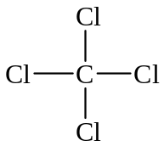
This uses up eight valence electrons The remaining 24 valence electrons are placed in pairs on the Cl’s:
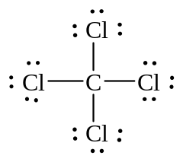
Now, all of the valence electrons have been used up, the octet rule is satisfied everywhere, and all of the atoms have formal charges of zero.

8. COCl₂
24 valence electrons (4 + 6 + 2×7)
Place the C in the center, and connect the O and the two Cl’s to it. (The relative placement of the O and the Cl’s does not matter, since we are not yet drawing a three-dimensional structure.) Place the remaining valence electrons on the oxygen and chlorine atoms:
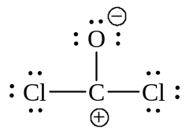
The octet rule is not satisfied on the C; in order to get eight electrons around the C, we must move a pair of electrons either from the O or one of the Cl’s to make a double bond. Making a carbon-chlorine double bond would satisfy the octet rule, but there would still be formal charges, and there would be a positive formal charge on a strongly electronegative atom (structure 2). Making a carbon-oxygen double bond would also satisfy the octet rule, but all of the formal charges would be zero, and that would be the better Lewis structure (structure 3):
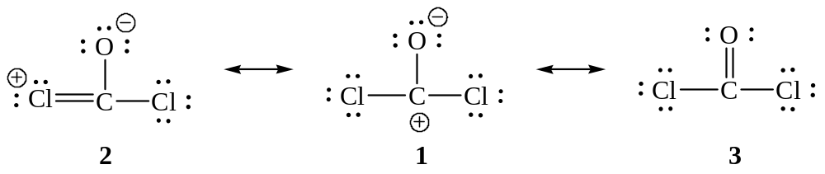

C. Resonance Structures — When One Lewis Structure Isn’t Enough

9. O₃ (ozone)
18 valence electrons (3×6)
Place one O in the center, and connect the other two O’s to it. Drawing a single bond from the terminal O’s to the one in the center uses four electrons; 12 of the remaining electrons go on the terminal oxygens, leaving one lone pair on the central oxygen:
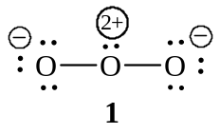
We can satisfy the octet rule on the central O by making a double bond either between the left O and the central one (2), or the right O and the center one (3):
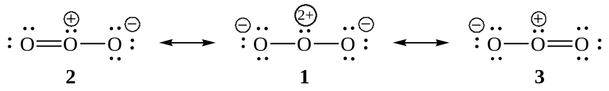
The question is, which one is the “correct” Lewis structure?

In this example, we can draw two Lewis structures that are energetically equivalent to each other — that is, they have the same types of bonds, and the same types of formal charges on all of the structures, and both structures (2 and 3) are used to represent the molecule’s structure. The actual molecule is an average of structures 2 and 3, which are called resonance structures. (Structure 1 is also a resonance structure of 2 and 3, but since it has more formal charges, and does not satisfy the octet rule, it is a higher-energy resonance structure, and does not contribute as much to our overall picture of the molecule.) Structures 2 and 3 in the example above are somewhat “fictional” structures, in that they imply that there are “real” double bonds and single bonds in the structure for ozone; in reality, however, ozone has two oxygen-oxygen bonds which are equal in length, and are halfway between the lengths of typical oxygen-oxygen single bonds and double bonds — effectively, there are two “one-and-a-half” bonds in ozone. The real molecule does not alternate back and forth between these two structures; it is a hybrid of these two forms. (This is analogous to describing a real person as having the characteristics of two or more fictional characters — the fictional characters don’t exist, but the real person does. Another analogy is to consider a mule: a mule is a cross or hybrid between a horse and a donkey, but it doesn’t alternate between being a horse and a donkey.)

The ozone molecule, then, is more correctly shown with both Lewis structures, with the two-headed resonance arrow (T) between them:

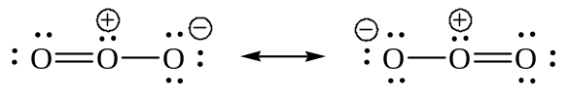

In these resonance structures, one of the electron pairs (and hence the negative charge) is “spread out” or delocalized over the whole molecule. In contrast, the lone pairs on the oxygen in water are localized — i.e., they’re stuck in one place. Resonance delocalization stabilizes a molecule by spreading out charges, and often occurs when lone pairs (or positive charges) are located next to double bonds. Resonance plays a large role in our understanding of structure and reactivity in organic chemistry. (A more accurate picture of bonding in molecules like this is found in Molecular Orbital theory, but this theory is more advanced, and mathematically more complex topic, and will not be dealt with here.)

As a general rule, when it’s possible to make a double bond in more than one location, and the resulting structures are energetically equivalent to each other, each separate structure must be shown, separated from each other by resonance arrows.

10. CO₃²⁻ (carbonate ion)
24 valence electrons (4 + 3×6 + 2)
Place the C in the center, with three lone pairs on each of the O’s:
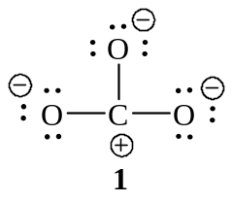
We can satisfy the octet rule and make the formal charges smaller by making a carbon-oxygen double bond. Since there are three equivalent ways of making a C=O, we draw each of the three possible structures, with a resonance arrow between them:
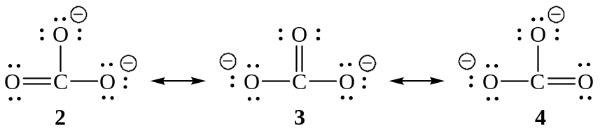
Once again, structure 1 is a resonance structure of 2, 3, and 4, but it is a higher energy structure, and does not contribute as much to our picture of the molecule. Since the double bond is spread out over three positions, the carbon-oxygen bonds in carbonate are “one-and-a-third” bonds.

D. Multi-Center Molecules

Molecules with more than one central atoms are drawn similarly to the ones above. The octet rule and formal charges can be used as a guideline in many cases to decide in which order to connect atoms.

11. | C₂H₆ | 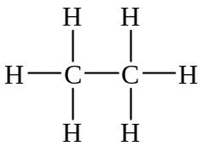
12. | C₂H₄ | 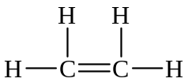
13. | CH₃CH₂OH | 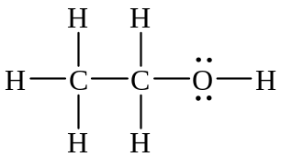

E. “Violations” of the Octet Rule

A number of species violate the octet rule by having fewer than eight electrons around the central atom, or by having more than eight electrons around the central atom. Once again, the formal charge is a good guideline to use to decide whether a “violation” of the octet rule is acceptable.

- Electron deficient species, such as beryllium (Be), boron (B), and aluminum (Al) can have fewer than eight electrons around the central atoms, but have zero formal charge on that atom. Molecules with electron deficient central atoms tend to be fairly reactive (many electron-deficient species act as Lewis acids).
- Free radicals contain an odd number of valence electrons. One atom will have an odd number of electrons, and will not have a complete octet in the valence shell. As a result, these species are extremely reactive. When drawing these compounds, optimize the placement of bonds and the odd electron to minimize formal charges; there are often several possible resonance structures than can be drawn.
- Expanded valence shells are often found in nonmetals from period 3 or higher, such as sulfur, phosphorus, and chlorine. These species can accommodate more than 8 electrons by shoving “extra” electrons into empty d orbitals. Note that period 2 elements CANNOT have more than eight electrons, since the n=2 shell has no d orbitals to put “extra” electrons in.

Examples:

14. BF₃
24 valence electrons (3 + 3×7)
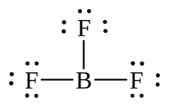
The octet rule is not satisfied on the B, but the formal charges are all zero. (In fact, trying to make a boron-fluorine double bond would put a positive formal charge on fluorine; since fluorine is highly electronegative, this is extremely unfavorable.)

15. NO (nitrogen monoxide, or nitric oxide)
11 valence electrons (5 + 6)
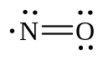
In this structure, the formal charges are all zero, but the octet rule is not satisfied on the N. Since there are an odd number of electrons, there is no way to satisfy the octet rule. Nitric oxide is a free radical, and is an extremely reactive compound. (In the body, nitric oxide is a vasodilator, and is involved in the mechanism of action of various neurotransmitters, as well as some heart and blood pressure medications such as nitroglycerin and amyl nitrite)

16. PCl₅
40 valence electrons (5 + 5×7)
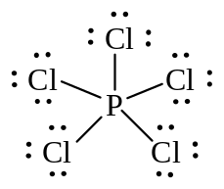
The octet rule is violated on the central P, but phosphorus is in the p-block of row 3 of the periodic table, and has empty d orbitals that can accommodate “extra” electrons. Notice that the formal charge on the phosphorus atom is zero.

17. SF₆
48 valence electrons (6 + 6×7)
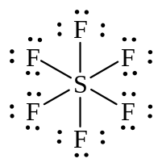
The octet rule is violated on the central S, but sulfur is in the p-block of row 3 of the periodic table, and has empty d orbitals that can accommodate “extra” electrons. Notice that the formal charge on the sulfur atom is zero.

18. SF₄
34 valence electrons (6 + 4×7)
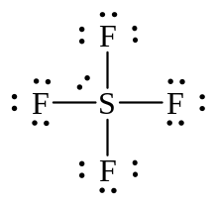
The octet rule is violated on the central S, but sulfur is in the p-block of row 3 of the periodic table, and has empty d orbitals that can accommodate “extra” electrons. Notice that the formal charge on the sulfur atom is zero.

19. XeF₄
36 valence electrons (8 + 4×7)
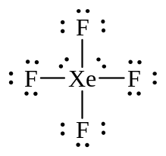
The octet rule is violated on the central Xe, but xenon is in the p-block of row 5 of the periodic table, and has empty d orbitals that can accommodate “extra” electrons. Notice that the formal charge on the xenon atom is zero.

20. H₂SO₄ (S is the central atom; each H is bonded to a different O)
32 valence electrons (2×1 + 6 + 4×6)
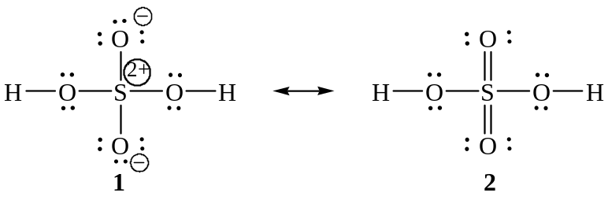
Structures 1 and 2 are resonance structures of each other, but structure 2 is the lower energy structure, even though it violates the octet rule. Sulfur can accommodate more than eight electrons, and the formal charges in structure 2 are all zero.

F. The Shapes of Molecules: The VSEPR Model

Drawing a Lewis structure is the first steps towards predicting the three-dimensional shape of a molecule. The shape of molecules strongly affect their physical properties, and is very important in the way that biological molecules interact with each other.

The approximate shape of a molecule can be predicted using the Valence-Shell Electron-Pair Repulsion (VSEPR) model, which depicts electrons in bonds and lone pairs as “electron groups” that repel one another and stay as far apart as possible:

1. Draw the Lewis structure for the molecule of interest and count the number of electron groups surrounding the central atom. Each of the following constitutes an electron group:
- a single, double or triple bond (multiple bonds count as one electron group)
- a lone pair
- an unpaired electron

2. Predict the arrangement of electron groups around each atom by assuming that the groups are oriented in space as far away from one another as possible.

3. The shapes of larger molecules having more than one central are a composite of the shapes of the atoms within the molecule, each of which can be predicted using the VSEPR model.

Two Electron Groups
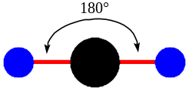
2 bonds, 0 lone pairs
linear
bond angles of 180°
Three Electron Groups
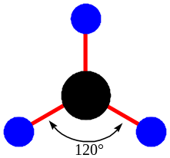 |  |  |  | 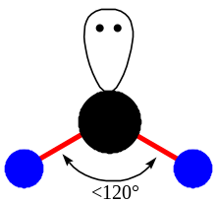
3 bonds, 0 lone pairs |  |  |  | 2 bonds, 1 lone pair
trigonal planar |  |  |  | bent
bond angles of 120° |  |  |  | bond angles of < 120°

Lone pairs take up more room than covalent bonds; this causes the other atoms to be squashed together slightly, decreasing the bond angles by a few degrees.

Four Electron Groups
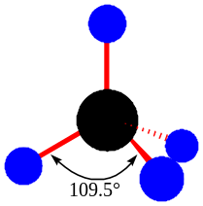 |  |  |  | 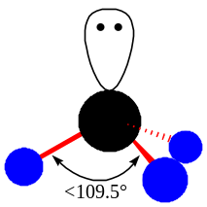 |  |  |  | 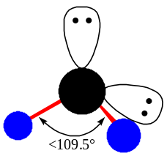
4 bonds, 0 lone pairs |  |  |  | 3 bonds, 1 lone pair |  |  |  | 2 bonds, 2 lone pairs
tetrahedral |  |  |  | trigonal pyramidal |  |  |  | bent
bond angles of 109.5° |  |  |  | bond angles of <109.5° |  |  |  | bond angles of <109.5°

Five Electron Groups
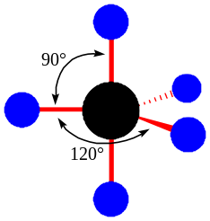 | 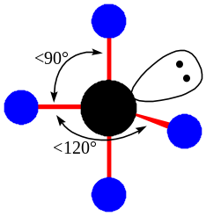 | 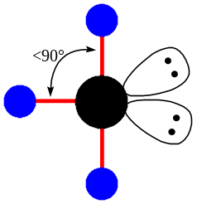 | 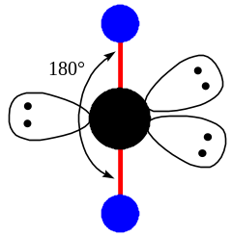
5 bonds, 0 lone pairs | 4 bonds, 1 lone pair | 3 bonds, 2 lone pairs | 2 bonds, 3 lone pairs
trigonal bipyramidal | seesaw | T-shaped | linear
bond angles of 120° (equatorial),  90° (axial) | bond angles of <120° (equatorial),  <90° (axial) | bond angles of <90° | bond angles of 180°

The trigonal bipyramidal shape can be imagined as a group of three bonds in a trigonal planar arrangement separated by bond angles of 120° (the equatorial positions), with two more bonds at an angle of 90° to this plane (the axial positions).
Lone pairs go in the equatorial positions, since they take up more room than covalent bonds. In the equatorial position, lone pairs are ~120° from other bonds, while in the axial positions they would be 90° away from other bonds.

Six Electron Groups
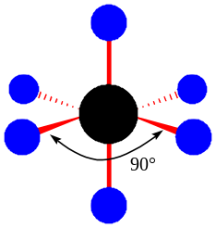 |  |  |  | 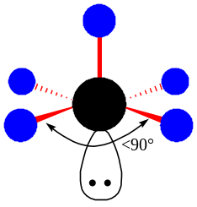 |  |  |  | 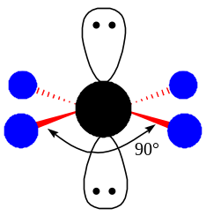
6 bonds, 0 lone pairs |  |  |  | 5 bonds, 1 lone pair |  |  |  | 4 bonds, 2 lone pairs
octahedral |  |  |  | square pyramidal |  |  |  | square planar
bond angles of 90° |  |  |  | bond angles of <90° |  |  |  | bond angles of 90°

The Lewis structures of the previous examples can be used to predict the shapes around their central atoms:

 | Formula | Lewis Structure | Bonding | Shape
1. | CH₄ |  | 4 bonds  0 lone pairs | tetrahedral
2. | NH₃ |  | 3 bonds  1 lone pair | trigonal pyramidal
3. | H₂O |  | 2 bonds  2 lone pairs | bent
4. | H₃O⁺ |  | 3 bonds  1 lone pair | trigonal pyramidal
5. | HCN | 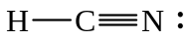 | 2 bonds  0 lone pairs | linear
6. | CO₂ | 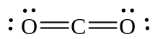 | 2 bonds  0 lone pairs | linear
7. | CCl₄ |  | 4 bonds  0 lone pairs | tetrahedral
8. | COCl₂ | 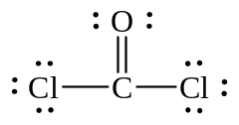 | 3 bonds  0 lone pairs | trigonal planar
9. | O₃ | 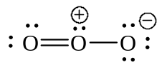 | 2 bonds  1 lone pair | bent*
10. | CO₃²⁻ | 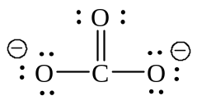 | 3 bonds  0 lone pairs | trigonal planar*
11. | C₂H₆ |  | 4 bonds  0 lone pairs | tetrahedral
12. | C₂H₄ |  | 3 bonds  0 lone pairs | trigonal planar
13. | CH₃CH₂OH |  | C: 4 bonds  0 lone pairs  O: 2 bonds  2 lone pairs | C: tetrahedral  O: bent
14. | BF₃ |  | 3 bonds  0 lone pairs | trigonal planar
15. | NO |  |  | linear
16. | PCl₅ |  | 5 bonds  0 lone pairs | trigonal bipyramidal
17. | SF₆ |  | 6 bonds  0 lone pairs | octahedral
18. | SF₄ |  | 4 bonds  1 lone pair | seesaw
19. | XeF₄ |  | 4 bonds  2 lone pairs | square planar
20. | H₂SO₄ | 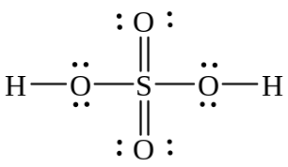 | S: 4 bonds  0 lone pairs  O: 2 bonds  2 lone pairs | S: tetrahedral  O: bent

G. Polar and Nonpolar Covalent Bonds

Electronegativity is a measure of the ability of an atom in a molecule to attract shared electrons in a covalent bond. Electronegativity is a periodic property, and increases from bottom to top within a group and from left to right across a period:

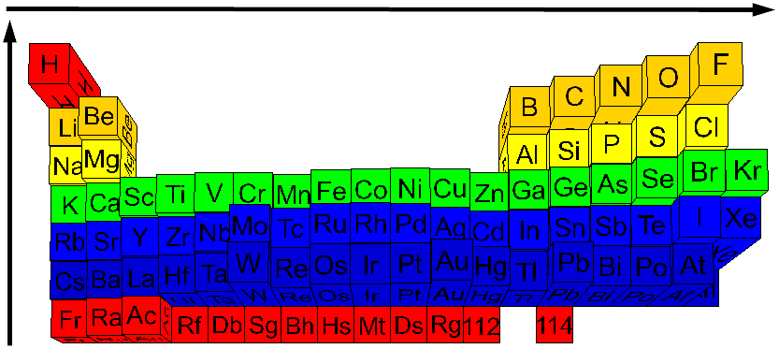
Table 1. Periodic Trends in Electronegativity

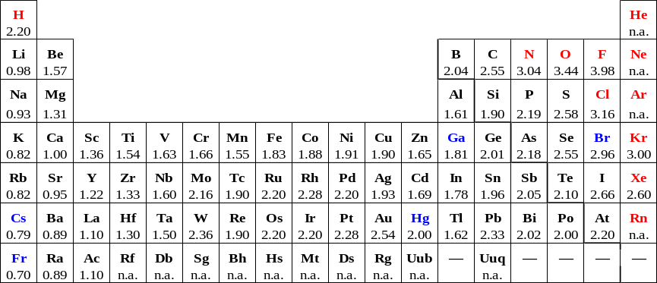
Table 2. Electronegativity Values (Pauling scale)

When two atoms of the same electronegativity share electrons, the electrons are shared equally, and the bond is a nonpolar covalent bond — there is a symmetrical distribution of electrons between the bonded atoms. (As an analogy, you can think of it as a game of tug-of-war between two equally strong teams, in which the rope doesn’t move.) For example, when two chlorine atoms are joined by a covalent bond, the electrons spend just as much time close to one chlorine atom as they do to the other; the resulting molecule is nonpolar (indicated by the symmetrical electron cloud shown below):

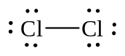 | 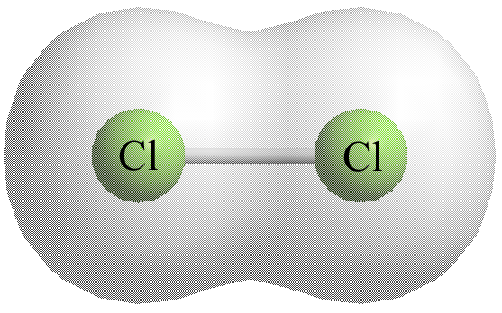
When two bonded atoms have a difference of greater than 2.0 electronegativity units (see Table 2), the bond is an ionic bond — one atoms takes the electrons away from the other atom, producing cations and anions.

When two bonded atoms have a difference of between 0.4 and 2.0 electronegativity units (see Table 2), the electrons are shared unequally, and the bond is a polar covalent bond — there is an unsymmetrical distribution of electrons between the bonded atoms, because one atom in the bond is “pulling” on the shared electrons harder than the other, but not hard enough to take the electrons completely away. The more electronegative atom in the bond has a partial negative charge (δ⁻), because the electrons are pulled slightly towards that atom, and the less electronegative atom has a partial positive charge (δ⁺), because the electrons are partly (but not completely) pulled away from that atom. For example, in the HCl molecule, chlorine is more electronegative than hydrogen by 0.96 electronegativity units. The shared electrons are pulled slightly closer to the chlorine atom, making the chlorine end of the molecule very slightly negative (indicated in the figure below by the larger electron cloud around the Cl atom), while the hydrogen end of the molecule is very slightly positive (indicated by the smaller electron cloud around the H atom), and the resulting molecule is polar:

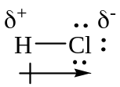 | 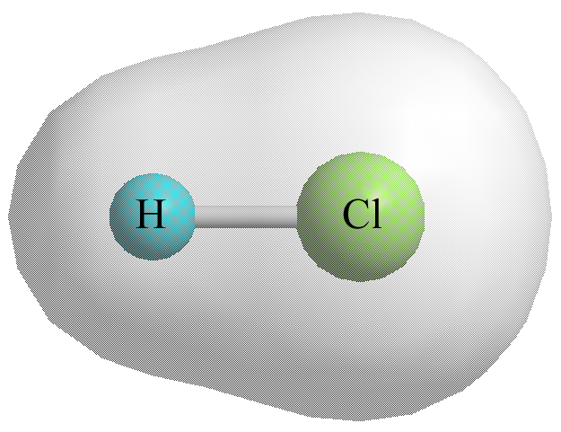

H. Molecular Shape and Polarity

In a diatomic molecule, there is only one bond, and the polarity of that bond determines the polarity of the molecule: if the bond is polar, the molecule is polar, and if the bond is nonpolar, the molecule is nonpolar.

In molecules with more than one bond, both shape and bond polarity determine whether or not the molecule is polar. A molecule must contain polar bonds in order for the molecule to be polar, but if the polar bonds are aligned exactly opposite to each other, or if they are sufficiently symmetric, the bond polarities cancel out, making the molecule nonpolar. (Polarity is a vector quantity, so both the magnitude and the direction must be taken into account.)

For example, consider the Lewis dot structure for carbon dioxide. This is a linear molecule, containing two polar carbon-oxygen double bonds. However, since the polar bonds are pointing exactly 180° away from each other, the bond polarities cancel out, and the molecule is nonpolar. (As an analogy, you can think of this is being like a game of tug of war between two teams that are pulling on a rope equally hard.)

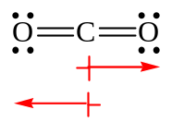 | 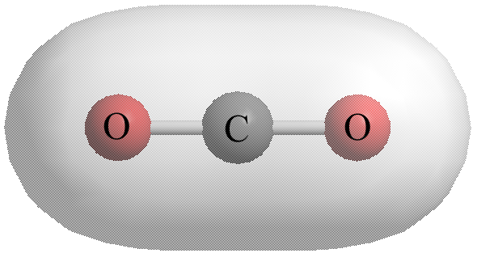

The water molecule also contains polar bonds, but since it is a bent molecule, the bonds are at an angle to each other of about 105°. They do not cancel out because they are not pointing exactly towards each other, and there is an overall dipole going from the hydrogen end of the molecule towards the oxygen end of the molecule; water is therefore a polar molecule:

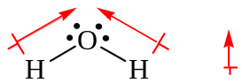 | 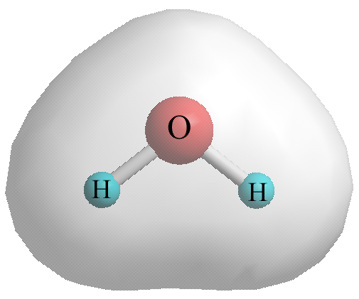

Molecules in which all of the atoms surrounding the central atom are the same tend to be nonpolar if there are no lone pairs on the central atom. If some of the atoms surrounding the central atom are different, however, the molecule may be polar. For example, carbon tetrachloride, CCl₄, is nonpolar, but chloroform, CHCl₃, and methyl chloride, CH₃Cl are polar:

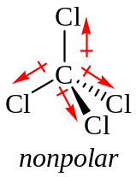 | 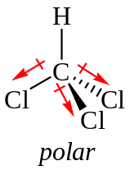 | 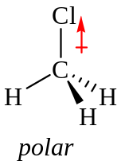
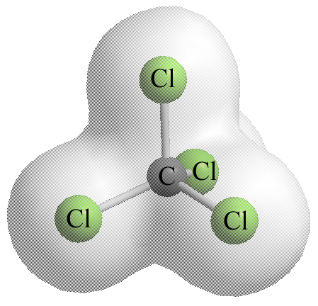 | 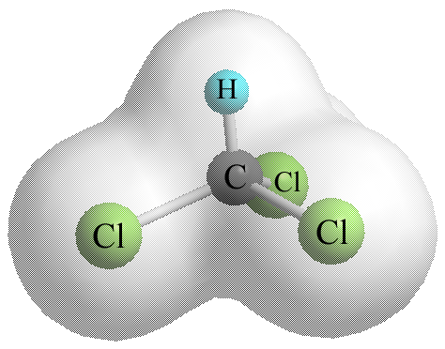 | 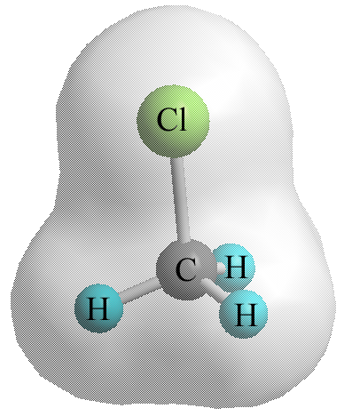

The polarity of a molecule has a strong effect on its physical properties. Molecules which are more polar have stronger intermolecular forces between them, and have, in general, higher boiling points (as well as other different physical properties).

The table below shows whether the preceding examples are polar or nonpolar. For species which have an overall charge, the term “charged” is used instead, since the terms “polar” and “nonpolar” do not really apply to charged species; charged species are, by definition, essentially polar. Lone pairs on some outer atoms have been omitted for clarity.

 | Formula | Shape / 3D Structure / Polarity | Explanation
1. | CH₄ | 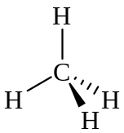  tetrahedral  nonpolar | The C—H bond is nonpolar, since C and H differ by only 0.35 electronegativity units.
2. | NH₃ | 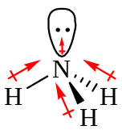  trigonal pyramidal  polar | Since this molecule is not flat, the N—H bonds are not pointing directly at each other, and their polarities do not cancel out. In addition, there is a slight dipole in the direction of the lone pair.
3. | H₂O | 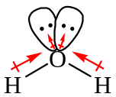  bent  polar | Since this molecule is bent, the O—H bonds are not pointing directly at each other, and their polarities do not cancel out.
4. | H₃O⁺ | 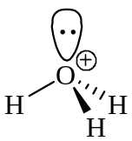  trigonal pyramidal  charged | Since this species is charged, the terms “polar” and “nonpolar” are irrelevant.
5. | HCN | 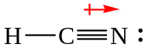  linear  polar | Linear molecules are usually nonpolar, but in this case, not all of the atoms connected to the central atom are the same. The C—N bond is polar, and is not canceled out by the nonpolar C—H bond.
6. | CO₂ | 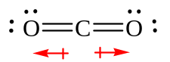  linear  nonpolar | The polar C=O bonds are oriented 180° away from each other. The polarity of these bonds cancels out, making the molecule nonpolar.
7. | CCl₄ | 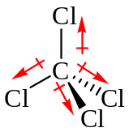  tetrahedral  nonpolar | The polar C—Cl bonds are oriented 109.5° away from each other. The polarity of these bonds cancels out, making the molecule nonpolar.
8. | COCl₂ | 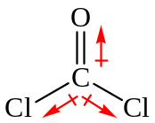  trigonal planar  polar | Trigonal planar molecules are usually nonpolar, but in this case, not all of the atoms connected to the central atom are the same. The bond polarities do not completely cancel out, and the molecule is polar. (If there were three O’s, or three Cl’s attached to the central C, it would be nonpolar.)
9. | O₃ | 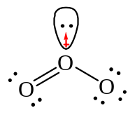  bent  polar | Bent molecules are always polar. Although the oxygen-oxygen bonds are nonpolar, the lone pair on the central O contributes some polarity to the molecule.
10. | CO₃²⁻ | 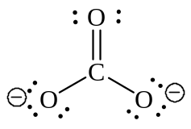  trigonal planar  charged | Since this species is charged, the terms “polar” and “nonpolar” are irrelevant.
11. | C₂H₆ | 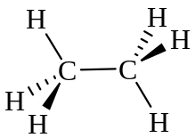  tetrahedral  nonpolar | Both carbon atoms are tetrahedral; since the C—H bonds and the C—C bond are nonpolar, the molecule is nonpolar.
12. | C₂H₄ | 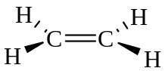  trigonal planar  nonpolar | Both carbon atoms are trigonal planar; since the C—H bonds and the C—C bond are nonpolar, the molecule is nonpolar.
13. | CH₃CH₂OH | 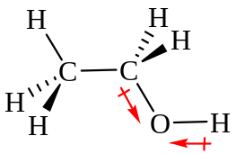  C: tetrahedral  O: bent  polar | The C—C and C—H bonds do not contribute to the polarity of the molecule, but the C—O and O—H bonds are polar, the since the shape around the O atom is bent, the molecule must be polar.
14. | BF₃ | 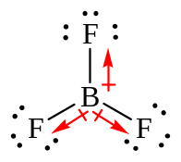  trigonal planar  nonpolar | Since this molecule is planar, all three polar B—F bonds are in the same plane, oriented 120° away from each other, making the molecule nonpolar.
15. | NO | 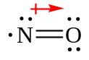  linear  polar | Since there is only one bond in this molecular, and the bond is polar, the molecule must be polar.
16. | PCl₅ | 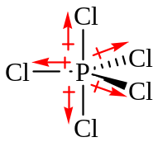  trigonal bipyramidal  nonpolar | The P—Cl bonds in the equatorial positions on this molecule are oriented 120° away from each other, and their bond polarities cancel out. The P—Cl bonds in the axial positions are 180° away from each other, and their bond polarities cancel out as well.
17. | SF₆ | 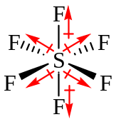  octahedral  nonpolar | The S—F bonds in this molecules are all 90° away from each other, and their bond polarities cancel out.
18. | SF₄ | 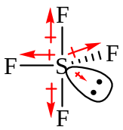  seesaw  polar | The S—F bonds in the axial positions are 90° apart, and their bond polarities cancel out. In the equatorial positions, since one position is taken up by a lone pair, they do not cancel out, and the molecule is polar.
19. | XeF₄ | 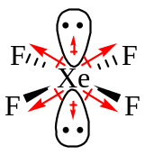  square planar  nonpolar | The Xe—F bonds are all oriented 90° away from each other, and their bond polarities cancel out. The lone pairs are 180° away from each other, and their slight polarities cancel out as well.
20. | H₂SO₄ | 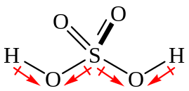  S: tetrahedral  O: bent  polar | This molecule is polar because of the bent H—O—S bonds which are present in it.

Shapes summary
print separately

* With Lewis structures involving resonance, it is irrelevant which structure is used to determine the shape, since they are all energetically equivalent.

