Alkenes and Alkynes Review Name ____________________________ # _______
For some of the questions, you will need to refer to the PPt (slides 1-44) and/or the book.
- What kind of reaction is shown below? ________________________
- Name the reactant and the product. ___________________ ___________________________

- What kind of reactions are shown below? ____________________________
- Are the products saturated or unsaturated? __________________________
- Name the product of the first reaction ______________________________________
- Name product of 2nd reaction _________________________________

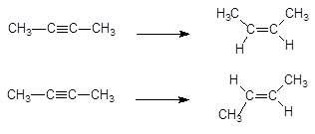

- Observe to 2 molecules below. Circle the hydroxyl group.
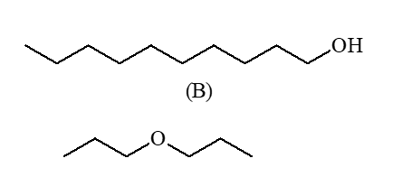
- To the right of each, identify the 1) alcohol and 2) ether
- Compare this molecule with the first molecule, above. Which would be more soluble and why?

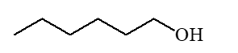
- A- Look at the below molecule. In terms of solubility, how would it compare to the other 2? ______________________________________________________________________________B- RANK THEM from most soluble to least soluble.

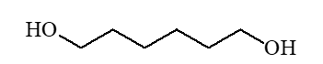
- Name the following:
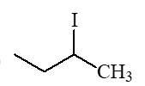____________________________________________________________
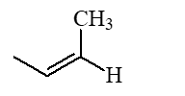___________________________________________________________
_____________________________________________________
___________________________________________________

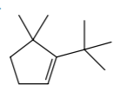_________________________________________________________________

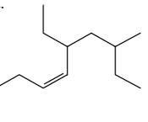______________________________________________________________

- Complete the following reaction (remember Markovnikov’s Rule). Name both the reactants and the products.
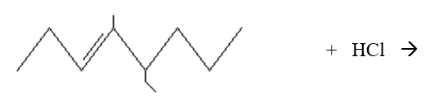
- From slide #22 in PPt: “To determine the # of stereoisomers, use the formula 2^{n}, where
n = # double bonds”.
Draw 2, 4-heptadiene and determine the # of stereoisomers:

- Name the stereoisomers from #13.

- Go to page 361. Explain what must happen for an optic nerve to fire and produce a visual image.

Answer these questions regarding catalysts (see PPt and book-Chapter 7)
- Why are catalysts used in reactions?

- What is activation energy? How do enzymes affect it? *Make sure you understand Fig 7.9

- A- Go to p. 222 (Chem Connections 7C). Why do solids in powder form react faster than pill form?

B- Explain how a time-released drug works.

Complete the following reactions (draw structures and name products):
- ethylcyclopentene reacts with HBr (using a catalyst).

- 4-isopropyl-2-octene reacts with Br₂ (catalyst)

- 1-hexene is hydrated (strong acid catalyst).

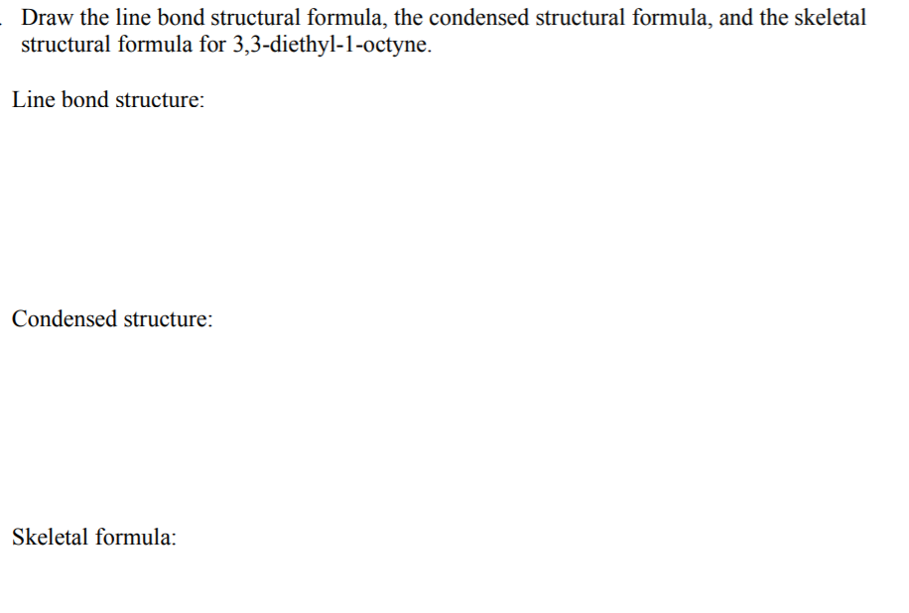

- A. What is a terpene?

B. Draw one example of a terpene.

C. What unit repeats in all terpenes?

Given the PRODUCT, determine the REACTANTS (presume catalysts are used)
- 1, 2-dichloro-1-methyl-(1)-cyclohexane * ( ) means the number isn’t necessary

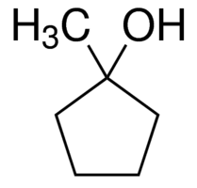 * you don’t have to name alcohols on this test

