Part 2- AP Bio Final Exam Review
*while this may suffice for studying for my final, it’s not inclusive enough for preparing for AP Exam
Molecular Biology
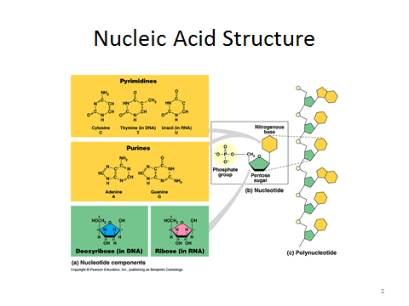
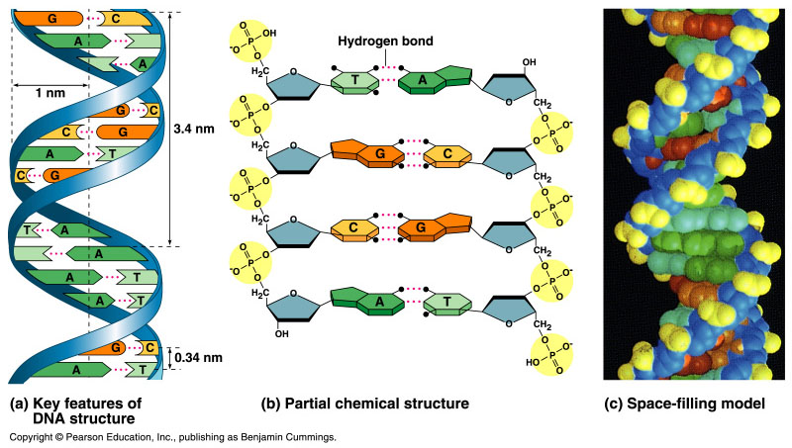
- Griffith – Transformation (Avery did this same experiment but use on certain parts of the heat killed S [protein, DNA, etc.] to figure out what was the “instructional agent”
- 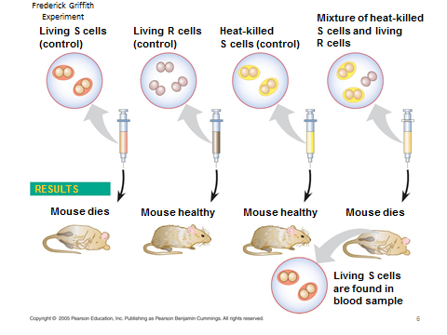
- 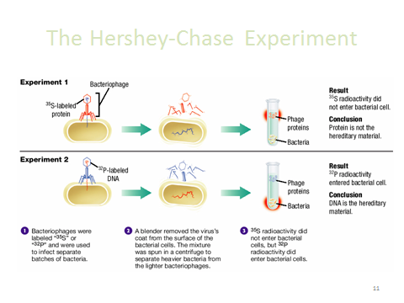
- Chargaff – A/T and C/G will be in equal percentages
- Watson & Crick (Wilkins & Franklin)
- REPLICATION:
  - WHAT? COPY DNA
  - WHERE? NUCLEUS
  - WHY? 2 COPIES FOR DIVISION
  - HOW? BELOW

- 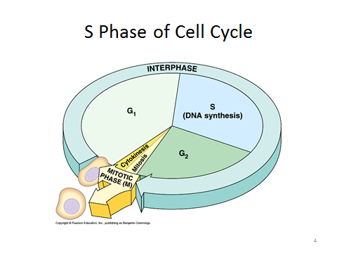
- 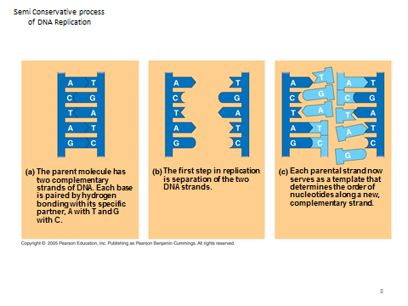
- 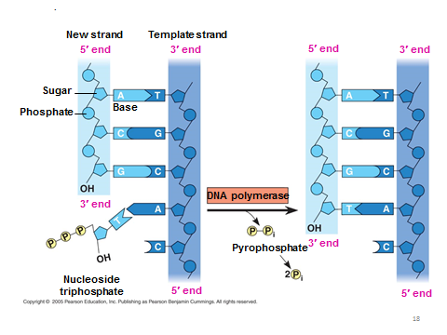
- 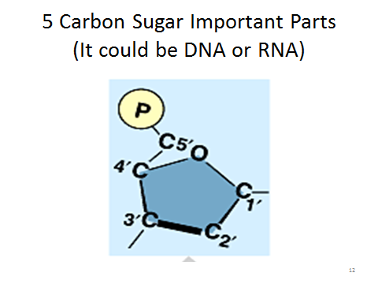
- Strands are always built AND transcribed to be used in the 5’ TO 3’ direction (the parent strand is read 3’ TO 5’ to build the daughter strand – remember DNA always runs antiparallel)
- 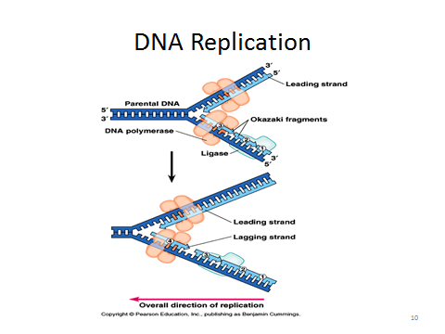
- Enzymes involved in replication
  - Helicase, Polymerase, Primase, Topoisomerase, Ligase, Single-strand binding protein (not an enzyme)
- 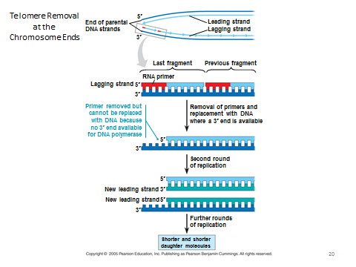

- TRANSCRIPTION:
  - WHAT? DNA TO MRNA
  - WHERE? NUCLEUS
  - WHY? MAKE COPY OF DNA FOR PROTEIN SYNTHESIS
  - HOW?BELOW
- Key words
  - template/non-coding DNA strand
  - non-template/coding DNA strand
- Central Dogma of molecular biology:
  - DNA RNA proteins/enzymes traits, metabolism, homeostasis
- 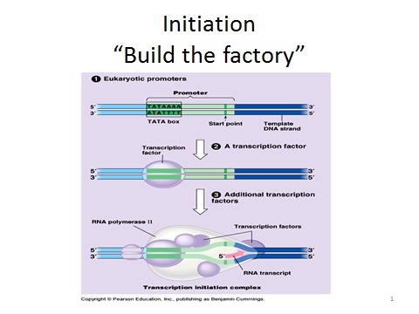
- 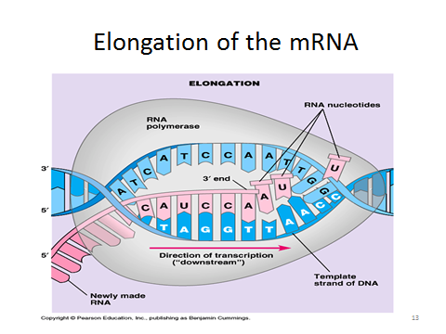

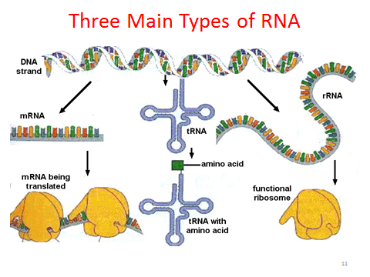

- TRANSLATION:
  - WHAT? MRNA TO PROTEIN
  - WHERE? RIBOSMES (ROUGH ER OR CYTOPLASM)
  - WHY? PROTEINS ARE WORKHORSES OF CELLS
  - HOW? BELOW
- 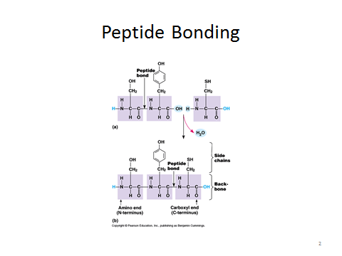
- 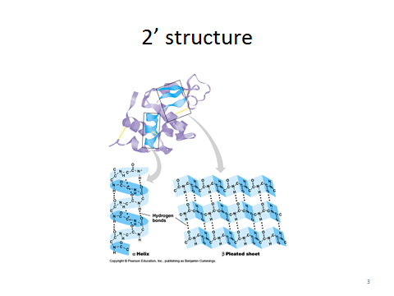
- 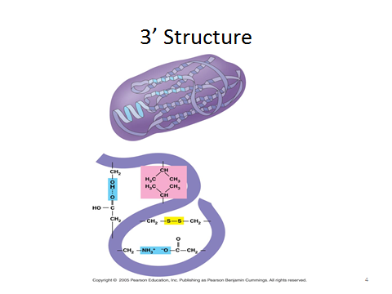
- 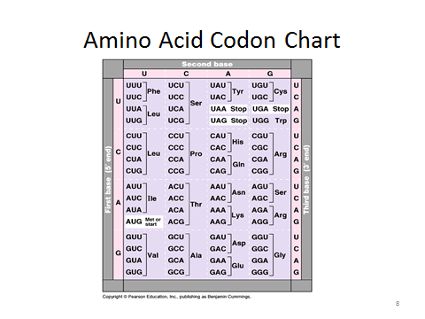
- 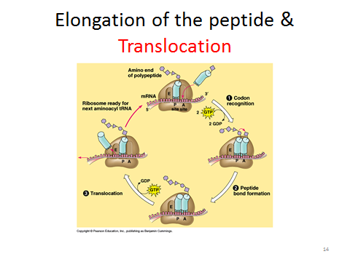
- 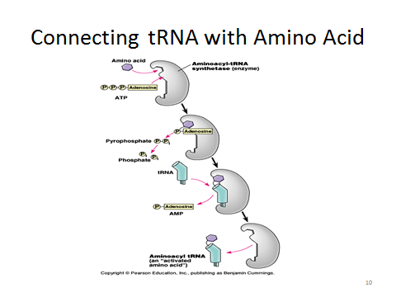
- 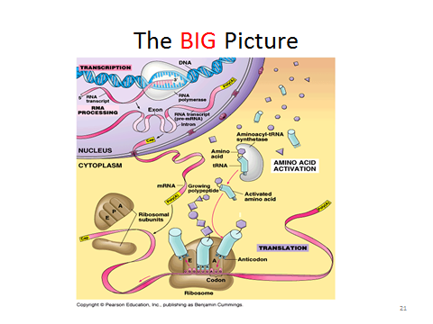
- 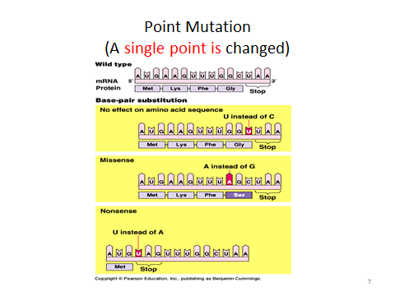
- 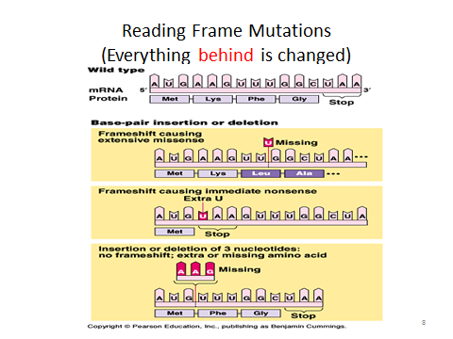
- Both point mutations and reading frameshifts can cause silent, missense, and nonsense mutations

- Gene expression and control mechanisms
  - Methylations mutes (long term deactivation by causing chromatin to wrap around histones in methylated areas)
  - Acetylation activates (activates section of DNA by acetylating histones so that DNA cannot wrap around it in that section)
  - 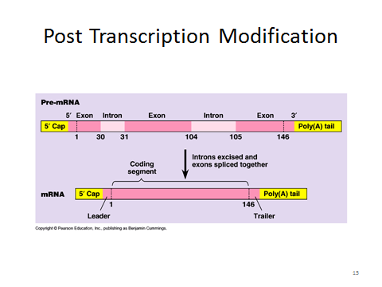
  - 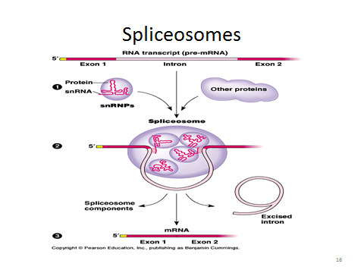

- Control of gene expression in PROKARYOTES
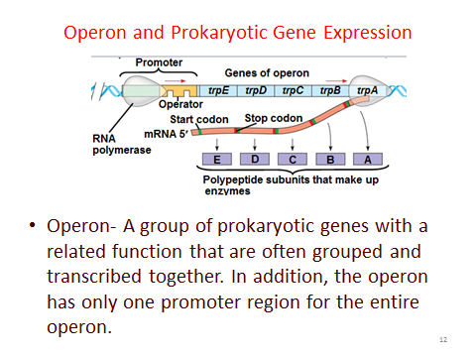
  - Inducible (lac operon)
  - Repressible (trp operon)
- BIOTECHNOLOGY
- 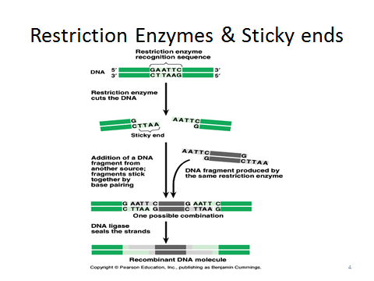
- 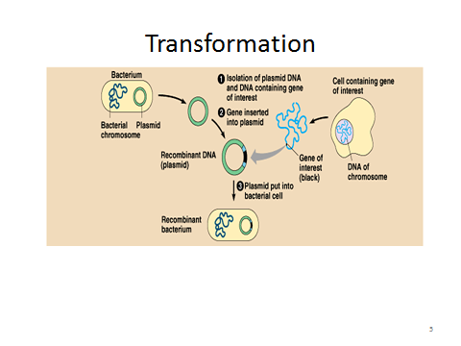
- 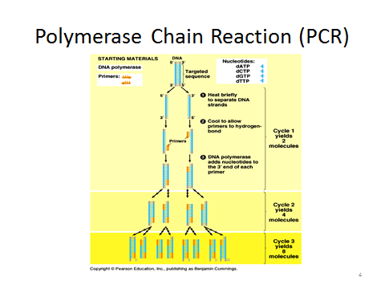
- 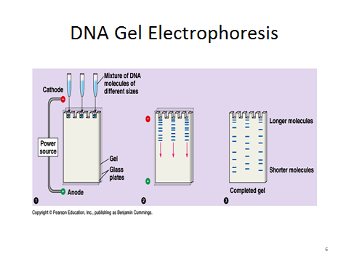
- 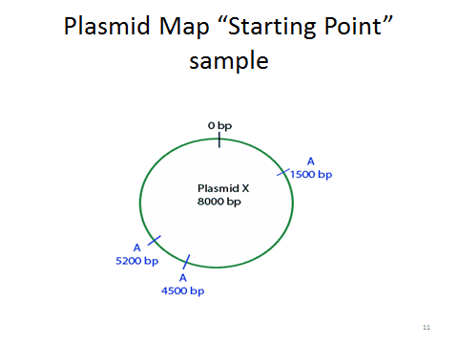

Evolution
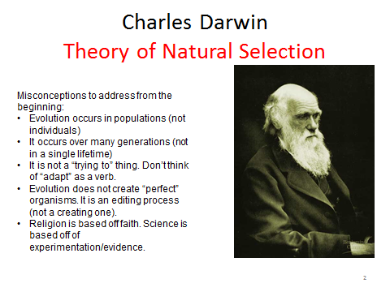
- Linnaeus, Lamarck, etc
- 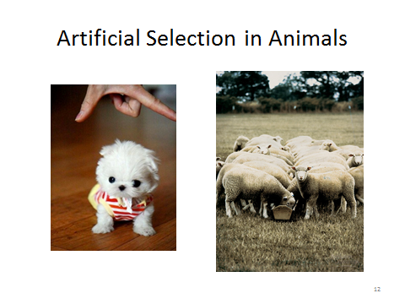

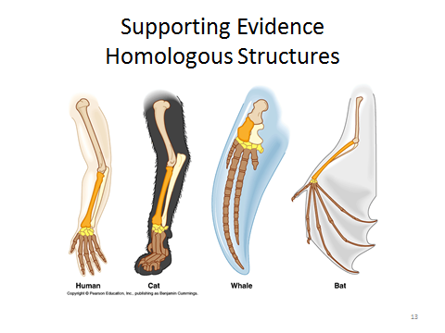
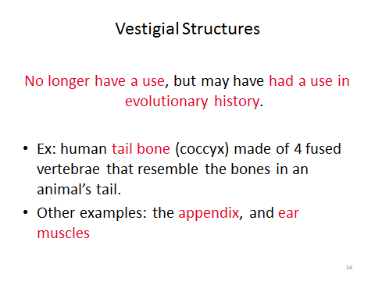
Go over:
-Microevolution vs Macro
- Causes of microevolution (natural selection, genetic drift, gene flow, mutation, etc)
- Hardy Weinberg equilibrium (go over PPt from Unit 6)
-Types of selection (directional, diversifying, etc)
-Convergent vs Divergent
-Macroevolution (speciation)
-Pre-zygotic vs post-zygotic
-Adaptive radiation: Punctuated equilibrium vs. Gradualism
-Phylogeny (phylogenetic trees)
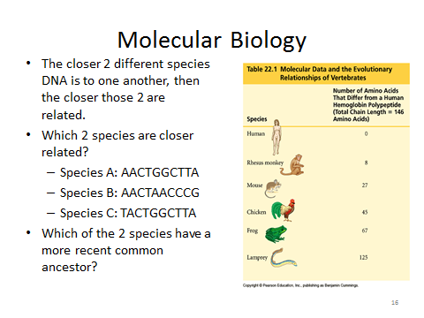
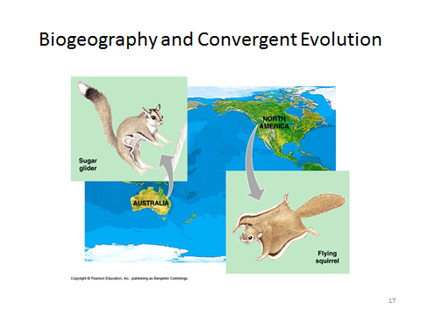
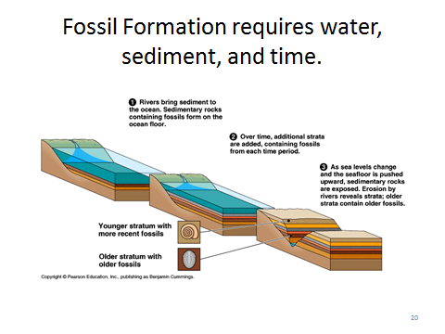
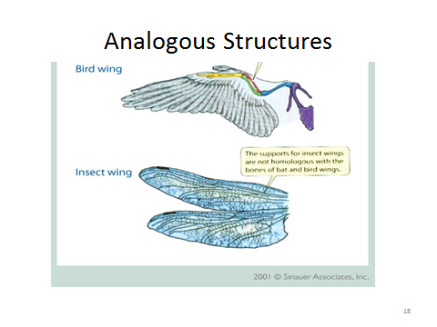
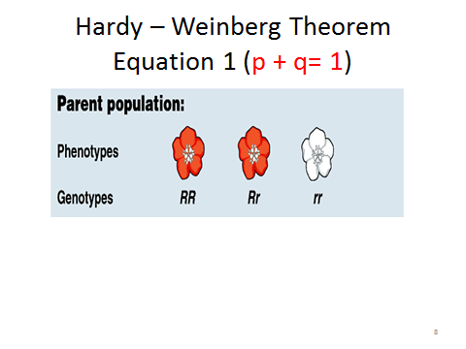
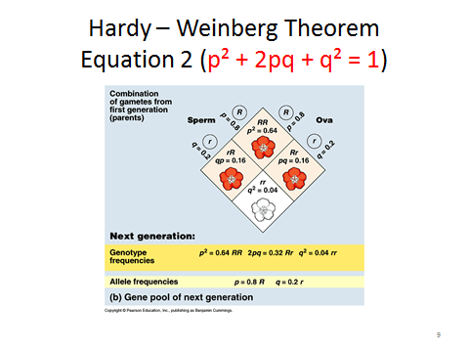
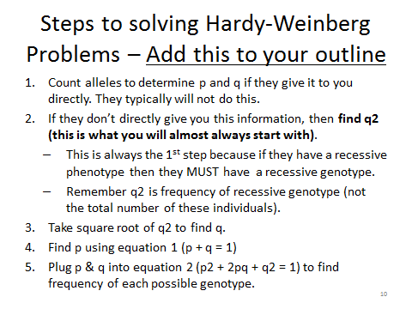
H-Wbg Equilibrium: (see below)
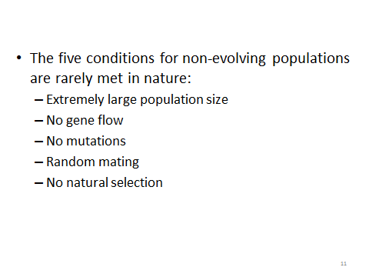

- Evolution REQUIRES genetic variation
  - Mutations in gametes are ultimate source of all new ALLELES
  - Sexual reproduction
    - Crossing over
    - Independent Assortment
    - Segregation
    - Random Fertilization
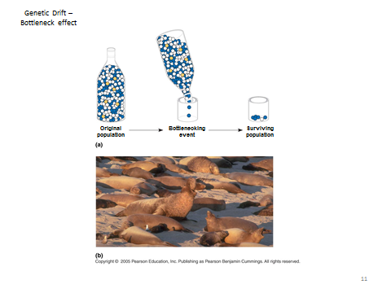
  - BOTTLENECK EFFECT AND FOUNDER EFFECT
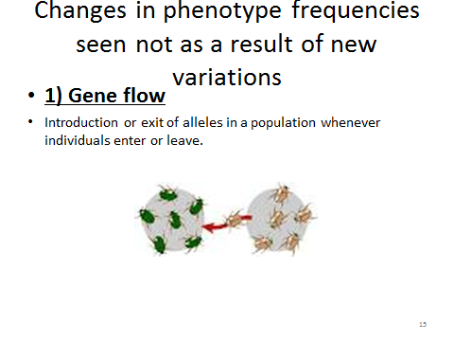
- 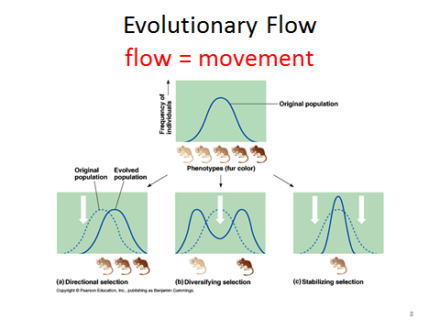
- 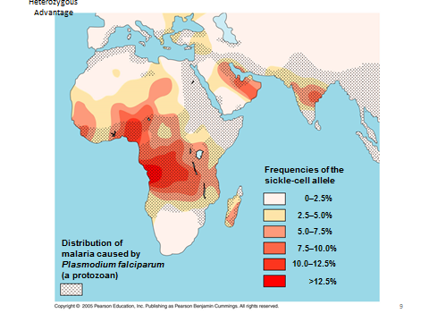
- 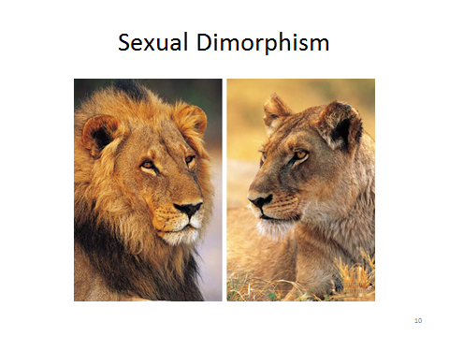

MACROEVOLUTION – CREATION OF NEW SPECIES AFTER REPRODUCTIVE ISOLATION
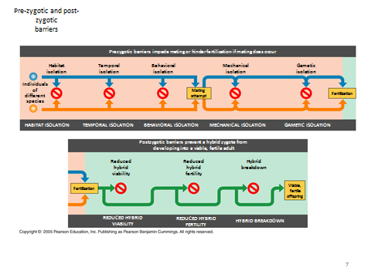
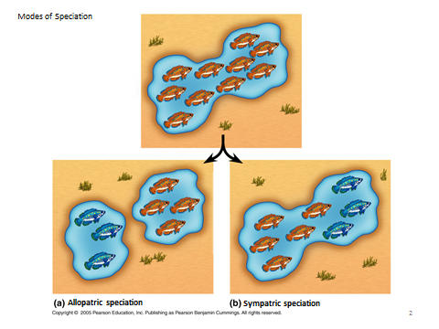
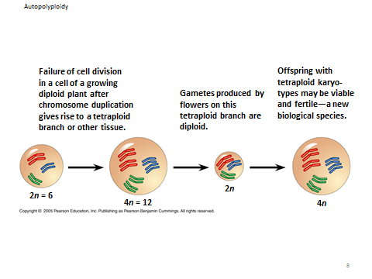
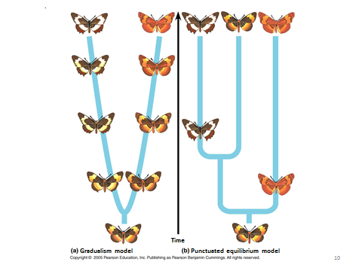
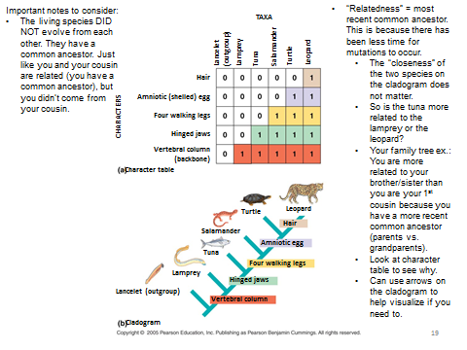
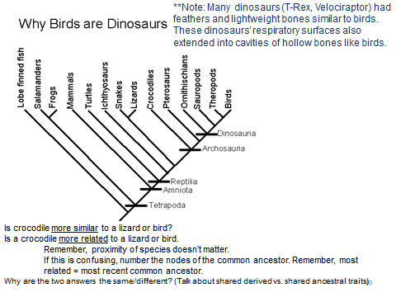
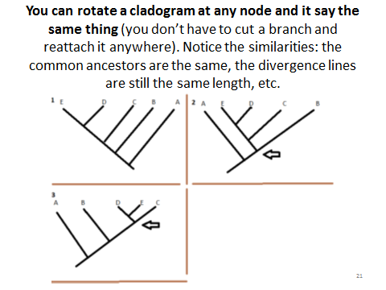
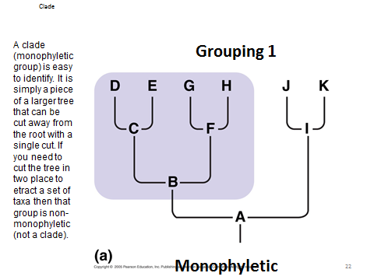
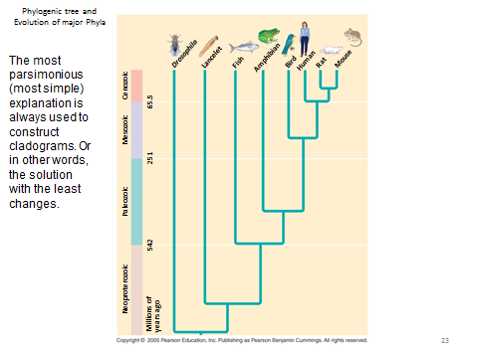
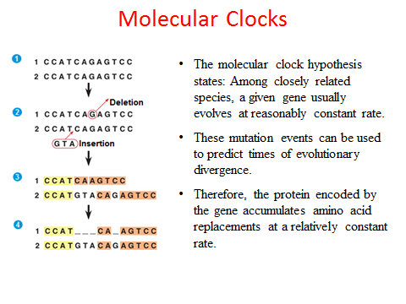

Cell Communication 2: Nervous, Immune, and Endocrine Systems

- Noteworthy trends in nervous system evolution
  - Increase in ganglia (mass of nerve cell bodies)
  - Increase in sensory reception
  - Increase in cephalization
    - Cephalization is the concentration of nervous tissue in the anterior region of the organism.
- 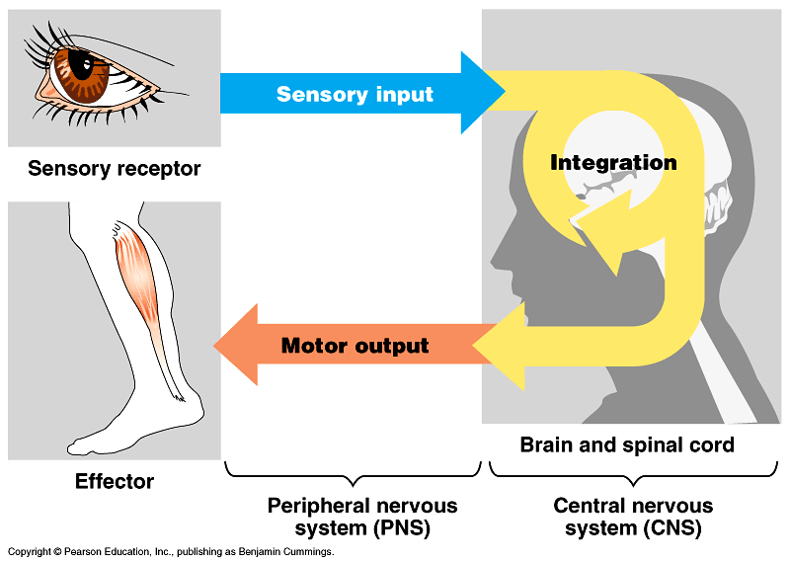

- Reflex (next page)
- 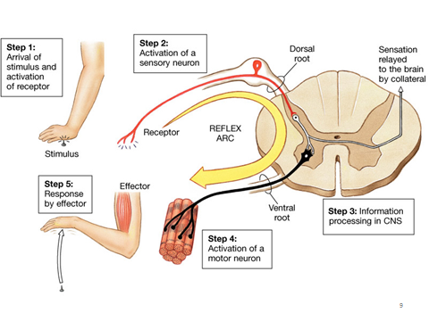
- Central vs. Peripheral
- 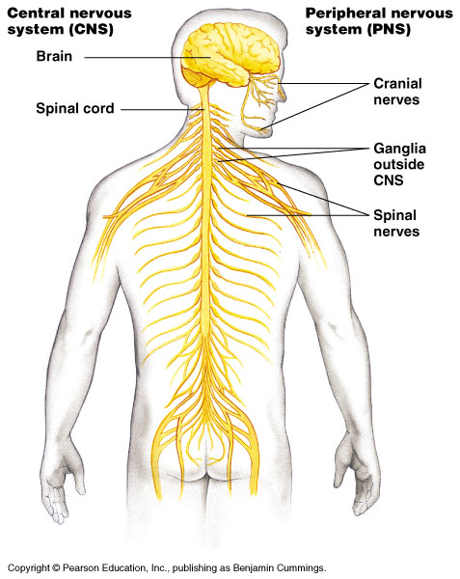
Neuron Structure – Glial cells are supportive cells for neurons. These are supporting cells for neurons to “hang’ onto. They are analogous to the frame for a house.
1. They help to maintain the integrity (functioning) of system.
- 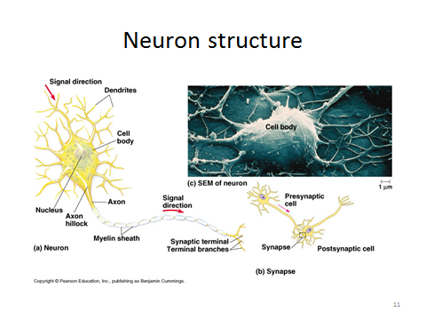

- Membrane Potential (voltage and concentration gradient across a membrane – has potential energy as the membrane potential wants to become 0).
  - The resting membrane potential is around -70 mV because outside is more positive (Na+) and inside is more negative (K+ and negative Anions&proteins) are inside the cell
- Action Potential (Na diffuses inside; K goes outside)
- Na+/K+ pump- restores original membrane potential by pumping Na from inside to outside and K from outside to inside. Requires ATP
  - 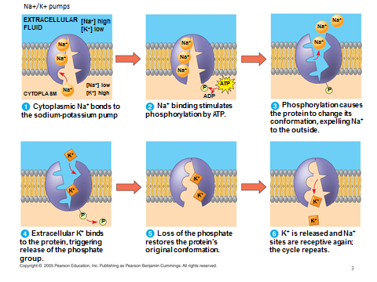
- 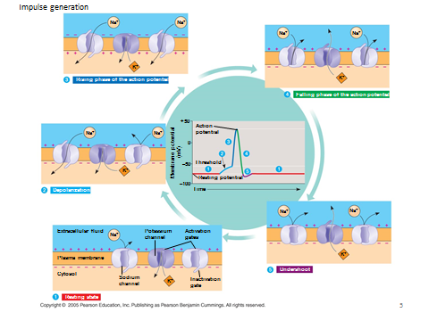
- 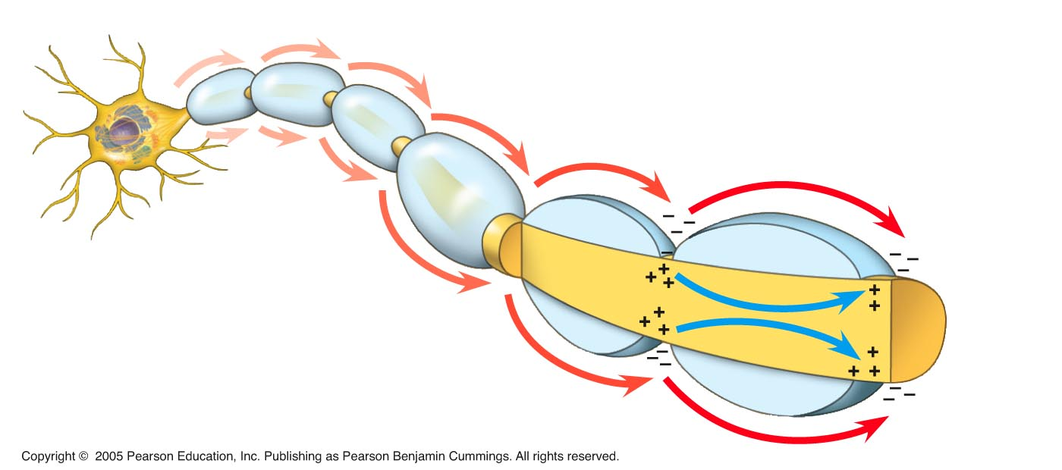
- Above diagram shows saltatory propagation. Impulse goes faster if neuron is mylenated (jumps from node to node)

- 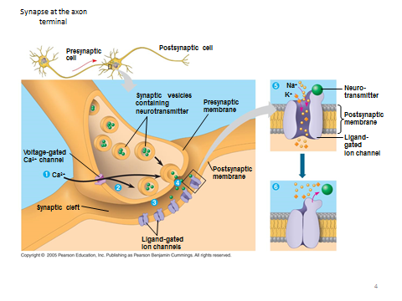
- Types of Neurotransmitters
A. Acetylcholine
1. Most common –This is mostly for making muscles of the PNS contract .
2. In the CNS – It can be excitatory OR inhibitory.
B. Others:
1. Epinephrine – speeds up body functions. (Such as breathing, metabolism, heart rate)*
2. Norepinephrine – also assists with speeding up body functions.*
* These two together are called your “fight or flight response”.
3. Dopamine – This is your happy neurotransmitter. #
4. Serotonin – This is your sleep neurotransmitter. #
# These are out of balance in ADD, Schizophrenia. LSD and Xtasy mimic these neurotransmitters.
- 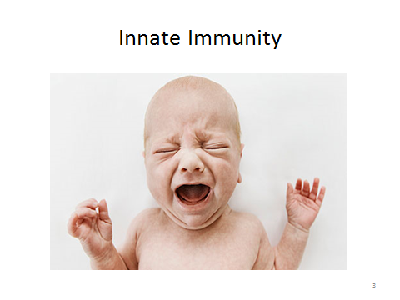
- Skin, mucous membranes

- Inflammatory Response – HISTAMINES

- 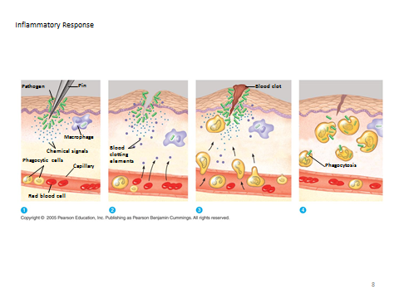

- Phagocytic cells can engulf pathogens. They can also use: Major Histocompatibility Complexes (MHC’s) – These membrane proteins display part of the antigen on membrane for other WBC to recognize so they can destroy the cell (Acquired/Adaptive immunity)

- SPECIFIC IMMUNITY (ACQUIRED/ ADAPTIVE IMMUNITY)

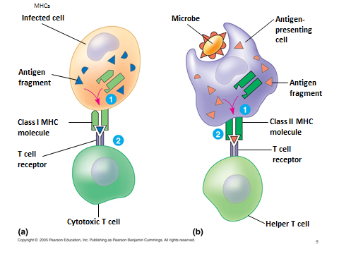
- 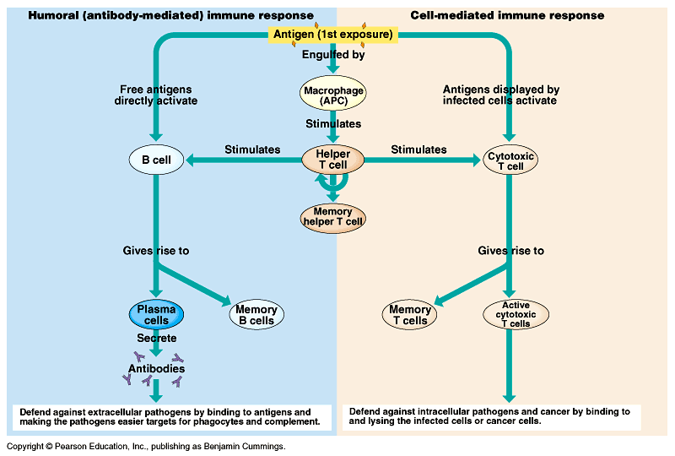
  - Use MHC to display antigen on surface
  - Macrophages, Helper T Cells, B Cells, Cytotoxic T Cells, Memory Cells
  - Helper T cells release cytokines to alert B cells and Cytotoxic T cells
  - Humoral (B cells make antibodies) and Cell-Mediated Immunity (T cells. Cytotoxic T cells destroy infected cells by poking holes in them and releasing perforins)
    - Antibodies can either tag antigens so cytotoxic T cells to find them or they can use antibodies to neutralize antigen

Abnormal Immune System Function:
A. Allergy (This is a false alarm.) (Mast cells are the problem by over producing histamine; take an antihistamine.) This happens in Innate Immunity
B. Autoimmune Disorders (Caused by faulty DNA genes and cells don’t recognize “self” cells)
1. Lupus 2. Rheumatoid Arthritis – WBCs attack and break down the connective tissues. (Mostly cartilage affected.)
3. Insulin – dependent Diabetes (Type 1 – ‘Juvenile’ Diabetes) – WBCs attack the pancreas cells that make Insulin.
4. Multiple Sclerosis (MS) – WBCs attack the Schwann cells and myelin sheathes of neurons.
C. HIV/AIDS - This is caused by a retrovirus.
a. Host cell is the T-helper lymphocyte. (It keys in on the CD 4 membrane marker protein.)

Endocrine System
Hormone – This is a chemical produced in one part of the body and travels to another part of the body to have an effect.
A. Target tissue – This is where the hormone travels to. (The target cells have the special proteins receptors “hands”.)
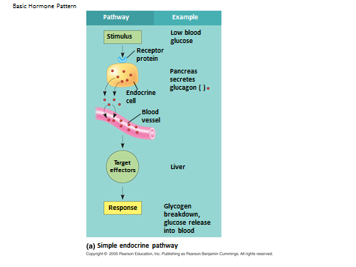
Hormone reception by cells:
A. Ligand (hormone) attaching to the membrane receptor proteins causes a signal-transduction pathway to begin.
1. If the pathway ends in the cytoplasm – turned on/off an enzyme.
2. If the pathway ends in the nucleus – turned on/off transcription.
B. Steroid hormones go through the phospholipid bilayer portion of the membrane to find its receptor protein in the cytoplasm. They do not need secondary messengers. Most are Transcription activators.
Hormonal control mechanisms:
A. Negative feedback loops – These stop a process already occurring and get it going in the opposite direction toward homeostasis.
B. Positive feedback loops – These enhance a process that is already occurring and take it away from homeostasis
.
Major Endocrine Glands
Hypothalamus (part of brain, but has some endocrine function) - This is the master control of homeostasis.
A. It controls the majority of the homeostasitc mechanisms in our body.
B. Controls the pituitary gland – second in command.
Pituitary Gland - This is the second in charge in control of homeostasis.
A. This gland is affected by Hypothalamus Hormones.
1. Releasing hormones—Starts a process.
2. Inhibiting hormones —Stops a process that is occurring.
Pancreas – control of blood glucose
A. Insulin – lowers blood glucose by triggering cells to take in glucose and convert to ATP or take in glucose to make glycogen
B. Glucagon – raises blood sugar by triggering cells to break down glycogen and release glucose.

Prokaryotes
- Binary Fission
- Bacterial Variation Processes (Remember, variation increases survival chances within a changing environment.)
  - Transformation (This is a simple change of DNA content.)
    - A bacteria took in DNA from an external source. Recombination of DNA occurred. Causes Variation.
    - Biotechnology? This is what we do, in laboratories, to make bacteria express new traits.
  - Transduction (This is when new DNA has been injected by a virus thus creating “change”.)
    - A phage (virus) introduced the new DNA into the bacterial. The two DNAs combined into one genome.
  - Conjugation (This is “Bacterial sex”.)
    - Bacteria exchange plasmids (small circular pieces of DNA) or parts of plasmids through a conjugation tube (using pili). Increases variation.
      - Example: transfer a gene to make another bacteria resistant

Embryological development
I. DNA genes control the process of development through the production of proteins and enzymes.
A. Cytoplasmic determinants (proteins in the cytoplasm) act as signals within the cells 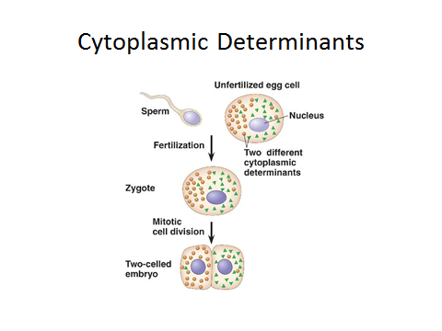
B. Pattern and positional genes control the pattern (shape) of an organism while it is being developed and control the position (location) of various structures.
1. HOX genes
C. Apoptosis – this is the “programmed” death of cells that is needed to create important anatomical structures.
1. Examples of apoptosis include the death of cells in-between digits such as fingers and toes.
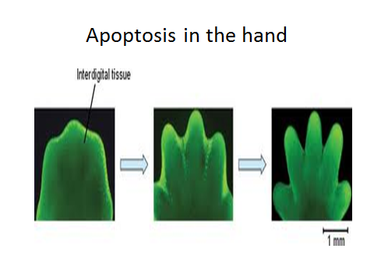

Cleavage (rapid cell division) of zygote occurs. Becomes morula (solid ball of stem cells) and finally a Blastula (hollow ball of cells) by blastulation.
1. Cells are beginning to specialize or differentiate in gene expression

Ecology

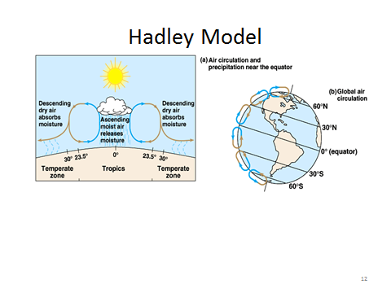
Regions to an Ocean body of water, commonly referred to as marine systems.
- Photic Zone – This is the upper region with light penetration. (photo means “having light)
1. Red light penetrates deeper than other wavelengths of white light. (Because it has the longest waves)
B. Aphotic Zone– This is the lower region without light penetration. (Aphoto means “having no light”)
C. Benthic Zone - Bottom of the ocean. (Benthos – communities of bottom dwelling, detritus feeding organisms)
1. Organisms here get no sunlight, so no photosynthesis can occur. Here producers use Chemosynthesis
to convert Hydrogen Sulfide into sugars.
D. Abyss – These are the deepest parts of the Benthic Zone. (These are deep sea trenches mostly.)
E. Pelagic Zone – Area ranging from the surface to bottom in the “mid-region” for the body of water.
F. Thermocline - These are temperature gradients, like incline or decline, that occur within a body of water as water heats or cools.

Marine Biomes
- Intertidal Zone – This is a very harsh environment due to tides crashing and receding .It is rich in biodiversity due to the presence of light for photosynthesis.
B. Neritic Zone – This runs from shore to the continental shelf drop off. It is very rich in biodiversity due to light.
C. Oceanic Pelagic – Contains the photic and aphotic and lacks biodiversity; it is mostly big fish and mammals and plankton on the surface.
D. Coral Reef – These are very rich in biodiversity.
- Called the rainforests of the oceans.
- They are endangered and therefore protected by laws.
- They are found in warm water climates.
E. Benthic – Moderate in biodiversity. (Mostly around deep sea thermal vents and mid ocean rift valleys.)

POPULATION ECOLOGY

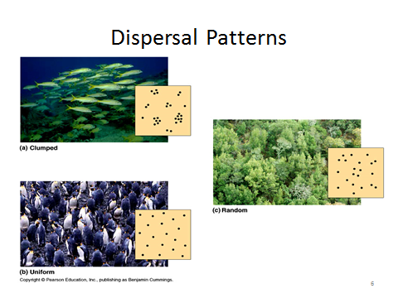
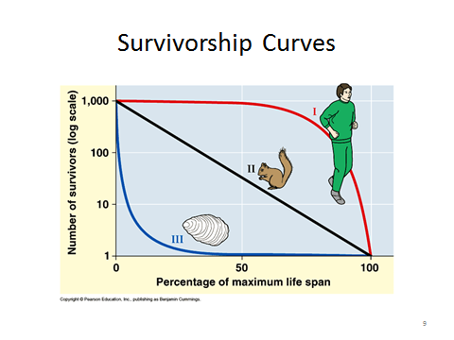
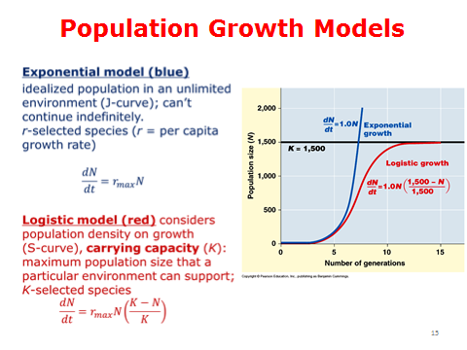
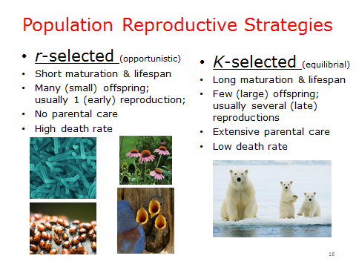
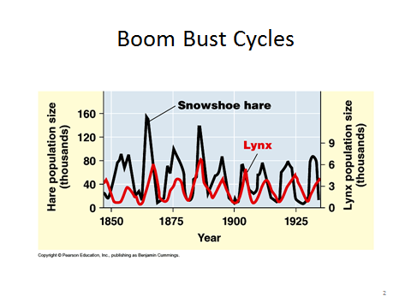
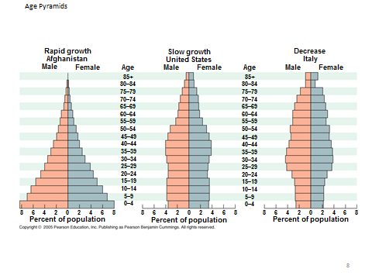
- HUMAN IMPACT ON ECOSYSTEMS
  - Acid rain
  - Greenhouse Effect
  - Reduced Biodiversity
  - cultural eutrophication
  - hole in ozone layer (caused by CFC’s)
COMMUNITY ECOLOGY
- Mutualism, Predation, Parasite, Competition
- Go over Food Webs
- 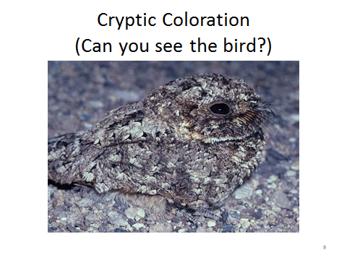
- 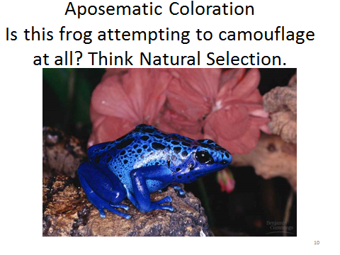
- 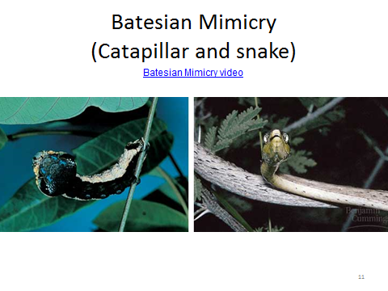
- 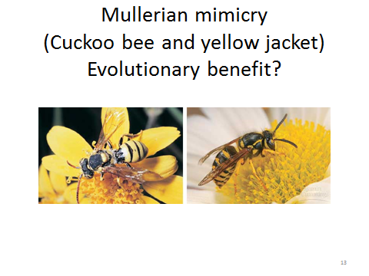
- 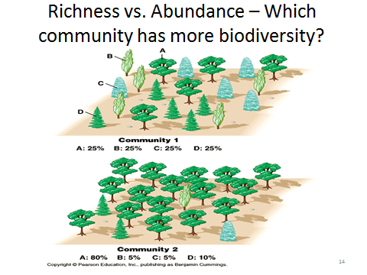
- 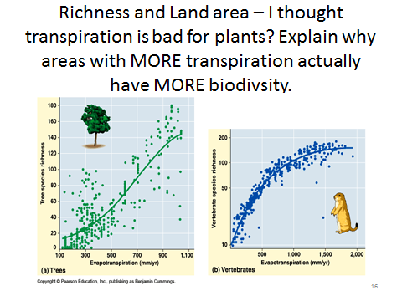

- Primary vs. secondary succession
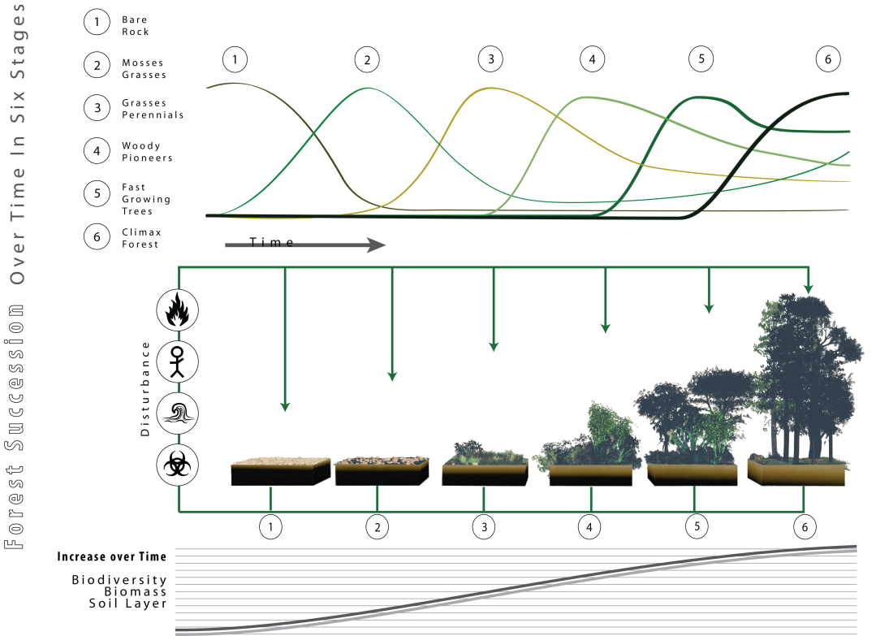
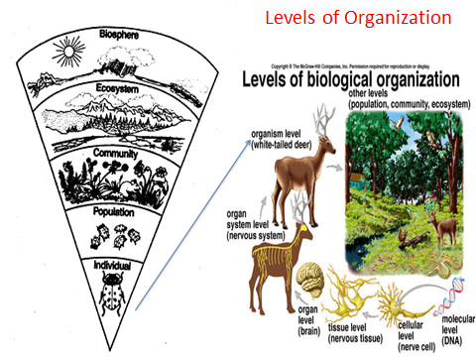
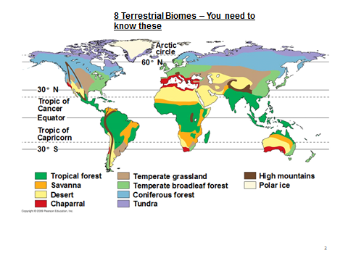
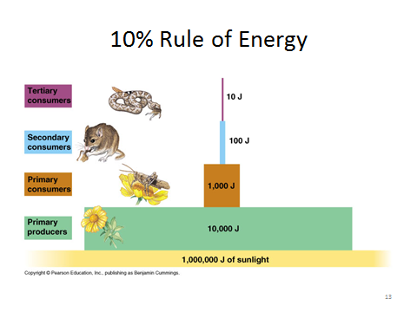
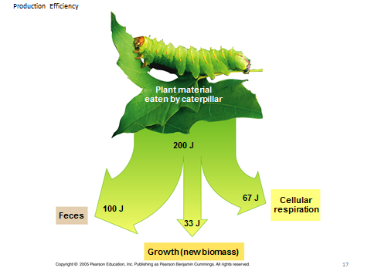

- Biogeochemical cycles
  - Water (evaporation, condensation, precipitation, transpiration/respiration)
  - Nitrogen – Key is knowing the different forms nitrogen is found in. Needed for DNA and Proteins
    - N2 (atmospheric nitrogen can’t be directly used by plants)
    - Nitrogen fixing bacteria in soil convert to Ammonium (NH4) by nitrogen fixation.
    - Some ammonium (NH4) converted to Nitrite (NO2) and then Nitrate (NO3) by nitrifying bacteria during nitrification
    - Nitrate absorbed by plants
    - Denitrifying bacteria break Nitrate (NO3) to O2 and N2 which is returned to the air through denitrification
    - Plants have taken up NO3 (nitrate) and ammonium (NH4) for DNA AND PROTEINS
    - When animals eat plants, they get nitrogen for the same purpose.
    - When we die, we decompose to make ammonia (NH3).
    - Bacteria convert NH3 back to NH4 by ammonification so plants can take it back up.
  - Phosphorous – Needed for ATP, DNA, Phopspholipids
    - Initially in rocks which break down through weathering, and it is released into the soil.
      - Can go into bodies of water
    - Producers (phytoplankton and plants) take it up to use for phospholipids, DNA, and ATP

  - Carbon
    - CO2 removed from air during photosynthesis
    - CO2 converted to sugar
    - Passed through food chains and webs
    - Exhaling puts CO2 back into the air after the glucose has been broken down for ATP during cellular respiration

- Ecosystem
  - Low transpiration = low energy (Even though excessive transpiration is bad for a plant if there is a shortage of water.)
    - This is because low transpiration indicates low sunlight OR stomata closed so no photosynthesis occurring).
  - Trophic structure
    - Energy 1 way flow (converted to unusable heat)
    - Matter cycles (biogeochemical cycles)
    - Food chain, food web, food pyramids (10% rule)
  - Primary Productivity
    - Producers are what convert sunlight to chemical energy (i.e. plants)
    - All the energy available in an ecosystem comes from them.
    - Even so, they use some of the energy they make so only some of it is passed on to the next trophic level.
    - Primary Productivity equation
      - Net Primary Productivity = Gross Primary Productivity – Respiration

- Cycles: Why do we need each?
  - Water
  - Carbon
  - Nitrogen
  - Phosphorous – REMEMBER AS WEATHERING FROM ROCKS
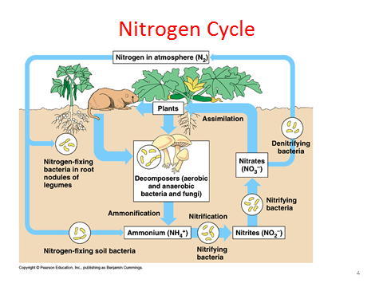

PLANTS- Go Over:

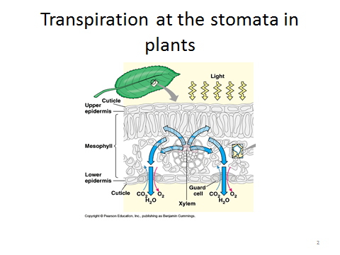

Plant Hormones and Tropisms
Example:
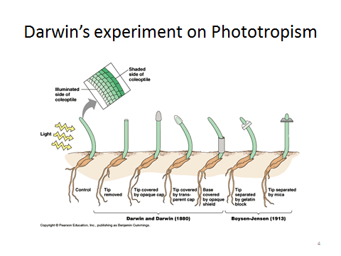

Behaviors

