Asexual vs Sexual Reproduction Name ____________________ # _____
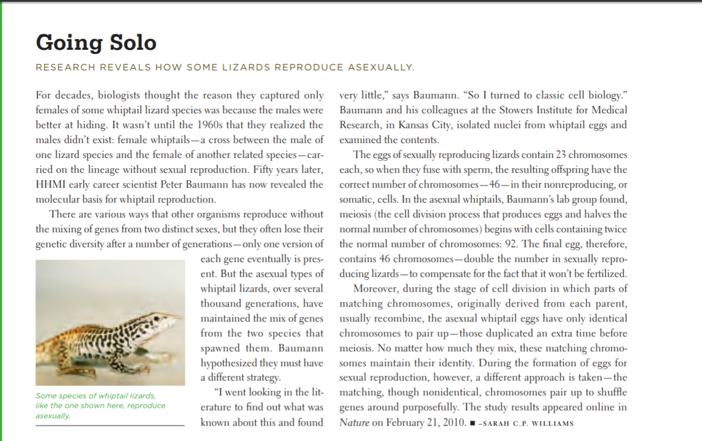
In class, we looked at different strategies from several different organisms use to reproduce. Our goal now is to decide which strategy, asexual or sexual, we believe to be most advantageous. To do this, we will be focusing on a species of lizard that lives here in North America called the whiptail lizard. As a group, you will read the short article below and answer some questions to find the most important details your group will focus on.
- Why have scientists not found any male whiptail lizards?

- How many chromosomes does an adult lizard have?

- Do you think asexual reproduction allows for genetic diversity?

- What advantage do whiptails lizards have over other species? Be specific.

- What advantage might other species have over the whiptails? Be specific.
Now, read some more background information about asexual and sexual reproduction. Your group will use this information and what you have learned about whiptail lizards to make a claim.
Asexual Reproducers:
For most living things, sexual reproduction has proven the best overall strategy to perpetuate a species in the rough-and-tumble, unpredictable fray of natural selection. With two partners combining varied genes, a species has more flexibility to adapt to changing environments.
There are, however, rare examples of asexual species that reproduce by cloning. Each offspring is genetically identical to the parent, with little variation generation after generation. (Mutations do create a minor amount of change.)
If asexual reproduction survives at all, conditions must sometimes favor it, even in competition for a niche with sexually reproducing species. Some insects, like aphids, are both asexual and sexual reproducers. Though rare, those species that reproduce asexually tend to persist.
Efficiency, for one thing, is on the side of asexual organisms: Without the need for males, every clonal individual passes a full set of identical genes onto the next generation. In addition, a single female can establish a new population. This gives asexual creatures on the fringes of a habitat an edge in colonizing a new one.
Clonal organisms with tolerance for a broad range of conditions also exist. Even if they do not vary much genetically, they possess what scientists have dubbed "general-purpose genotypes." One example is a type of minnow found in Minnesota that tolerates both highly oxygenated and poorly oxygenated waters. Able to survive in an unpredictable environment, this minnow outlasts more specialized strains.
Asexual animals arose from diversified sexually reproducing ancestors. Often they are hybrids between two different species, and may possess two complete sets of chromosomes.
One such asexual organism is the whiptail lizard in the U.S. Southwest, Mexico, and South America, which consists only of females who reproduce by parthenogenesis. They appear to be the only known unisexual reptile.
Clones generally hit a dead end, going extinct when their limited variation collides with changing environmental conditions or with better-surviving sexual reproducers. With their unusual way of reproducing, they continue to fascinate scientists because they are natural experiments in interactions between fixed genotypes and varying environment.

Claim: ________________ reproduction is the most advantageous.
Evidence: Direct quotes from both articles. | Why the information in the quote shows why that type of reproduction is the most advantageous.
Your task now is to, as a group, decide whether sexual or asexual reproduction is the most advantageous. To do this, you will create a Claim-Evidence-Reasoning chart like the one shown below on your piece of butcher paper. Your claim should use the sentence frame below. All of your evidence should be direct quotes from both the whiptail article and background information above. The reasoning should be why the quotes show that your form of reproduction is the best.

