Name ___________________________ # ______ Biology Exploration Guide: Cell Metabolism #1
Introduction to Metabolism
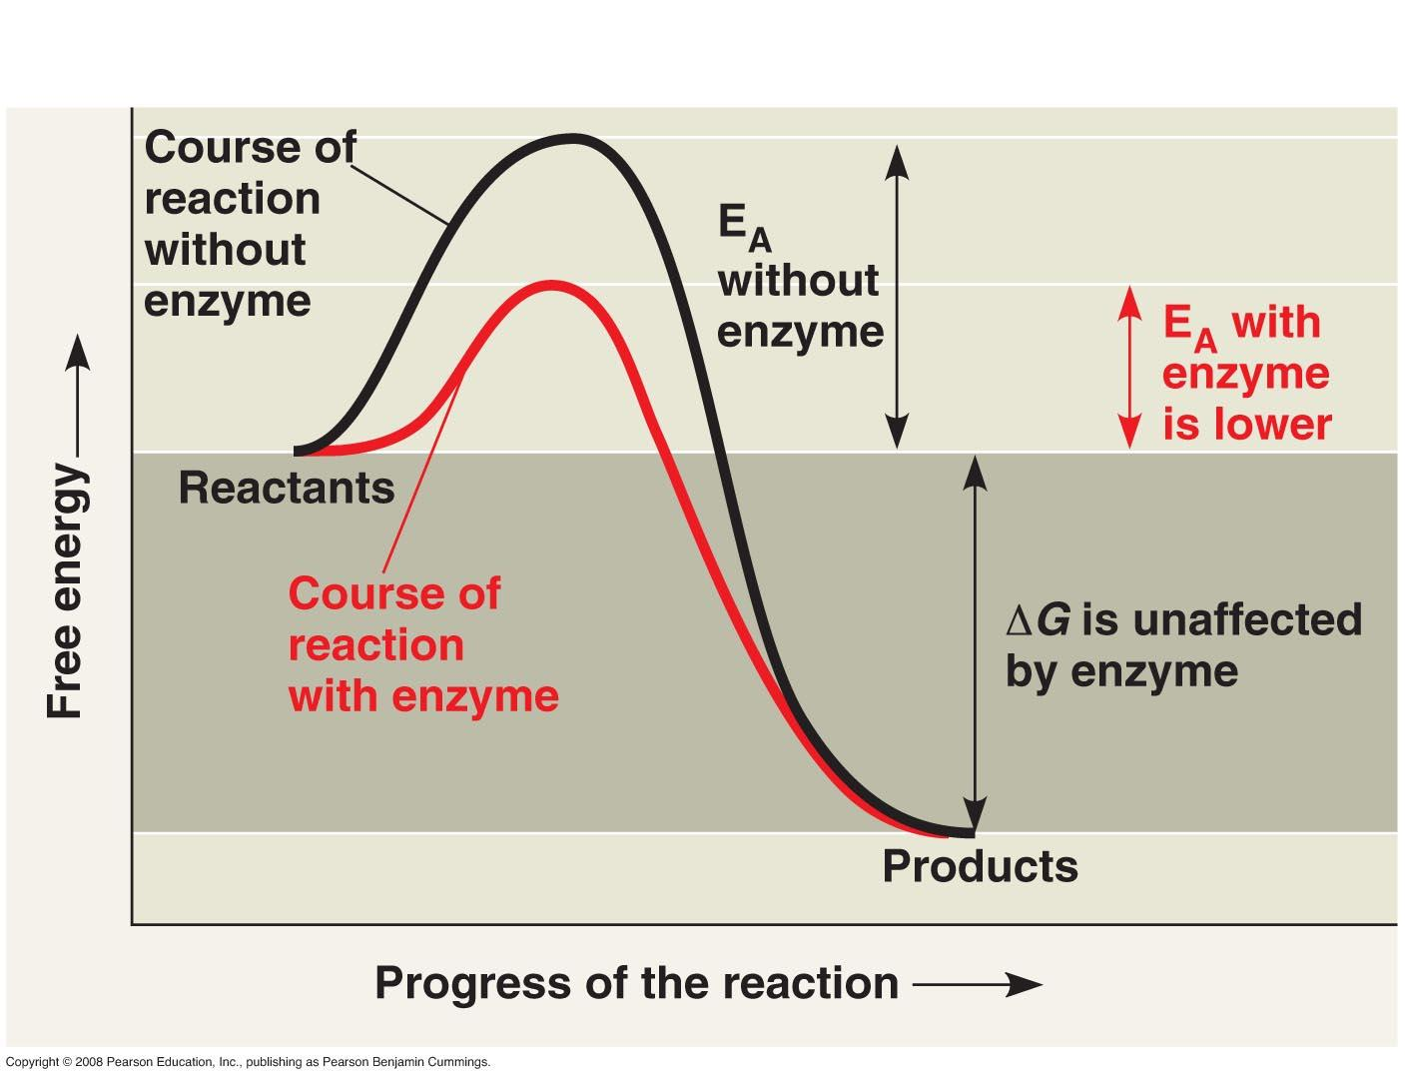
Key Concepts:
- An organism’s metabolism transforms matter and energy
- The free-energy change of a reaction tells us whether or not the reaction occurs spontaneously
- ATP powers cellular work by coupling exergonic reactions to endergonic reactions

Read:
- Chapter 8.1-8.3

Key Terms: Here is a list of key terms and concepts you will hear about and see during the chapter readings. Get to know them!

Catabolic pathways | Entropy
Anabolic pathways | Free energy
Kinetic energy | Endergonic reaction
Potential energy | Exergonic reaction
Thermodynamics | Energy coupling
1st law of thermodynamics | ATP – adenosine triphosphate
2nd law of thermodynamics | Phosphorylation

Exploration Questions

- Explain the role of catabolic and anabolic pathways in cellular metabolism.
- State the first law of thermodynamics in your own words and explain how living systems comply with this law. Provide one real-life example to support your explanation.
- State the second law of thermodynamics in your own words and explain how living systems comply with this law. Provide one real-life example to support your explanation.
- Describe the forms of energy found in an apple as it grows on a tree, falls, and then is digested by someone who eats it.
- Define free energy.
- Distinguish between exergonic and endergonic reactions in terms of free energy change.
- Is a living system ever in equilibrium with its surroundings? Explain why or why not, and when equilibrium occurs (if ever).
- Explain the energetic advantage of coupling exergonic reactions to endergonic reactions. Which reaction must be greater in terms of energetic magnitude?
- Organisms are endergonic systems. What are the exergonic reactions that provide living systems with energy (give 2 examples).
- Cellular respiration uses glucose and oxygen, which have high levels of free energy, and releases CO2 and water, which have low levels of free energy. Is cellular respiration spontaneous or not? Is it exergonic or endergonic? What happens to the energy released from glucose?
- Describe the structure of ATP and identify the major class of macromolecules to which ATP belongs.
- Draw a sketch of the ATP-ADP cycle. Explain how ATP performs cellular work using energy coupling. In other words, describe how ATP and ADP are used in both the storing (endergonic) and releasing (exergonic) of energy

