Name _____________________________ # _______ Biology Exploration Guide: Cell Metabolism #4
Thermoregulation and Energy Budgets
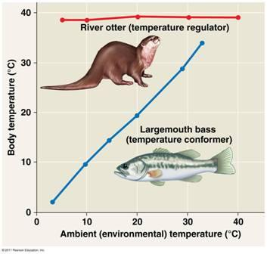
Key Concepts:
- Feedback control maintains the internal environment in many animals
- Energy requirements are related to animal size, activity, and environment
- Feedback circuits regulate digestion, energy allocation, and appetite

Read:
- Chapter 40.2- 40.4

Key Terms: Here is a list of key terms and concepts you will hear about and see during the chapter readings. Get to know them!

Thermoregulation | Countercurrent exchange | Metabolic rate | Energy budgets
Endothermic | Circadian rhythms | Basal metabolic rate (BMR) | Homeostasis
Ectothermic | Bioenergetics | Standard metabolic rate (SMR) | Feedback Control

Questions:

Feedback Control (40.2)
- Distinguish between positive and negative feedback.
- What are circadian rhythms?
- Make a claim and provide evidence using Fig 40.9 in your book

Thermoregulation (40.3)
- What is thermoregulation?
- Describe the difference between endothermy and ectothermy. Give an animal that exhibits each.
- What are the four processes by which heat is exchanged with the environment? Use Figure #1 (next page) to name and explain each process. (Cut out Figure #1, LABEL it, and place it in your notebook)
- Discuss how each of the following are involved in thermoregulation:
  - fur/feathers adipose tissue
  - goose bumps
  - vasodilation/vasoconstriction
  - panting/sweating
  - burrowing/sunning
- Heat loss in extremities is reduced by countercurrent exchange (text- p. 884). Use Figure #2 (next page) to explain how countercurrent exchange works. (Cut out Figure #2, LABEL it, and place it in your notebook)
- What is the role of the hypothalamus in temperature regulation?

Energy Requirements (CH 40.4)
- Define metabolic rate and identify what units it is measured in.
- Distinguish between basal metabolic rate (BMR) and standard metabolic rate (SMR). Identify the broad categories of animals to which each term applies.
- What is the relationship between BMR and body mass? (See Fig 40.21)
- The energy required to maintain each gram of body mass is much greater for a mouse than for an elephant. What can you conclude about the metabolic rates from the mouse and the elephant?

FIGURE #1

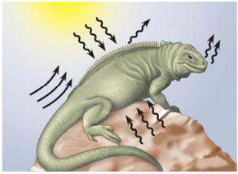

FIGURE #2

