- The base unit of the nervous system is the ________________________________________
- Neurons send messages through __________________________ _____________________
- An electrical message cannot “jump across” a synapse. To cross the synapse, _____________________________________________________ are used between neurons.
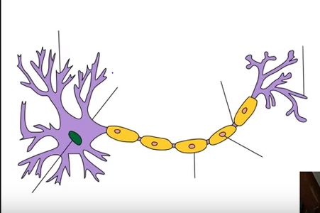
- Label and Define each of the following parts of the neuron:

  - Dendrite:_____________________________________________________________
  - Axon:________________________________________________________________
  - Cell body/soma:_______________________________________________________
  - Myelin:______________________________________________________________
  - Node of Ranvier:_______________________________________________________
  - What comes after the axon terminal?__________________________________

- How is a neuron like a salty banana?
__________________________________________________________________________________________________________________________________________________________________
- Why is the outside of a neuron relatively positive?
__________________________________________________________________________________________________________________________________________________________________
- If a neuron was a battery, what would be its voltage?________________________________

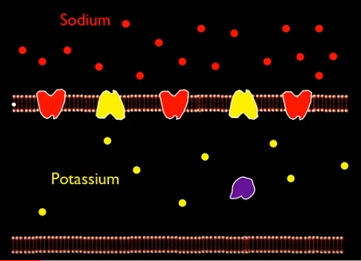
- The flow of sodium ions is like ______________________________ falling.

- After sodium flows into the neuron, the __________________________ channels open.

- How is the ion gradient re-established?
_________________________________
_________________________________
_________________________________
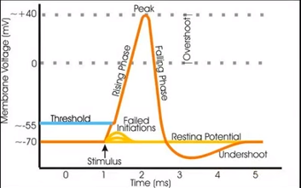
- How are action potentials different when the strength of the stimulus changes?
______________________________________
______________________________________
______________________________________

- When the action potential reaches the end of the axon, it causes an influx of
______________________________________

- The influx of ___________________________ causes the release of ____________________________________ across the synapse.

- Why does a neurotransmitter travel across the synapse?_____________________________________
_________________________________________________________________________________

- How are inhibitory messages and excitatory messages different?
__________________________________________________________________________________________________________________________________________________________________

