AP Biology Calculations and Grid-Ins Review

A Reminder Regarding the Test Format:

The AP Biology Exam is approximately 3 hours in length. There are two sections.

- Section I is 90 minutes and consists of 63 multiple-choice questions and 6 grid-in questions accounting for 50 percent of the final score.
- Section II is 90 minutes and consists of 2 long free-response questions and 6 short free-response questions accounting for 50 percent of the final score. It begins with a 10-minute reading period to read the questions and plan your answers. The remaining 1 hour and 20 minutes is for writing. The 2 long free-response questions should require about 20 minutes each to answer. Questions 3 through 8 are short free-response questions and should require about 6 minutes each to answer.

Calculation Grid-In Tips:

- If a diagram is provided, analyze the diagram before you start calculating. You have to know what you are looking for!
- They won’t ask you for units in your answers on the calculation grid-in questions, but they may on the short / long free response questions. However, looking at the units may give you a hint as to which term in the equation you are being asked to find.
- Don’t round your work until you get to the answer!
- Read the directions carefully for each question you answer. The question will indicate whether you should round to the nearest whole number, tenth, hundredth, etc. If you round to a different place, your answer will be scored as INCORRECT!
- With your four function calculator, there is no exponent function. You must use the “old school” method of multiplying a number by itself to square it.
Example: 2³ = 2 X 2 X 2 = 8
- You must be able to convert back and forth between scientific notation and whole numbers.
Examples:
- 5.1 X 10³ = 5100
- 6.2 X 10⁻⁴ = 0.00062
- 442 = 4.42 X 10²
- 0.008 = 8.0 X 10⁻³
- If you want to “get rid” of an exponent on the variable you are solving for, take each side of the equation to the power of the inverse of the exponent
Example: X^{1/3} = 5 can be adjusted to (X^{1/3})³ = (5)³ to isolate “X” and further simplified to X = 125

The “Grid-In Chart”
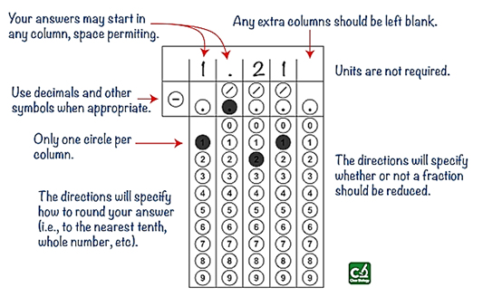

Acceptable Grid-In Responses:
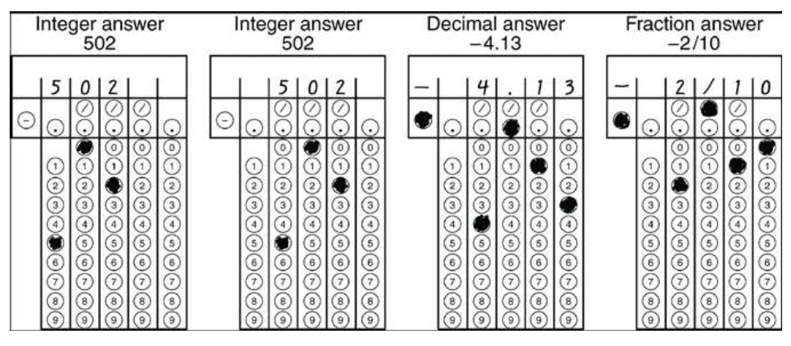

*One other piece of advice: The grid-in questions will be the last 6 questions of the Multiple Choice section (69 total questions in 90 minutes) of the AP Exam. Might want to consider doing those questions first. If you run out of time, you can’t ‘guess’ the grid-ins, but you could quickly bubble something in for true multiple choice questions.

**Be sure to go over the AP Bio Formulas Sheet thoroughly. Be very familiar with where the equations are located on the sheet. Although they will provide you the sheet, don’t waste any time trying to find the correct formula. There is a link (right column) on my blog for the sheet.

