Cats Falling Out of Windows- CER: Pt. 1 Name ______________________ Blk ____ # ____
Feline High-Rise Syndrome (FHRS) is the term used in medical cases of cats falling from balconies or windows of high-rise buildings in urban areas. The cause of the fall in most cases happens when play, when the animal jumps from the window or over the balcony, when chasing a bird or insect, or it slips while walking on the edge of the balcony, railing or window.
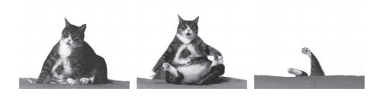
This begs the essential question: How do the number of injuries per cat relate to the number of stories a cat falls?

Good news, we have data…

Number of Stories Fallen | Number of Total Injuries Per Cat | Number of Cats  Per Stories Fallen
1 | 0.00 | 0
2 | 0.75 | 8
3 | 1.00 | 14
4 | 1.60 | 27
5 | 2.00 | 34
6 | 2.30 | 21
7-8 | 2.40 | 9
9-32 | 1.10 | 13

- Examine the data and look for trends. Graph the data if you feel it is important to do so. Pay attention to your graph type.
- Write a claim that answers the essential question on your explanation tool.
- Collect the evidence you need to make a claim and write it into your explanation tool.
- For each piece of evidence you collect, give your reasoning to why it supports your claim. Write this in your explanation tool.
- Write the argument for your claim, combining your claim, evidence and reasoning statements into a paragraph.
Further Analysis- Pt. 2
- Please click on the link and read the article Why Cats Have Nine Lives by Jared Diamond. Our analysis did not attempt to answer the question of “Why” cats survive the way they do from different heights. What are some of the assumptions the author makes in an attempt to answer this new question?

- If you examine the number of total injuries per cat from 2-5 stories fallen, what trend do you spot?

- Does it make sense that the number of cats falling from the 5th floor would be greater than those of the 4th? Why or why not?

- How things like sample size vs population size or reporting bias alter our way of thinking about the data?

- What additional information might you want if you were going to alter your CER to make it more accurate?

- The figure below (or next page) shows the number of cats falling per month of the year (month 1 = January).
  - What claim can you make about the relationship between number of cats falling and months of the year?

  - What is your evidence for your claim and your reasoning for each piece of evidence?

  - Can you justify a correlation between number of cats falling and months of the year? Either justify the correlation or explain your reasoning if there is none.

  - Can you pose any simple solutions to cats falling out of windows?

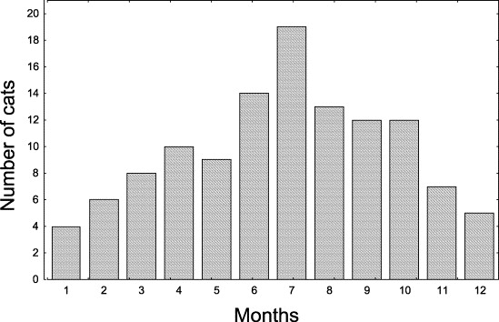

Vnuk et al. 2004. Feline high-rise syndrome: 119 cases (1998-2001 ). J. Fel. Med. Surg. 6:305-312.
Whitlock, M. and Schluter, D 2009. The analysis of biological data. Roberts and Company, Colorado. p.3
W.O. Whitney, C.J. Mehlhaff. High-rise syndrome in cats. Journal of the American Veterinary Medical Association, 191 (1987), pp. 1399–1403
Vnuk et al. 2004. Feline high-rise syndrome: 119 cases (1998-2001 ). J. Fel. Med. Surg. 6:305-312.

