Cell Structure & Function Quiz Study Guide Name__________________________ # _____
Part 1: Label the 3 Cells below, including the type of cell and the organelles. Know the function of the organelles.
Cell A:
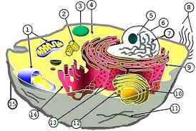
- This is a ________________ cell.
- Prokaryotic or eukaryotic?
- Identify these structures and give their function: (omit #11)
  - Mitochondria

  - Smooth ER

  - Rough ER

  - Lysosome

  - Centriole

  - Golgi apparatus

  - Cytosol

  - Ribosome

  - Cell (plasma) membrane

  - Nucleus

  - Chromosomes/Chromatin (DNA)

  - Nucleolus

  - Cilia (*not all cells have these)

Cell 2:
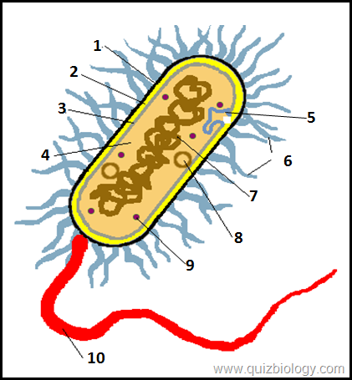

- This is a ________________ cell.
- Prokaryotic or eukaryotic?
- Identify these structures and give their function:
*Structure #1 is a capsule. It is OUTSIDE of the wall.
Structures:
2-

3-

7-

9-

10-

Cell 3:
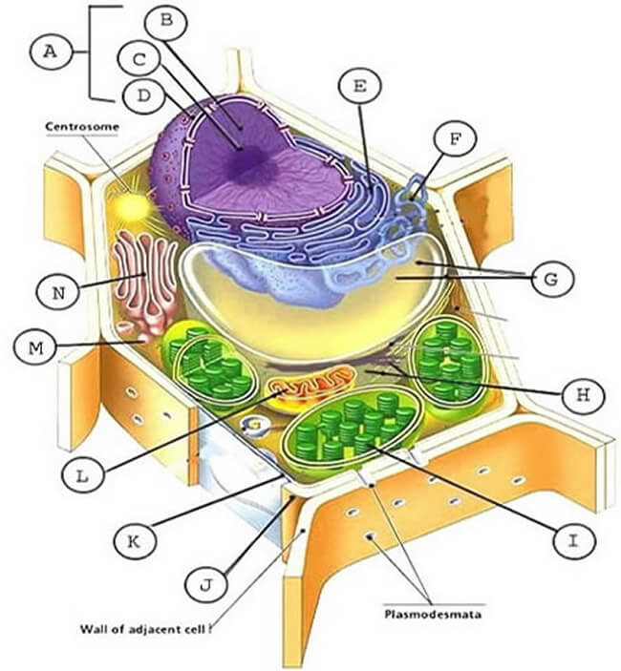

1.This is a ________________ cell.
2.Prokaryotic or eukaryotic?
3.Identify these structures and give their functions:
*Although ribosomes are not clearly shown, they are there! Also, note the labeled Plasmodesmata. What does it do?

A (B, C, D)-

E-

G-

I-

L-

N-

K-

J-

Part II- Cell/Plasma Membrane

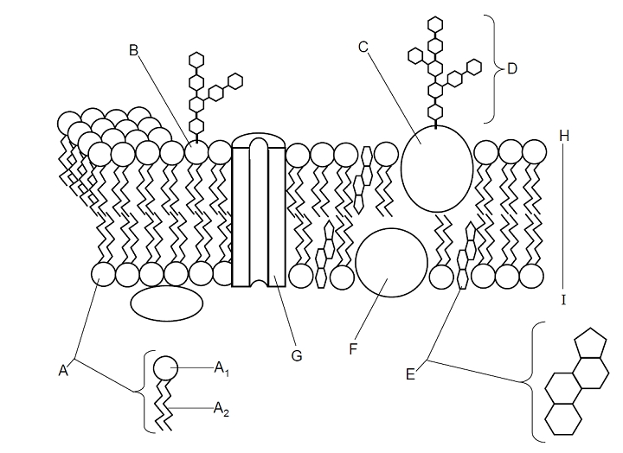

Label and know function of:
A (A1 & A2)-

C & F-

D-

E-

G-

Make sure you also go over the Power Point. This review sheet is not all inclusive.

