Name _________________________________________________Block______ # ________

**CELL TRANSPORT**

**Match the definition on the left with the term on the right.**

1. _____ release of wastes or cell products from inside to outside a cell
2. diffusion
3. dynamic equilibrium
4. exocytosis
5. osmosis
6. _____ diffusion of water molecules through a selectively permeable

membrane

1. _____ continuous movement of particles but no overall change in

concentration

1. _____ movement of particles from an area of higher concentration to one

of lower concentration

**In the space at the left, write true if the statement is true. If the statement is false, change the italicized term to make the statement true. Write this answer in the blank provided.**

_______________ 5. In *passive transport*, the movement of particles across a membrane requires energy.

_______________ 6. *Endocytosis* is a process by which a cell membrane surrounds and takes in material from

the environment.

_______________ 7. A membrane that allows only some materials to pass through shows *selective permeability.*

**Circle the word(s) or phrase(s) that best completes the statement or answers the question (some may require more than one answer)**

8. The structure most responsible for maintaining cell ***homeostasis*** is the

**cytoplasm cell wall mitochondria cell membrane**

9. A cell membrane is composed of

**cholesterol enzymes lipid tails protein heads**

10. Which of the following requires ATP energy by the cell?

**diffusion facilitated diffusion phagocytosis osmosis**

11. Osmosis occurs until

**equilibrium is obtained turgor pressure is obtained dynamic equilibrium is obtained**

12. If a cell is placed in salt water, water leaves the cell by

**osmosis diffusion active transport phagocytosis**

13. A cell moves particles from a region of lesser concentration to a region of higher concentration by

**diffusion osmosis passive transport active transport**

**Use the pictures on the left to answer the questions on the right.**

**14. After digestion:**

 = glucose molecule

a. Which side has the higher concentration of glucose? ________

b. Which way will the glucose move? _____________________

**blood**

**cell**

c. Does this require ATP energy? ___________

d. Is this active or passive transport? _______________________

**15. Easter egg coloring**:

A blue food coloring tablet is placed in a cup of vinegar and water. The blue tablet will

dissolve and spread evenly throughout the liquid.

beaker

a. Is this diffusion or osmosis? _______________________

b. Does this require energy? _________________________

c. Is the blue dye going from a lower to a higher concentration,

Water and vinegar

or from a higher to a lower concentration? ______________

Blue food color tablet

**16. Plant cells after the plant takes up water from its roots.**

1. 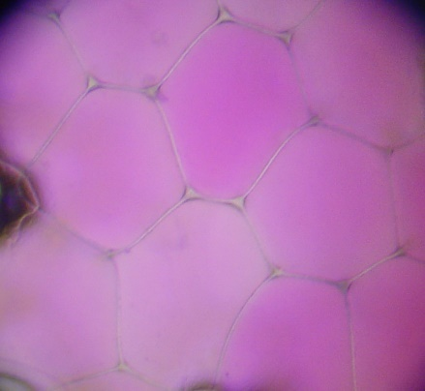Water rushes into the plant cell’s vacuole. Is this diffusion

or osmosis? _________________________

b. Are the plant cells turgid or flaccid? ________________

**17. Plant cells after a plant has not obtained water for several days**

[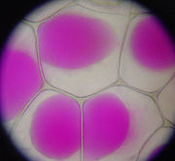](http://en.wikipedia.org/wiki/Image:Rhoeo_Discolor_-_Plasmolysis.jp)

1. Which way will the water go? Into the vacuole, or out of the

vacuole? ______________________

1. By what process will the water move? _________________

c. In terms of tonicity, does water move from hypertonic to hypotonic, OR hypotonic to hypertonic? _________________________________

d. Is this plasmolysis or crenation? _____________________________

e. Water moves from an area of _____________ water potential to an area of ______________ water potential.

**18. An amoeba engulfs a particle of food.**

[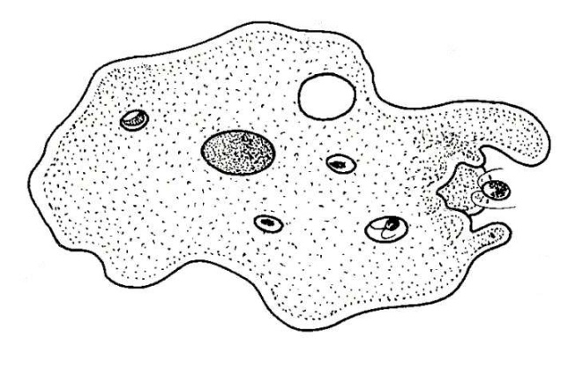](http://www.biology-resources.com/drawing-amoeba-breathing.htm)

1. Does this require ATP?_______________________
2. Is this active or passive transport? _________________
3. Is this phagocytosis or pinocytosis? _______________

**19. An amoeba expels waste.**

1. [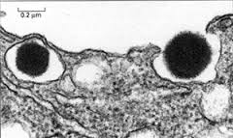](http://www.pitt.edu/~biohome/Dept/Img/graphics/diabetes2.jp)What is this process called? ___________________
2. Is this active or passive transport? ______________

**20. Red bloods cells placed in deionized water**

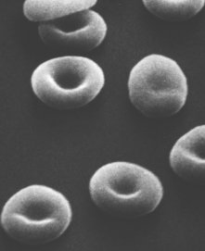

a. Will water move from the red blood cells to the beaker of water,

or from the beaker of water to the red blood cells?

______________________________________________

b. Which has the higher concentration of water, the beaker of water

or the red blood cells?_______________

c. Explain the fate of the cells. ___________________________________________________________

___________________________________________________________

Identify each image as: **diffusion**, **osmosis**, **passive transport, active transport**,

**exocytosis** or **endocytosis**.

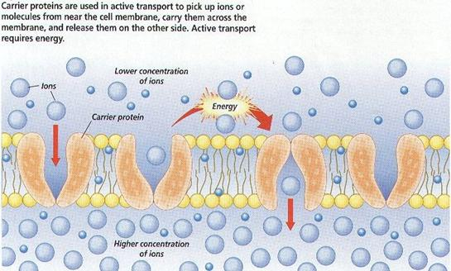

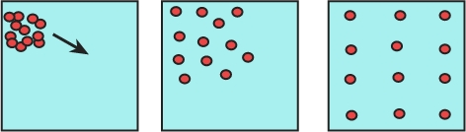

21. ________________________ 22. ________________________

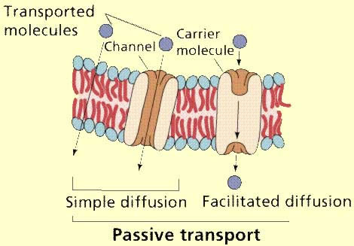

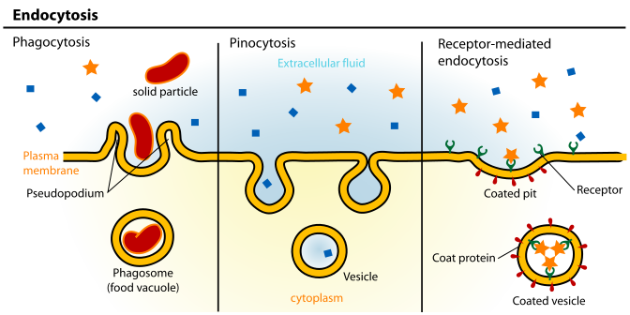

23. _________________________ 24. _____________________

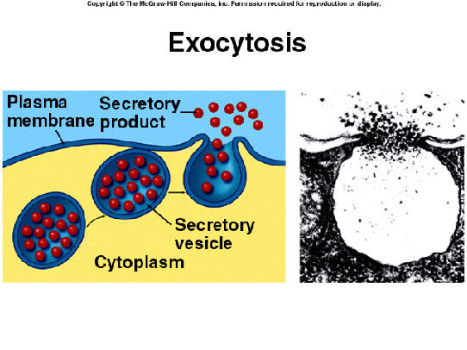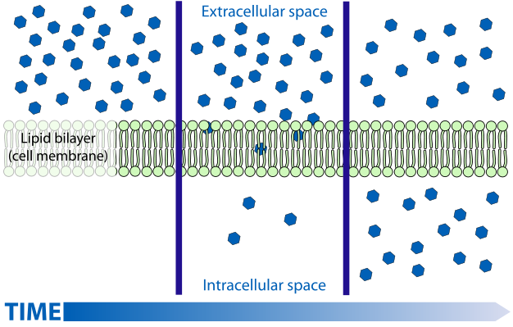

25. ______________________ 26. ____________________