**AP Biology - Fall 2020** Name _________________________ Block ______ # ______

**CHAPTERS 1-4 (Campbell Text) QUESTIONS** *These questions are a review of content from Magnet or Honors Bio, as well as Magnet or Honors Chem. You will be responsible for knowing this info for the 1st test. The content and understanding are required for ALL of the AP Bio units. I created these questions several years ago using our former Campbell Biology AP 8th edition text, but the questions also apply to last year’s newly adopted 11th edition (the page #s may be “off” by a page or 2, but it’s the same content). Since you only have 2-3 days to complete these questions after school starts (while we are also learning other content), some kids like to get an early start. If that’s the case and you cannot yet access the Campbell Biology (Pearson publisher) digital text, there’s a great free online book (from Rice University) that should help you answer most of these questions. Go to* [*www.openstax.org*](http://www.openstax.org)*. Go to science textbooks and find the book titled Biology (****AP****). You can even download it for free, if you’d like. When we get the Pearson codes for our textbook, you should be able to answer any remaining questions. *Also, please refer to my blog (AP Biology Unit 1) for highly recommended videos, etc. that will be helpful for reviewing these chapters and any content you may have “forgotten” (or if you just need a good refresher!). Answer the below questions thoroughly…this is your study guide for Ch 1-4!*

1. Review the properties of life and levels of biological organization.
2. What is an emergent property? Give an example.
3. Compare and contrast a prokaryotic and eukaryotic cell.
4. Explain what is meant by the term “gene expression”?
5. Define the term ‘genome’.
6. Differentiate: genomics vs. proteomics.
7. Explain why is energy flow and chemical recycling vital for life on earth? *Note- only matter can be recycled…not energy
8. Distinguish between positive and negative feedback, including an example of each. \**Relate these concepts to homeostasis.*
9. Identify the core theme of biology that accounts for the unity and diversity of life.
10. Compare/Contrast the 3 Domains of life.
11. Explain the process of natural selection, including the term adaptation in the response.
12. State what Darwin meant by “descent with modification”?
13. Why is data so important in biology?
14. Is an “if…then” statement inductive or deductive reasoning?
15. **Go over the steps of the scientific method** (you’ll be applying this often in this course). Is an invalid hypothesis the same as a falsified hypothesis? Explain.
16. See Fig 1.27 “Inquiry” p. 22. Answer the ‘what-if’ question.
17. The CB Exam will likely ask you to design a model. See Fig 1.25 of the text (Inquiry). Go over the experiment and “INTERPRET THE DATA”.
18. Distinguish between the types of data in a controlled experiment.
19. Do the SCIENTIFIC SKILLS EXERCISE on Interpreting a Pair of Bar Graphs.
20. List the 4 elements make up > 95% of living organism.
21. Go over Concept Check 2.1. Explain how table salt has emergent properties.
22. Recall atomic structure, including proton, neutron, electron, mass number and orbital. Describe what is meant by electrons in an "excited state" vs those in a "ground state", in terms of energy.
23. Define: isotope. Explain two important physical properties of radioactive isotopes that make them useful in biological research.
24. Compare/contrast: C-12 and C-14. What is radiometric dating?
25. Recall- ionic bond. **Given**: CaSO4.

A- State which is the cation and which is the anion.

B- Describe why this bond is ionic, rather than covalent, in terms of electronegativity.

C- Would this substance disassociate in water? _____ If so, explain WHY and indicate how many ‘particles’ it would disassociate into.

D- If glucose (C6H12O6) was the solute, would it disassociate in water? Explain (and include if disassociation means the same as solubility).

1. Does a valence e- in Carbon have higher or lower chemical (potential) bond energy than a val e- of Sulfur?
2. Distinguish between a polar and nonpolar covalent bond. BE SPECIFIC! Give an example of each.
3. Diagram 2 water molecules and indicate the Hydrogen bond(s) with labeled dashed lines.
4. Give an example of any BIOLOGICAL (organic) molecule that forms H bonds with water. Diagram your example, showing the positive and negative attractions, as were done above. Predict at least one ‘consequence’ if the bond was either covalent or ionic.
5. Does a chemical reaction in dynamic equilibrium mean that the concentration of reactants and products are equal? Explain.
6. Water is essential for life on earth.
7. List at least 5 properties of water.
8. Explain why water is a good solvent (include the terms polar and hydrophilic)

C- Explain how the high surface tension of water affects evaporation.

D- Compare & contrast cohesion and adhesion. Give an example of each as it relates to a living organism (ex- root uptake of a tree)

E- Explain water in terms of specific heat. Compare with a substance that has a ‘contrasting’ specific heat, such as a metal.

1. A- Define what is meant by pH.

B-Describe how the pH scale works (in terms of H+ and OH-)

C- Explain how buffers resist changes in pH (refer to carbonic acid/bicarbonate for an example)

1. A- Describe an example of how acid precipitation affects life on earth.

B- CO2 is the main product of fossil fuel combustion. Although the majority stays in the atmosphere, contributing to the greenhouse effect, about 30% is absorbed in the oceans. Explain what happens when CO2 dissolves in seawater.

1. *Review: Molarity/Concentration from chemistry. You must apply the formula C1V1 = C2V2 (or M1V1 = M2V2). *\*Refer to AP Bio Formula Sheet…it’s required*! (see link under Resources on my blog). Given: Your teacher tells you to prepare 0.5L of 1X TAE solution for an electrophoresis experiment, but s/he gives you a bottle of 50X TAE. Describe the procedure for doing this (*include showing your work, using the equation).
2. Why is organic chemistry so important in the study of biology?
3. Does Carbon primarily form ionic bonds, covalent bonds, or H bonds?
4. Why was the Urey-Miller experiment significant?

38. What is unique about carbon that makes it the central atom in the chemistry of life?

39. Use the diagram below and label the three types of isomers (\**both exp from ‘c’ are same type*)

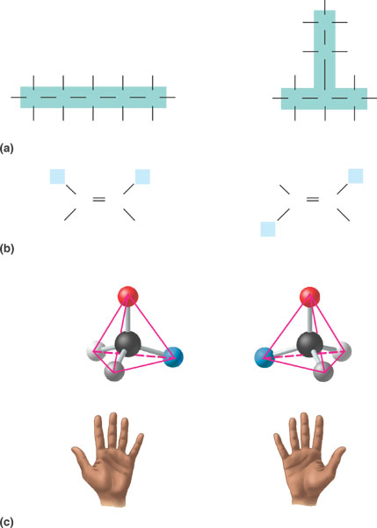

40. Be very familiar with the following functional groups, as their properties are most important in the processes of life. Create a table (*below or on a separate sheet*): after each functional group, draw the structure, name the compound, state an example & note the functional properties of each

* 1. Hydroxyl
  2. Carbonyl- aldehyde

c. Carbonyl- ketone

d. Carboxyl

e. Amino

f. Sulfhydryl

g- Methyl   
  
h. Phosphate

***Take a deep breath…you’re done!***

*While I won’t review this material (Ch 1-4), since it’s content from previous courses that CB expects you to already know, I will spend (only) 1 day reviewing content from Ch 5. While I do have a PPt you can study, you each need to READ THE BOOK AND TAKE GOOD NOTES (just as will be the case in college!).