**AP Bio UNIT 1: Independent Student Work**

* Campbell “Biology” AP Edition Text (11thed): Chapters 1-4. You are responsible for studying the info from these chapters for the Unit 1 quiz (as well as the Unit 1 test).
* These questions are due the 3rd day of class. Answers for Pt. 1 must be hand-written. You may answer the questions either directly on this document or on a separate sheet of paper (staple to the back of this handout). Pay attention to what the prompt asks you to do (ex- ‘describe’ is not the same as ‘explain’ or ‘predict’). *It’s never too early to start preparing for the College Board FRQs (50% of your score!).* Prompts have been underlined for some of the questions.
* **There will also be a QUIZ over the Summer Assignment (Intro to Statistics) AND Chap 1-4, likely on the 3rd day of class. Read & study the chapters from the etext (taking notes is HIGHLY recommended) and answer the below questions thoroughly. You are responsible for not only knowing the information from these chapters, but also applying it.** *\*Most of the info is a review of Magnet/Honors Biology & Chemistry.*
* FYI: The Unit 1 **Test** also includes Chapter 5. The **TEST** is typically the 8th day of class
* Please refer to my blog (Unit 1) for other recommended assignments/videos/’lectures’ for these chapters.
* For those wanting to start working on these questions during the summer:

I will send info (via Remind) as soon as I have the Pearson Access Codes for next semester. That will enable you to access the book’s e-text. Until then, you can go to [www.openstax.org](http://www.openstax.org) and get free access to their online AP Biology text (*use Chap 1-3).

**CH 1-4 QUESTIONS: Part 1.** *Questions are not necessarily in the exact order as the e-text. *Be sure and study/review the ‘Figures’ given throughout the chapters.*

1. Review the properties of life and identify the core theme of biology that accounts for the unity and diversity of life.
2. Why is life considered to be an emergent property of a cell?
3. Compare and contrast a prokaryotic and eukaryotic cell.
4. Briefly explain what is meant by the term ‘gene expression’.
5. What is genomics? Bioinformatics?
6. Compare and contrast: Producer (autotroph) and Consumer (heterotroph).
7. Distinguish between positive and negative feedback, including an example of each. \**Relate these concepts to homeostasis.*
8. Compare/Contrast the 3 Domains of life.
9. Explain the process of natural selection (include the term ‘adaptation’ in your response).
10. State what Darwin meant by “descent with modification”?
11. Differentiate: inductive reasoning vs deductive reasoning. Give an example of each.
12. Review the scientific method. Differentiate: invalid hypothesis vs falsified hypothesis.
13. Why is *Drosophila melanogaster* considered a model organism?
14. Make sure you can answer questions regarding the Scientific Skills Exercise on p. 23 (Interpreting a Pair of Bar Graphs). Go over the Chapter Review for this chapter (and ALL chapters we study).
15. You are expected to recall basic chemistry concepts and are expected to apply them to biology. Review those definitions & concepts, if needed
16. List the 4 elements make up ~ 96% of living organisms.
17. Recall atomic structure, including proton, neutron, electron, mass number and orbital. Describe what is meant by electrons in an "excited state" vs those in a "ground state", in terms of energy.
18. Define: isotope. Explain two important physical properties of radioactive isotopes that make them useful in biological research.
19. Compare/contrast: C-12 and C-14. *Also, review the Scientific Skills Ex (Decay Curve) p. 33
20. Recall- ionic bond. **Given**: CaSO4.

A- State which is the cation and which is the anion.

B- Describe why this bond is ionic, rather than covalent, in terms of electronegativity.

C- Would this substance disassociate in water? _____ If so, explain WHY and indicate how many ‘particles’ it would disassociate into.

D- If glucose (C6H12O6) was the solute, would it disassociate in water? Explain (and include if disassociation means the same as solubility).

1. Does a valence e- in Carbon have higher or lower chemical (potential) bond energy than a val e- of Sulfur?
2. Distinguish between a polar and nonpolar covalent bond. BE SPECIFIC! Give an example of each.
3. Diagram 2 water molecules and indicate the Hydrogen bond(s) with labeled dashed lines.
4. Give an example of any BIOLOGICAL (organic) molecule that forms H bonds with water. Diagram your example, showing the positive and negative attractions, as were done above. Predict at least one ‘consequence’ if the bond was either covalent or ionic.
5. Does a chemical reaction in dynamic equilibrium mean that the concentration of reactants and products is equal? Explain.
6. A- Define what is meant by pH.

B-Describe how the pH scale works \**in terms of [H+] and [OH-]*

C- Explain how buffers resist changes in pH (refer to carbonic acid/bicarbonate for an example). Also, refer to Fig 3.12

1. Water is essential for life on earth.
2. List at least 5 properties of water.
3. Explain why water is a good solvent (include the terms polar and hydrophilic)

C- Explain how the high surface tension of water affects evaporation.

D- Compare & contrast cohesion and adhesion. Give an example of each as it relates to a living organism (ex- root uptake of a tree)

E- Explain water in terms of specific heat. Compare with a substance that has a ‘contrasting’ specific heat, such as a metal.

1. A- Describe an example of how acid precipitation affects life on earth.

B- CO2 is the main product of fossil fuel combustion. Although the majority stays in the atmosphere, contributing to the greenhouse effect, about 30% is absorbed in the oceans. Explain what happens when CO2 dissolves in seawater.

1. *Review: Molarity/Concentration from chemistry. You must apply the formula C1V1 = C2V2 (or M1V1 = M2V2). *\*Refer to AP Bio Formula Sheet*. Given: Your teacher tells you to prepare 0.5L of [1X] TAE solution for an electrophoresis experiment, but s/he gives you a bottle of [50X] TAE. Describe the procedure for doing this (*include showing your work, using the equation).
2. Why is organic chemistry so important in the study of biology?

30. Why was the Urey-Miller experiment significant?

31. What is unique about carbon that makes it the central atom in the chemistry of life?

32. Use the diagram below and label the three types of isomers (\**both examples from ‘c’, below, are the same type*)

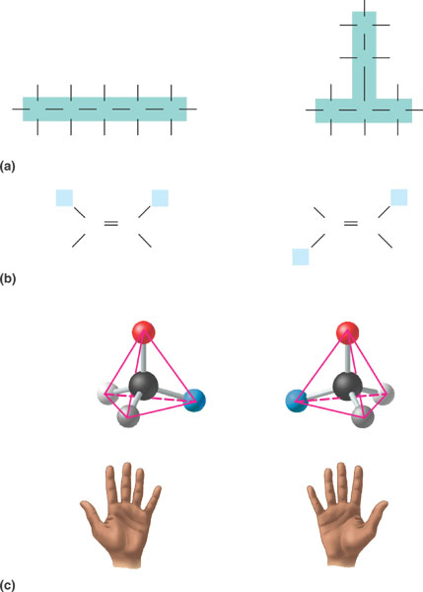

33. Be very familiar with the following functional groups, as their properties are most important in the processes of life. Create a table (*below or on a separate sheet*): after each functional group, draw the structure, name the compound, state an example & note the functional properties of each

* 1. Hydroxyl
  2. Carbonyl- aldehyde

c. Carbonyl- ketone

d. Carboxyl

e. Amino

f. Sulfhydryl

g- Methyl   
  
h. Phosphate

**CHAP 1-4 QUESTIONS: Part 2- Application of Concepts.** These questions will be assigned on the 1st day of class and will be done online at [www.masteringbiology.com](http://www.masteringbiology.com). If you did not register over the summer, you will need to do that first (*the handout will be given today in class, or you may also refer to the Remind that I sent over the summer). All students will have to join the ‘new’ course/class (different from the one given during the summer for the “Intro” book assignment) with the specific class code, which will differ for each block. Regardless of Pearson’s default settings, you will not be penalized for missing a HW question, as long as you retry each missed question and complete the assignment on time.