**CHAPTERS 1-4 (Campbell Text- 8th Edition).** *These will have to be ‘tweaked’ for*

*CHAPTERS 1-3 in the 11th edition)***:** *If you haven’t emailed me requesting the access code for the Pearson (publisher) website, please do so according to the dates listed on the ‘Summer Assignment’. THESE QUESTIONS ARE DUE THE 3RD DAY OF SCHOOL. You may answer these either directly on this document or on a separate sheet of paper and staple to the back of this handout. Answers **MUST** be handwritten, or **NO CREDIT GIVEN! Pay attention to what the prompt asks you to do (ex-describe). Prompt words have been underlined for many questions, below.** *It’s never too early to start preparing for the College Board FRQs!*

1. Compare and contrast a prokaryotic and eukaryotic cell.
2. Define the term ‘genome’.

3. Distinguish between positive and negative feedback, including an example of each. \**Relate these concepts to homeostasis.*

1. Identify the core theme of biology that accounts for the unity and diversity of life.
2. Compare/Contrast the 3 Domains of life.
3. Explain the process of natural selection, including the term adaptation in the response.
4. State what Darwin meant by “descent with modification”?
5. Differentiate: inductive reasoning vs deductive reasoning. Give an example of each.
6. Differentiate: invalid hypothesis vs falsified hypothesis.
7. See Fig 1.27 “Inquiry” p. 22 (8th edition). Answer the ‘what-if’ question.
8. The CB Exam will likely ask you to design a model. See Fig 1.28 of the text. Answer the question (?) about blood flow (shown at the top of the page in your text).
9. Do the Self Quiz at the end of Chap 1.
10. List the 4 elements make up > 95% of living organism.
11. Explain how table salt has emergent properties.
12. Recall atomic structure, including proton, neutron, electron, mass number and orbital. Describe what is meant by electrons in an "excited state" vs those in a "ground state", in terms of energy.
13. Define: isotope. Explain two important physical properties of radioactive isotopes that make them useful in biological research.
14. Compare/contrast: C-12 and C-14.
15. Recall- ionic bond. **Given**: CaSO4.

A- State which is the cation and which is the anion.

B- Describe why this bond is ionic, rather than covalent, in terms of electronegativity.

C- Would this substance disassociate in water? _____ If so, explain WHY and indicate how many ‘particles’ it would disassociate into.

D- If glucose (C6H12O6) was the solute, would it disassociate in water? Explain (and include if disassociation means the same as solubility).

1. Does a valence e- in Carbon have higher or lower chemical (potential) bond energy than a val e- of Sulfur?
2. Distinguish between a polar and nonpolar covalent bond. BE SPECIFIC! Give an example of each.
3. Diagram 2 water molecules and indicate the Hydrogen bond(s) with labeled dashed lines.
4. Give an example of any BIOLOGICAL (organic) molecule that forms H bonds with water. Diagram your example, showing the positive and negative attractions, as were done above. Predict at least one ‘consequence’ if the bond was either covalent or ionic.
5. Does a chemical reaction in dynamic equilibrium mean that the concentration of reactants and products is equal? Explain.
6. Take the self-quiz at the end of Ch 2
7. A- Define what is meant by pH.

B-Describe how the pH scale works (in terms of H+ and OH-)

C- Explain how buffers resist changes in pH (refer to carbonic acid/bicarbonate for an example)

1. Water is essential for life on earth.
2. List at least 5 properties of water.
3. Explain why water is a good solvent (include the terms polar and hydrophilic)

C- Explain how the high surface tension of water affects evaporation.

D- Compare & contrast cohesion and adhesion. Give an example of each as it relates to a living organism (ex- root uptake of a tree)

E- Explain water in terms of specific heat. Compare with a substance that has a ‘contrasting’ specific heat, such as a metal.

1. A- Describe an example of how acid precipitation affects life on earth.

B- CO2 is the main product of fossil fuel combustion. Although the majority stays in the atmosphere, contributing to the greenhouse effect, about 30% is absorbed in the oceans. Explain what happens when CO2 dissolves in seawater.

1. *Review: Molarity/Concentration from chemistry. You must apply the formula C1V1 = C2V2 (or M1V1 = M2V2). *\*Refer to AP Bio Formula Sheet*. Given: Your teacher tells you to prepare 0.5L of [1X] TAE solution for an electrophoresis experiment, but s/he gives you a bottle of [50X] TAE. Describe the procedure for doing this (*include showing your work, using the equation).
2. Do the self-quiz at the end of Ch 3.
3. Why is organic chemistry so important in the study of biology?

30. Why was the Urey-Miller experiment significant?

31. What is unique about carbon that makes it the central atom in the chemistry of life?

32. Use the diagram below and label the three types of isomers (\**both examples from ‘c’ are same type*)

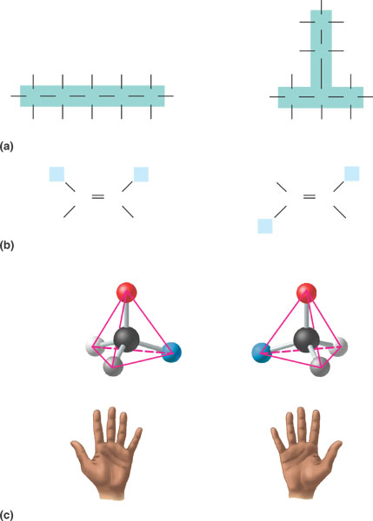

33. Be very familiar with the following functional groups, as their properties are most important in the processes of life. Create a table (*below or on a separate sheet*): after each functional group, draw the structure, name the compound, state an example & note the functional properties of each

* 1. Hydroxyl
  2. Carbonyl- aldehyde

c. Carbonyl- ketone

d. Carboxyl

e. Amino

f. Sulfhydryl

g- Methyl   
  
h. Phosphate

34. Take the self-quiz at end of Ch 4