Chromosome Mapping Name ______________________________ # _____
Introduction- Mag Bio
Chromosome Map Practice Problem
In pea plants, flower color and pollen shape are located on the same chromosome. A plant with purple flowers and long pollen (AaBb) is crossed with one that is recessive for both traits (aabb).
The F1 results are as follows:
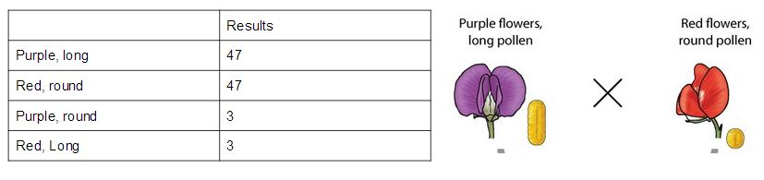
- Does this follow Mendel’s 1:1:1:1 phenotypic ratio results obtained with crossing pea plants?

- What does this imply? (Explain your answer)

- Are the majority of the offspring like the parents, or are they recombinant?

- What % of the time did they cross over?

- How far apart are the genes?

- Draw a chromosome and map the genes (scale the distance appropriately)

