Biology Name ______________________ # ____

CLADOGRAM ANALYSIS- Animals
Background Information: A cladogram is a diagram that shows evolutionary relationships among groups. It is based on phylogeny, which is the study of evolutionary relationships. In the past, biologists would group organisms based solely on their physical appearance. Today, with the advances in genetics and biochemistry, biologists can look more closely at individuals to discover their pattern of evolution, and group them accordingly - this strategy is called EVOLUTIONARY CLASSIFICATION or Phylogeny. Cladistics is a form of analysis that looks at features of organisms that are considered "innovations", or newer features that serve some kind of purpose. These characteristics appear in later organisms but not earlier ones and are called derived characters.

PART I - Analyze the Cladogram
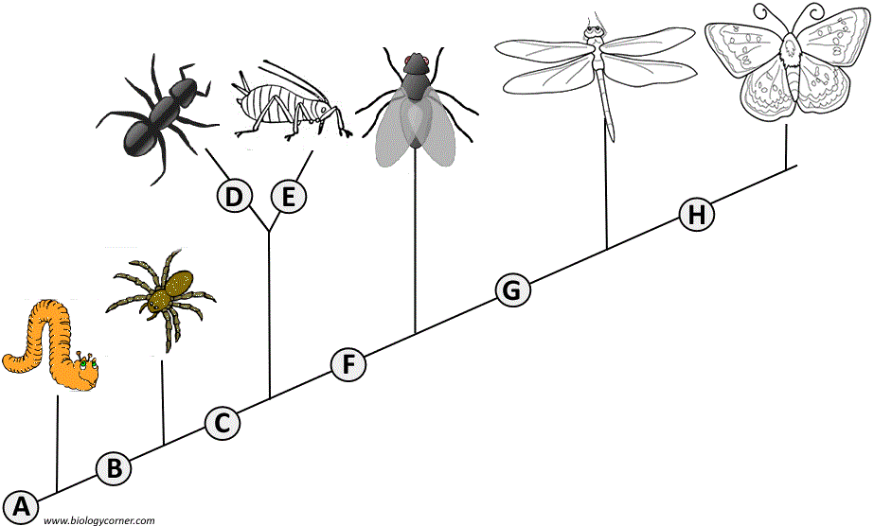
Examine the sample cladogram below. Each letter on the diagram points to a derived character, or something different (or newer) than what was seen in previous groups. Derived characters that are on the main, bottom line are found in all the organisms after that point. If a derived character is not found in all the later organisms, it is located above the main lower line, on a separate branch. For questions 1-8, match each letter on the cladogram to its character. Note: this cladogram was created for simplicity and understanding; it does not represent the established phylogeny for insects and their relatives.

1. ___ Wings
2. ___ 6 Legs
3. ___ Segmented Body
4. ___ Double set of wings
5. ___ Cerci (pair of appendages at rear end)
6. ___ Crushing/pinching mouthparts
7. ___ Legs
8. ___ Curly Antennae

9. Why aren’t letters “D” and “E” located on the bottom line where all the other letters are located?

______________________________________________________________________________

PART II - Create Your Own Cladogram
To make a cladogram, you must first look at the animals you are studying and establish characteristics that they share and ones that are unique to each group.
1. For the animals in the table below, indicate which animals have the characteristics by marking an “X” in each box if an organism has that trait.
2. Based on that chart, create a cladogram with the animals in the correct order.
3. Label the animal names at the top of the cladogram branches and label the derived characters at the bottom of the cladogram, like the samples in your notes.
 | Cells | Legs | 6 Legs | Wings
Worm
Spider
Ant
Fly

DRAWING OF YOUR CLADOGRAM:

4. According to your cladogram, which two species are more closely related (circle your answer):
worms and spiders OR worms and ants
Cite evidence to support your answer: _________________________________________________
5. According to your cladogram, what species are flies most closely related to? ___________ Cite evidence to support your answer: ___________________________________________________

PART III – Create Another Cladogram

Fill in the DATA TABLE below by placing an “X” in the box if the animal has the characteristic. You will have to do a little research on the hagfish (google is at your fingertips!):
Animal | Jaws | Lungs | Claws / Nails | Feathers | Fur and mammary glands | TOTAL Number of X’s
Lizard
Hagfish
Perch
Mouse
Chimpanzee
Pigeon
Salamander

- Using the Subset Diagram of the grouping just completed (as a guide), create a Cladogram below to illustrate the ancestry of these 7 animals in the correct order. The diagram should reflect all the derived characteristics from the data table, including feathers.

3. According to your cladogram, which two species are more closely related (circle your answer):
perch and lizard OR hagfish and lizard
Cite evidence to support your answer:

4. Look at the total number of X’s for each animal. What trend occurs with this number as you compare it to the order of animals in the cladogram?

Part IV – Construct Your Own Animal Cladogram
Using characteristics of the phyla and classes given in the PPt, make a cladogram of these animals. Indicate the derived characteristics for which the cladogram is based. *Be sure and remember that characters can be ‘gained’, as well as ‘lost’. BE NEAT!
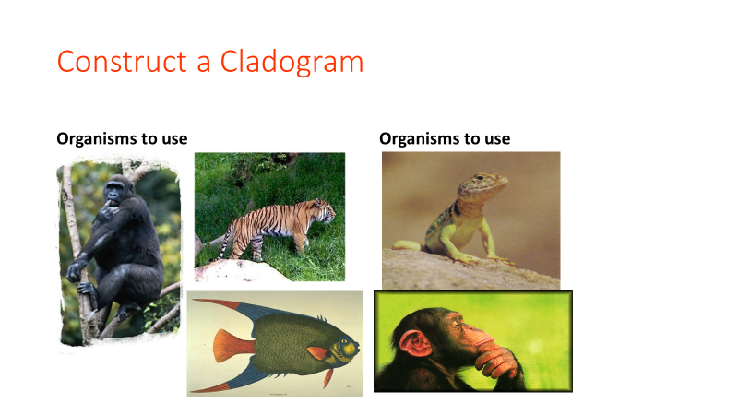
Tiger, fish, lizard, chimp, gorilla

