Name________________________________ # ____ Blk ____

How to Create a Chromosome Map from Crossover Frequencies
Recombination: During crossing-over (prophase I of Meiosis), genes on chromosomes switch places. Crossover is random, but the likelihood that 2 genes crossover will increase if those genes are farther apart. Genes closer together are more likely to "stick together" and not switch places.
Gene Linkage Maps: Using the crossover frequencies, you can construct a map to represent the distances between genes.
This map shows chromosome #2 of Drosophila melanogaster. The distance between the genes can be written as a percentage or as a MAP UNIT. The gene for body color and and wing size are 17 map units apart.
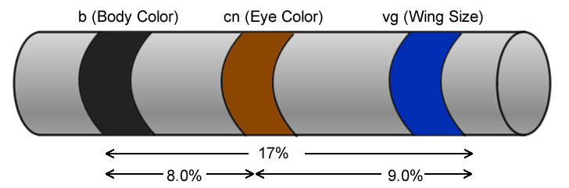Sample Problem: Given the crossover frequency of each of the genes on the chart, construct a chromosome map.
Gene | Frequency of Crossover
A-C | 30%
B-C | 45%
B-D | 40%
A-D | 25%
Step 1: Start with the genes that are the farthest apart first: B and C are 45 map units apart and would be placed far apart.
B ----------------------------------------- 45% ------------------------------------------C
Step 2: Solve it like a puzzle, using a pencil to determine the positions of the other genes.
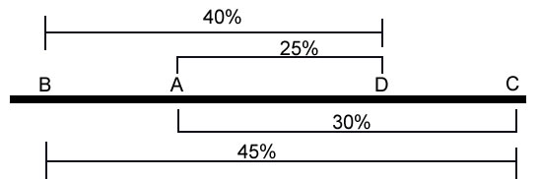
Step 3: Subtraction will be necessary to determine the final distances between each gene.
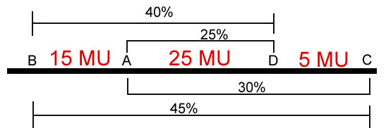

Practice Problem
1. In Drosophila, bar shaped eyes (B), scalloped wings (S), Crossveinless wings (W), and Eye Color (C) are located on the X chromosome. The recombination frequency of each gene is indicated on the table. Construct a chromosome map.
Gene | Frequency of Crossover
W-B | 2.5%
W-C | 3.0%
B-C | 5.5%
B-S | 5.5%
W-S | 8.0%
C-S | 11.0%
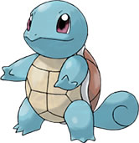

2. The following chart shows the crossover frequencies for genes on an autosome of the Armor Plated Squirtlesaur. Construct a chromosome map.
Gene | Frequency of Crossover
P-Q | 5%
P-R | 8%
P-S | 12%
Q-R | 13%
Q-S | 17%

3. Construct a map given the following data.
Gene | Frequency of Crossover
A-B | 24%
A-C | 8%
C-D | 2%
A-F | 16%
F-B | 8%
D-F | 6%

