Cystic Fibrosis & Protein Synthesis-Case Study Name_______________________ Blk _____ # _____

Introduction
Cystic fibrosis is a inherited disease that is marked by the buildup of thick, sticky mucus that can damage the lungs and many other organs. Cystic fibrosis affects the viscosity of the mucus lining of the lungs. Mucus is a collection of many substances including enzymes, proteins and mucins. In the lungs, specialized cells called Goblet cells help produce mucus. The lung tissues keep the mucus hydrated and moving. The mucus also traps bacteria and particulates and flushes them out of the lungs to avoid infection. In a person with Cystic Fibrosis, mucus becomes dehydrated and thick. Bacteria and particles get trapped and lead to infection.
These infections cause chronic coughing, wheezing, and inflammation. Over time, mucus buildup and infections result in permanent lung damage.

CFTR
CFTR gene is found on human chromosome 7 and the gene is 4400 nucleotides in length. CFTR gene produces CFTR protein. In the human body, it functions as a channel across the membrane of cells that produce mucus, sweat, saliva, tears, and digestive enzymes. In the lungs, the membrane channel transports negatively charged chloride ions into and out of cells. The transport of chloride ions helps control the movement of water in tissues, which is necessary for the production of thin, freely flowing mucus.
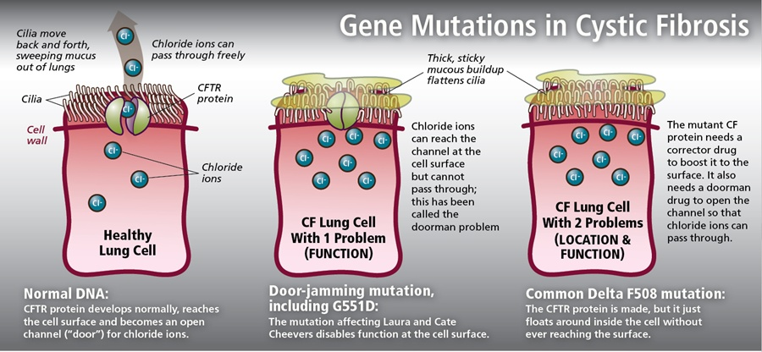

Figure 1: Normal and mutated versions of the CFTR structure and function.

In cells from non-CF (Cystic Fibrosis) individuals, the chloride channels open periodically to allow the cell to maintain a normal balance of chloride ion between the inside and outside of the cell. In CF individuals, these chloride channels do not function, and chloride ions build up inside the cell.

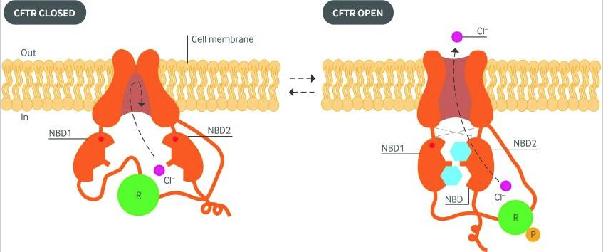
Figure 2: Image of the open and closed CFTR transmembrane protein. The NBD region binds ATP in order to transport Cl⁻.

- Why might the mucus of CF patients be thicker than that of non-CF individuals?

- Using your knowledge of osmosis and water potential, explain why a lack of transport of Cl⁻ ions might result in thicker mucus for people with CF.

- Using the model below, describe what is happening to the mucus thickness, cilia and airway surface liquid of the CF person.

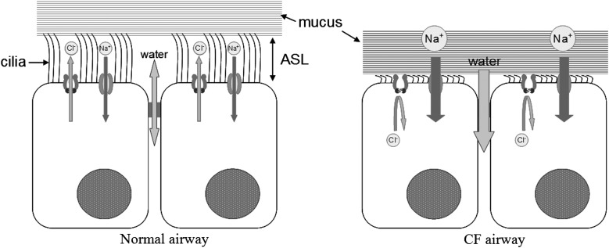
Figure 3: Model of a normal and a CF airway due to lack of Cl⁻ transport.

CFTR Mutation Phenotypes
There are over 1,800 mutations of CFTR in humans. Of those mutations, 32 of them combine for 85% of the phenotypic effects. Most mutations affect CFTR in two ways:

- Defects in the gene encoding CFTR that reduce its Cl⁻ transport capacity
- Altered level of cell surface expression of the transporter

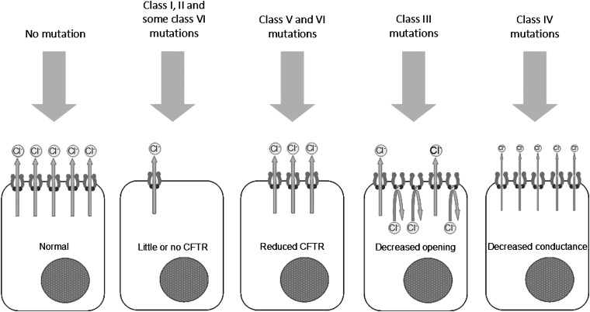

Mutation Class | Phenotype | Defect Type
Class I | The CFTR transporter is reduced in number or totally absent. | Nonsense (stop codon)
Class II | CFTR gets trapped in Golgi or rough ER. Little or none makes it to the surface of the cell. | Protein Degradation
Class III | Regulation of the CFTR is damaged and results in decreased channel opening. | Missense (substitution)
Class IV | CFTR present but conductance of Cl⁻ ions decreased. | Missense (substitution)
Class V | Reduced amounts of CFTR protein produced at cell surface. | mRNA splicing defect
Class VI | Reduced stability of CFTR at cell surface. | mRNA splicing defect

- There are other chloride channels on the epithelial cell surface of lung tissues. One of these is the calcium-activated chloride channel (CaCC). Many of these channels are shut down most of the time. Propose a treatment for CF patients by increasing CaCC activity.

- A premature stop codon results in a nonsense mutation in Class I phenotypes. The result is a shortened and basically useless CFTR. Some drugs have been proposed to ignore the premature stop signal and continue with full-length protein production. Considering a mutated mRNA being delivered to the ribosome, how might this treatment be effective?

- Most nonsense mutations of the CFTR are caused by deletions resulting in frameshift mutations.
  - Compare the phenotypic effects of Class I/II mutations to Class III/IV mutations (substitutions) using Figure 2.
  - Which mutation would you predict would yield a greater CF impact on the epithelial cells?

- “Correctors” are small molecules which assist trafficking of mutant CFTR to the cell surface membrane. As Class II mutants get “lost” in the golgi or rough ER, these molecules escort them to the surface. These mutant CFTRs are not as good as transporting as normal CFTR transporters. If these molecules are good at spotting and escorting mutated proteins, what might be one danger of using them if the specificity is not 100% for CFTR proteins?

- How might a cofactor that increases Cl⁻ conductance or increased channel activity affect the mutated Class IV CFTR proteins?

CFTR Mutations - Genetics
Up to 90% of all CFTR mutations are of the ΔF508 (Delta-F508) variety. The mutation is a deletion of three nucleotides at positions 507 and 508 of the CFTR gene on chromosome 7. This results in the loss of a single codon for the amino acid phenylalanine (Phe). A loss of Phe at this site causes the protein to be abnormally folded. The misfolded protein cannot leave the rough ER for processing or packaging by the Golgi. Because this mutation leads to reduced protein functionality, it is a recessive genetic disorder.

Below is an abbreviated DNA sequence from the CFTR gene. The F508 deletion that codes for phenylalanine is underlined.

GCCCGGCACCATCAAGGAGAACATCATCTTCGGCGTGAGCTACGACGAGTACAGGTACAGGAGCGTGATCAAGGCCTGCCAGCT

- Use the base code above and transcribe each letter into RNA to form the complete mRNA strand.

- Use the codon chart to translate the mRNA into the amino acid sequence.

- Delete the underlined code above and copy the frame shifted DNA below.

- Transcribe and translate into the mutated mRNA and amino acid sequence below.

- What percent of the amino acids changed after the frameshift? This is a small portion of the 4,440 base CFTR gene. Explain how this small mutation of 30 bases could affect the shape and function of the protein.

Delta F508 Effect on Protein Structure
The Delta F508 mutation reduces the number of functioning CFTR proteins at the surface of the epithelial cell membrane. The CFTR protein contains two transmembrane domains (MSD1 and MSD2), two nuclear binding domains (NBD1 and NBD2) and a regulatory domain (R). The NBD domains bind ATP which allows the channel to open and transmit Cl⁻ ions. The R domain is a regulatory domain that must be phosphorylated in order for the channel to open. A protein kinase phosphorylates the R domain at the end of a signal transduction pathway.

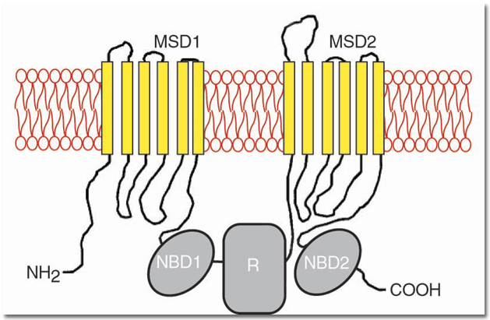

Mutation Name | Protein Region Affected | Altered Function
R117H | MSD1 | Affects ability of Cl⁻ ions to pass
Delta F508 | NBD1 | Ability for protein to leave ER; affects Cl⁻ ion transport
G551D | NBD1 | Affects activation by ATP
R553X | NBD1 | Truncates the protein; no ion channel present
Delta 708 | R Domain | ??

- The Delta 708 mutation occurs on the R domain of the CFTR protein. This mutation causes the channel to open without a kinase phosphorylation. Explain what effect this might have on the transport of Cl⁻ ions and the thickness of the mucus outside the membrane.

Evolutionary Aspects
Scientists have estimated that the original mutation occurred over 52,000 years ago in Northern Europe. Mutations that decrease reproductive fitness are kept low in the population. The CFTR F508 mutation occurs in 1 out of 30 people in western society and is the most common CF mutation. Traditionally, for a disease that kills individuals before reproductive age, that is a high frequency. Today, the CF disease is fatal even though it can be better managed for a longer lifespan. The question remains, for a fatal mutation why has it been maintained in the population?

Some theories include the following:
- People heterozygous for CF may have enough altered CFTR proteins to not cause CF but to reduce water loss through diarrhea when infected with the cholera pathogen. Skeptics of this hypothesis point out that cholera was not documented in Europe until the 17th century.
- People who are heterozygous for F508 are more resistant to the disease typhoid fever. The reasoning for this is the pathogen causing typhoid (Salmonella typhi) uses the CFTR protein as a binding site to enter intestinal epithelial cells.
- New findings point to a theory that being heterozygous for CF protects individuals against tuberculosis. Those with CF do not make a nutrient needed by the tuberculosis pathogen to survive in the body.

- All of these theories point to a phenomenon in human evolution called “heterozygous advantage”. Using the 3 theories above, explain how heterozygous people would have an advantage over homozygous dominant (normal) people and homozygous recessive (CF) people in a population.
- One question scientists asked is why the incidence of CF was highest in Europe and not tropical countries? People with CF often have saltier sweat than non-CF people. How would a person having CF in a tropical country be selected against even more so than a northern European person?

Cystic Fibrosis: Cause, Progression, and Treatment - Video & Lesson Transcript. (n.d.). Retrieved February 5, 2018, from http://study.com/academy/lesson/cystic-fibrosis-cause-progression-and-treatment.html
Akabas, M. H. (2000). Cystic Fibrosis Transmembrane Conductance Regulator STRUCTURE AND FUNCTION OF AN EPITHELIAL CHLORIDE CHANNEL. Journal of Biological Chemistry, 275(6), 3729–3732. https://doi.org/10.1074/jbc.275.6.3729
Doorway to a Cure for Cystic Fibrosis | DiscoverMagazine.com. (n.d.). Retrieved February 5, 2018, from http://discovermagazine.com/2013/september/14-doorway-to-a-cure
Quon, B. S., & Rowe, S. M. (2016). New and emerging targeted therapies for cystic fibrosis. The BMJ, 352. https://doi.org/10.1136/bmj.i859
Hull, J. (2012). Cystic fibrosis transmembrane conductance regulator dysfunction and its treatment. Journal of the Royal Society of Medicine, 105(Suppl 2), S2–S8. https://doi.org/10.1258/jrsm.2012.12s001
Hull, J. (2012). Cystic fibrosis transmembrane conductance regulator dysfunction and its treatment. Journal of the Royal Society of Medicine, 105(Suppl 2), S2–S8. https://doi.org/10.1258/jrsm.2012.12s001
ΔF508. (2018, February 2). In Wikipedia. Retrieved from https://en.wikipedia.org/w/index.php?title=%CE%94F508&oldid=823629597
CFTR - Cystic fibrosis transmembrane conductance regulator - Homo sapiens (Human) - CFTR gene & protein. (n.d.). Retrieved February 6, 2018, from http://www.uniprot.org/uniprot/P13569
Cystic Fibrosis Mutation Database: CFTR Domains. (n.d.). Retrieved February 6, 2018, from http://www.genet.sickkids.on.ca/CftrDomainPage.html
ΔF508. (2018, February 2). In Wikipedia. Retrieved from https://en.wikipedia.org/w/index.php?title=%CE%94F508&oldid=823629597

