Name: _________________________________________________ # ________
Group & Disease #: ____________________

Connect the dots…DNA to DISEASE

Introduction
We’ve learned that DNA is the genetic material that organisms inherit from their parents, but have you ever thought about what exactly this DNA encodes for? How do our cells use DNA as a set of instructions for life? How is the information in our DNA/genes used by our bodies? And what happens when the DNA is mutated or not used properly?
DNA Template Sequences:
1 TACGAGTGTAAGTACCGGAGACTGTCGCTCCTTCTTCACACACTA
2 TACCTACATAAGTACTTTCCTGAAAGTTTCCGGTTCCTCCCTCAA
3 TACGCGAAGGCGAAACCCCACCACCACGGTGGGCGGCACCGGCCG
4 TACGTAACCCCTTGGGACACGCCTAAGAACACCGAAACCGGGATA
5 TACGGATAACCTAGGTTTCTCTCCGGTTGTAAAAAACTTTAAAAA
6 TACTTTTTATAGTACCGACCTAACGTTGTTTGGTTGTCACTTTTC
7 TACTTCCAAGACACCCGACGCAACGACCAGTGTAAGGACCGTCCT

Materials (per group)
DNA sequence
Computer with an internet connection

Procedure
- Obtain your DNA sequence from your teacher.

- Convert your DNA sequence into a complementary mRNA sequence.
EXAMPLE: DNA: T A C G G C T A G
↓
mRNA: A U G C C G A U C

Your DNA sequence:

mRNA sequence:

- Determine the codons.
EXAMPLE: mRNA: A U G C C G A U C
↓
Codons: AUG CCG AUC

Codons:

______ ______ ______ ______ ______ ______ ______ ______ ______ ______ ______ ______ ______ ______ ______

- Translate the codon sequence into an amino sequence. Use the chart provided.
Codons: AUG CCG AUC
↓
Amino Acids: Methionine Proline Isoleucine

Amino Acid Sequence:

____________________ ____________________ ____________________ ____________________ ____________________

____________________ ____________________ ____________________ ____________________ ____________________

____________________ ____________________ ____________________ ____________________ ____________________

5. Write out the one-letter abbreviations for the amino acids in the sequence. Use the chart provided.

____ ____ ____ ____ ____ ____ ____ ____ ____ ____ ____ ____ ____ ____ ____

6. Go to http://www.ncbi.nlm.nih.gov/BLAST/ and choose Protein-Protein BLAST (top of the second column).

7. Enter the one-letter abbreviations for your amino acid sequence in the SEARCH box – be sure to enter them in the correct order!

8. Click on the “BLAST” button.

9. At the next page, click on the “FORMAT” button. It may take a few minutes to process your sequence.

10. At the next page, scroll down to the list of proteins that matched your sequence. Choose one that matches one on the list of possible proteins that was given to you.

11. The protein our DNA sequence encodes is (should be in the list provided): __________________________________

12. Now search www.google.com with the name of your protein to find out the disease your protein is involved in.

12. This protein is involved in the following disease: __________________________________

13. Write a paragraph explaining the disease caused by this protein or a mutation in this protein.

14. List 3 things you learned in this activity (either technical concepts, such as using the computer or scientific concepts).

(1)

(2)

(3)

AMINO ACID CHARTS AND PROTEIN NAMES

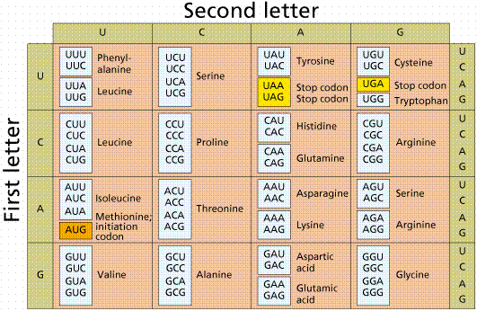
AMINO ACID | abbreviation
Alanine | A
Arginine | R
Asparagine | N
Aspartic acid | D
Cysteine | C
Glutamine | Q
Glutamic acid | E
Glycine | G
Histidine | H
Isoleucine | I
Leucine | L
Lysine | K
Methionine | M
Phenylalanine | F
Proline | P
Serine | S
Threonine | T
Tryptophan | W
Tyrosine | Y
Valine | V

Possible proteins
Presenilin 2
Synuclein
Laforin
Leptin
BRCA 2
Dystrophin
Apolipoprotein E

