Ecology Questions- KEY

**ECOLOGY**

1. List the 5 levels of ecological study and give examples of the focus of inquiry at each level:

**organism,** analyzing fertility of one individual dusky gopher frog

**population**, -monitoring the endangered dusky gopher frog population and monitoring their water source (only 100 left in the world!).

**community,** - monitoring interactions between said frogs and caddisfly prey availability.

**ecosystem,** Determining effects of abiotic factors including precipitation and temperature on frog/fly communities.

**Biosphere** A global study comparing related amphibian species of comparable ecosystems.

1. Give an example of a purposefully introduced species and an accidentally introduced species that have become pests in North America: Zebra mussels represent purposefully introduced species. Wooly adelgids were accidentally introduced.
2. Mountains affect local climate.  Describe their influence in the following three areas:

a. solar radiation: Higher altitudes result in decreased altitude decreasing solar radiation absorbency. Hence, in mountain ranges, organisms are more susceptible to UV light exposure. This is especially problematic as the Ozone layer diminishes.

b. temperature: Cooling air from mountains can condense and cool the air below in valleys.

c. rainfall: Transpiration occurs at heavy levels in mountain or cloud forests, this can contribute to the hydrological cycle.

1. Indicate with a + or – whether the following are relatively high or low in oxygen level, nutrient content and productivity.

|  |  |  |  |
| --- | --- | --- | --- |
| Biome | Oxygen level | Nutrient content | Productivity |
| Oligotrophic lake | + | - | - |
| Eutrophic lake | - | + | + |
| Headwater of stream | + | + | + |
| Turbid river | - | - | - |
| Estuary | + | + | + |

1. Define ecology: Study of interactions between organisms and their environment.
2. What methods are used to answer ecological questions? Surveying, population counts (demographics), catch & release programs, nutrient measurements, carrying capacity, land monitoring.
3. What are biomes? Regional ecosystems and their organisms ex) Tundra, Desert, Taiga
4. What accounts for the similarities in life forms found in the same type of biome in geographically separated areas? Climatic similarities often account for similar adaptations; Subequatorial Africa & Tropical Rainforests of Brazil both have prosimians (lemurs, or tarsier with large eyes to allow for light. Also, bright coloring or plumage is prominent since this camouflages them better than drab coloring as in deserts.
5. Many animals breed in the spring and early summer.  What is a probable proximate cause of this behavior? Availability of nutrients and resources for additional reproductive energy.  Probable ultimate cause? Temperate environment and time for growth before cold season.
6. What is the sign stimulus for attack behavior in male stickleback fish? Males are triggered by anything red and will accordingly display a threat against a perceived aggressor.
7. Give an example of a FAP in a human infant and the sign stimulus that elicits it. Fixed Action Pattern would be the sucking motion in infants if their cheek is touched; implying nursing.
8. Explain how Zack’s study of whelk-eating crow supports the optimal foraging theory. Optimal foraging implies organisms will expend the least amount of energy to obtain the most optimal amount of food. In this case, Zach noticed that crows would consistently drop larger welks from approximately 5 meters to gain the maximum nutrients.
9. Indicate the type of learning illustrated by the following examples:
   1. Ewes will adopt and nurse a lamb shortly after they five birth to their own lamb but will butt and reject a lamb introduced a day or two later. Motor Behavior p. 1104 (FAP-Fixed Action Pattern).
   2. A dog, whose early “accidents” were cleaned up with paper towels accompanied with harsh discipline, hides under the bed any time a paper towel is used in the house. Operant Conditioning
   3. Ducklings eventually ignore a cardboard silhouette of a hawk that is repeatedly flown over them. Habituation
   4. Kittens stalk and pounce on each other, biting and kicking as they roll around together. Innate Behavior/ Instinct
   5. In Pavlov’s experiments, the ringing of a bell caused a dog to salivate. Classical Conditioning
10. Sow bugs are placed in experimental chambers that are either humid or dry and have both light and dark areas.  In the humid chamber, the sow bugs move into the dark area and stop moving.  In the dry chamber, they move into the dark area and continue to move about in that area.  Explain these experimental results. Sow Bugs may be conditioned to conserve energy and prevent dehydration. Therefore, they are more active in the drier environment.
11. Why are many interactions between members of the same species agonistic? Principles of Natural Selection imply that only the strongest members survive. Therefore there’s constant competition for resources allowing the “fittest” members to produce offspring.
12. What mechanisms reduce violent encounters between members of the same social group? Overall fitness of the group- continuing genes
13. Explain the basis for the distinction between male competition and female choice in courtship behavior.

* Male competition might include physical features such as antler size in Whitetail Deer. (How well he can fend off other male competitors).
* Female Choice can depend on the male’s ability to obtain resources. Many female bird species seek males with bright plumage implying strong foraging ability.
* Courtship Behavior is an interaction between both genders but pertains more to a one-to-one relationship. For fruit flies or *Drosophila melanogaster,* this involves tapping and wing vibration for gender identification.

1. Natural selection has resulted in exclusive male and parental care being much more frequent in species with external fertilization, where the male’s genetic contribution to the offspring is more certain.  Explain how such behavior could evolve.

According to Hamilton’s rule, males are more invested in offspring with which they share relatedness.

1. Why is most communication among mammals olfactory and auditory, whereas communication among birds is visual and auditory? Mammals have smell and communicate through pheromones. Hearing is also a keener sense as vocalization is common. Since birds do not possess olfactory traits, hearing & vision are chief communication methods. For example, plumage is also a visual communicative factor. Birds possess a syrinx which is sensitive to tune changes and therefore auditory signals are generally used.
2. According to kin selection, would an individual be more likely to exhibit altruistic behavior toward a parent, a sibling, or a first cousin?  Explain your answer in terms of ***r*** in Hamilton’s rule. According to this rule, a sibling would have the most altruistic behavior based on their (r) relatedness of 0.5. While a cousin’s relatedness would be only (0.25). Also, because their siblings will likely outlive their parents, they have this additional genetic investment.

rB > C 

where

*r* = the genetic relatedness of the recipient to the actor, often defined as the probability that a gene picked randomly from each at the same [locus](http://en.wikipedia.org/wiki/Locus_(genetics)) is identical by descent.

*B* = the additional reproductive benefit gained by the recipient of the [altruistic](http://en.wikipedia.org/wiki/Altruistic) act,

*C* = the reproductive cost to the individual performing the act.

1. How does the nature vs. nurture controversy apply to behavior?

Nature implies that genetic factors drive evolution. A good example would be that naturally can camouflage blending into their surroundings.

However, nurture implies that learned behaviors are more evolutionarily successful. For example, male lizards patrol at the height of reproductive season thus increases mating probability while minimizing energy costs.

1. How does this concept of Darwinian fitness apply to behavior? “Fitness” is measured an organism’s ability to reproduce the highest amount of offspring. Therefore, those that survivability is directly correlated to fitness and offspring behave accordingly.
2. In a mark-recapture study, an ecologist traps, marks and releases 25 voles in a small wooded area.  A week later she resets her traps and captures 30 voles, 10 of which were marked.  What is her estimate of the population of voles in the area?

According to the Lincoln-Peterson method, one can calculate total populations

N = \frac{MC}{R}, N= (25X30) = 750

10 10 = 75 total estimated populations.

where

*N* = Estimate of total population size = unknown

*M* = Total number of animals captured and marked on the first visit= 25

*C* = Total number of animals captured on the second visit 30

*R* = Number of animals captured on the first visit that were then recaptured on the second visit 10

1. Identify the types of survivorship curves shown below and give examples of groups that exhibit each curve.

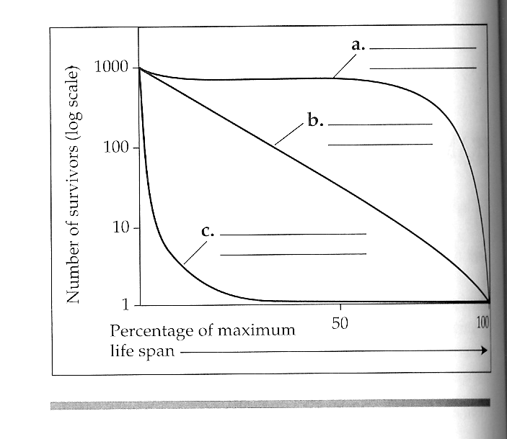

* A. Type I survivorship curves are characterized by high survival in early and middle life, followed by a rapid decline in survivorship in later life. [Humans](http://en.wikipedia.org/wiki/Human) are one of the species that show this pattern of survivorship.
* B. Type II curves are an intermediate between Type I and III, where roughly constant [mortality rate](http://en.wikipedia.org/wiki/Mortality_rate) is experienced regardless of age. Some [birds](http://en.wikipedia.org/wiki/Bird) follow this pattern of survival.
* C. In Type III curves, the greatest mortality is experienced early on in life, with relatively low rates of death for those surviving this bottleneck. This type of curve is characteristic of species that produce a large number of [offspring](http://en.wikipedia.org/wiki/Offspring) (see [r/K selection theory](http://en.wikipedia.org/wiki/R/K_selection_theory)). One example of a species that follows this type of survivorship curve is the [Octopus](http://en.wikipedia.org/wiki/Octopus).

1. Mortality, number of offspring per reproduction, and prenatal investment are usually interrelated.  On the following graphs, sketch the relationship you would predict between the variables.

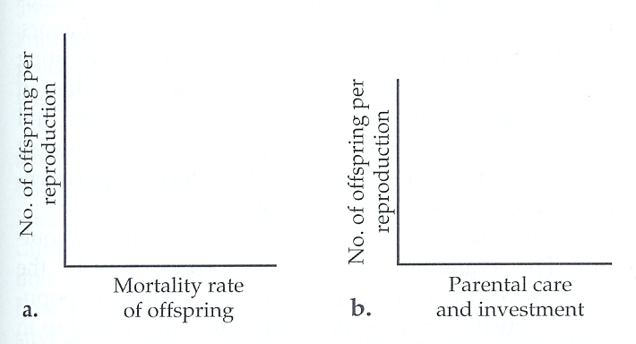



1. Label the exponential (a) and logistic (b) growth curves, and show the equation associated with each curve.  What is ***K*** for the population show with curve ***b***?

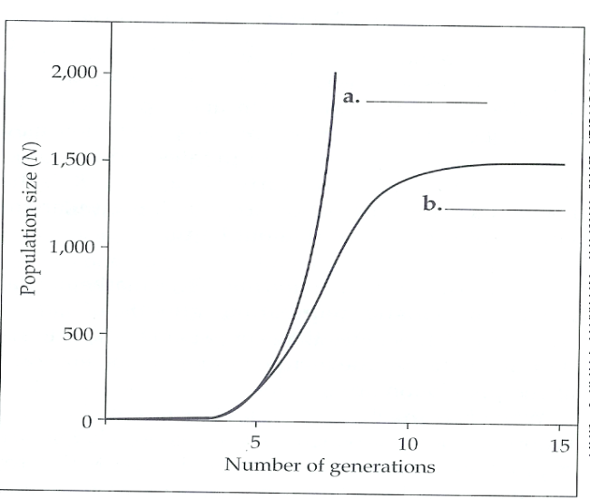

1. List some density-dependent factors that may limit population growth Resource availability i.e. living space, food, cover, water, minerals & sunlight p. 1132).
2. List some abiotic factors that may cause population fluctuations. Weather, Water availability, soil quality,
3. Species composition and distribution in most plant communities appear to be individualistic.  What may explain the occasional occurrence of sharp delineations in species composition between communities? Adaptive strategies & resource availability could make a difference; soil composition, sunlight exposure, leaf/stomatal ratios and herbivorous members can control height, canopy covering and plant structure.
4. Name the following 2 types of mimicry:
   1. Harmless species resembling a poisonous or distasteful species: Batesian Mimicry (Coral Snake and Scarlet King Snake are examples) p. 1155
   2. Mutual imitation by two or more distasteful species: Mullerian Mimicry between monarch and viceroy butterfly.
5. Name and give examples of the interspecific interactions symbolized in the table:

|  |  |  |
| --- | --- | --- |
|  | Interactions | Examples p. 1156 |
| +/+ | Mutualism | Mycorrhizae and plant species provide minerals and nourishment to soil |
| +/0 | Commensalism | Silver Fish sharing ant communities |
| +/- | Parasitism | Flukes in a host organism; Tapeworms; Viruses (Bacteriophages) |
| -/- | Interspecific Competition | Weeds competing with existing lawn grass for soil nutrients |

1. Experimental data from tree hole communities showed that food chains were longest when food supply at the producer level was greatest.  Which hypothesis about what limits food chain length do these results support? Energetic Hypothesis
2. Many freshwater lake communities appear to be organized along the top-down model.  What actions might ecologists take if they wanted to use *biomanipulation* to control excessive algae blooms in a lake with four trophic levels (algae, zooplankton, primary predator fish, and top predator fish)?

Increase the amount of top predator fish which would reduce primary predatory fish thus increasing zooplankton who can feed on algae reducing algal blooms.

1. Describe the effects of the alder stage of succession on soil pH and fertility. The alder stage contains nitrogen fixing compounds which would modify soil pH. Rather than the typically expected alkaline (basic soil, these compounds encourage further growth).
2. List some ecosystems with high rates of production. Tropical Rainforest, Deciduous Forest, Wetlands
3. List some ecosystems with low rates of production. Desert, Tundra, Taiga
4. The open ocean has low net primary production yet contributes the greatest percentage of earth’s net primary production.  Explain. Light availability, surface area and the high diversity of photosynthesizing algae contributes to the primary production. Net productivity= Gross Productivity-Oxygen Production
5. Antarctic seas are often more productive than most tropical seas, even though they are colder and receive lower light intensity.  Explain. Because of the water’s insulating properties, ice maintains thermoregulation. Antarctic seas have microbiota and algal organisms that have a unique ecological niche.
6. Why is production efficiency higher for fishes than for birds and mammals? Because fishes aren’t responsible for aerobic respiration and terrestrial metabolic requirements they don’t expend as much energy in water.
7. Assuming a 10% trophic efficiency (transfer of energy to the next tropic level), approximately what proportion of the chemical energy produced in photosynthesis makes it to a tertiary consumer? 0.1%
8. In which natural ecosystem do nutrients cycle the fastest?  Why? Tropical Rainforest. Because of high precipitation rates, soil doesn’t retain nutritive value very long so this must quickly be recycled.
9. In which natural ecosystem to nutrients cycle the slowest?  Why? Tundras cycle the slowest because of dormancy rates and slow microbial rates in soil decomposition. Oceans also cycle slowly (marine habitats cycle the largest amount of nitrogen and other chemical compounds).
10. What is the effect of loss of vegetation on nutrient cycling? Vegetation can remove vital nutrients from the cycle and can also reduce the amount of nitrogen fixation as decomposition rates dwindle.
11. List some of the potential consequences of global warming: Global warming causes oceanic temperatures to rise (although seemingly negligible a 1-3 degree increase can severely affect primary productivity, natural phenomena (like hurricanes) are closely correlated to global warming).
12. Two processes that emerge at the ecosystem level of organization are energy flow and chemical cycling.  Develop a **concept map** that explains, compares, and contrasts these 2 processes.

1. Describe four or five human intrusions in ecosystem dynamics that have detrimental effects. Habitat Encroachment, Introduced Species, Monoculture (Lawns vs. Meadows; Deforestation), Residential Development, Burning Fossil Fuels.
2. Give an example of how each of the following causes of the biodiversity crisis has reduced population numbers or caused extinctions.

a.       habitat destruction: Many endangered species (dusky gopher frog) are susceptible to extinction and are now limited to one pond in Mississippi.

b.      introduced species: Zebra Mollusks have no natural predators and now clog boat motors and leading to destruction of habitat.

c.       overexploitation Deforestation has rendered the tropical rainforests bereft of many unique ecological habitats.

d.      disruption of food chains: Overcapture or poaching of game fish has caused algal blooms in top-down trophic pyramids.

1. Is the effective population size usually larger or smaller than the actual number of individuals in the population?  Explain. Smaller than the actual number, these are based on conservative estimates.
2. Explain the basic premise of the small population approach.  The premise is to bolster genetic diversity in dwindling or threatened species. What conservation strategy is recommended for preserving small populations? By grouping several members of the same species for mating ecologists try to increase population counts.
3. Describe the declining-population approach to the conservation of endangered species. This approach is used to identify environmental factors contributing (habitat loss, extinction threats).
4. What are some potential benefits of corridors?  How may they be harmful? Riparian corridors are used as a protective avenue however, they can harm species by reducing genetic diversity through geographic isolation.
5. What factors would favor the creation of larger, extensive preserves?  Larger population counts What factors favor smaller, unconnected preserves? Smaller organisms which close relatedness.
6. What are the major threats to biodiversity, listed in order of importance?
7. How does the loss of biodiversity threaten human welfare? Resource availability, Primary Productivity, Oxygen Production and Nutrient Cycling are all consequences of biodiversity loss.
8. What do edges and movement corridors have to do with habitat fragmentation? Edges corridors are for species that avoid perimeters. Marine species actually do very well with this barrier. The area to perimeter ratio must be kept small to avoid this. Movement corridors are for highly mobile species. By establishing these fluid corridors, ecologists avoid habitat fragmentation.