Name_____________________

Epistatic Alleles

In labradors, coat color is controlled by two sets of alleles. Black is dominant to brown, but yellow is epistatic, when two yellow alleles are present (ee), the yellow coat color is expressed, independent of the brown/black alleles present.
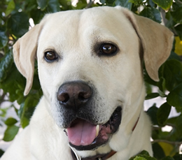
Do these crosses & find phenotypes:
1. A black lab (BBEe) x yellow lab (bbee)

2. A chocolate lab (bbEe) x black lab (BbEe)

3. Two black labs (BBEE x BbEe)

