Name(s)___________________________________________________________ Block_______

Organelle: ______________________________

Fakebook: An Organelle Project
This project is designed to be a creative investigation into the structure and function of eukaryotic organelles. Using the frame of an online profile, you will create a profile for one organelle, and through posts, show the relationships between organelles.

"Fakebook" allows you to create imaginary profile pages. Website: http://www.classtools.net/FB/home-page

You should have fun, and be creative, while remaining true to an accurate understanding of the material at hand. Essentially, you will be ‘telling’ (actually, more like implying/inferring) what your organelle does and how it interacts with other organelles, through the organelles’ profile and posts. (*Worth 1 lab grade)

List of Organelles:

- Nucleus  - Ribosomes  - Rough Endoplasmic Reticulum  - Smooth Endoplasmic Reticulum  - Golgi Apparatus  - Plasma Membrane  - Vesicle  - Cytoplasm  - Cytoskeleton  - Microfilaments (or tubules or Intermediate) | - Mitochondria  - Chloroplast  - Flagellum  - Cillia  - Lysosome  - Extracellular Matrix  - Peroxisome  - Central or Contractile Vacuole  - Cell Wall  - Centriole
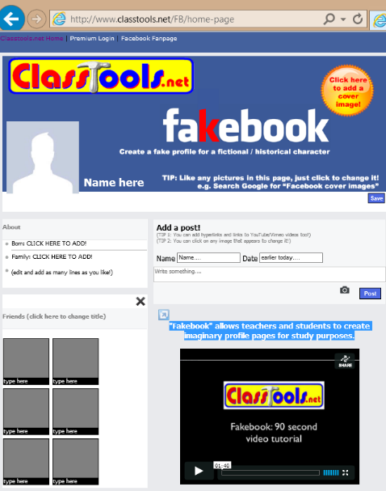

Online Profile:

You can work alone or in pairs. You will create a digital ‘Fakebook’ profile for one organelle you choose. The profile should contain a picture & information about what your organelle ‘does’, while being creative & imaginative. Give the organelle a person’s name, but relate it to the organelle (Ex: Chlora Greenlight).
Images should be included for: profile, cover, friends, and at least 2 images within posts. You may also include ‘likes’, video links, etc., just like a ‘real’ Facebook. Each person or group (include both names AND your block) will send me an email with the link to your ‘Fakebook’ by Monday, 8/20 NO LATER than 9:00 PM.

Relationships:
Posts must be made by other at least 8 other organelles (with images and names). The posts should be conversational, but the organelle’s function, and how it relates to your chosen organelle, should be implied or inferred, based on what it ‘posts’. Have some fun and entertain me!

