Gene Regulation in Eukaryotes WQ Name_________________________ # _____ Blk _____
Kidney cells and brain cells are different from each other. How so? Brain cells express brain proteins/enzymes and Kidney cells express kidney proteins/enzymes.
Kidney cells and brain cells are also quite similar to each other. How so? Kidney cells and brain cells also both express proteins/enzymes common to both cell types.
This is called cell differentiation and requires a higher level of gene coordination.
Here is a recap:
Overview of Differences between Prokaryotic and Eukaryotic Gene Expression and Regulation
 | Prokaryotes | Eukaryotes
Structure of genome | Single, generally circular genome sometimes accompanied by smaller pieces of accessory DNA, like plasmids | Genome found in chromosomes; nucleosome structure limits DNA accessibility
Size of genome | Relatively small | Relatively large
Location of gene transcription and translation | Coupled; no nucleoid envelope barrier because of prokaryotic cell structure | Nuclear transcription and cytoplasmic translation
Gene clustering | Operons where genes with similar function are grouped together | Operons generally not found in eukaryotes; each gene has its own promoter element and enhancer element(s)
Default state of transcription | On | Off
DNA structure | Highly supercoiled DNA with some associated proteins | Highly supercoiled chromatin associated with histones in nucleosomes

Let’s work backwards and start with gross chromosome structure in the nucleus and move on to the finer details of what is happening at the DNA level later on.

Perhaps chromosomes have their equivalent to tertiary and quaternary structure. Otherwise how does one explain constancy of karyotypes across primate lineages unless invoking positive selection? Check out this link: http://phys.org/news/2013-09-x-shape-true-picture-chromosome-imaging.html

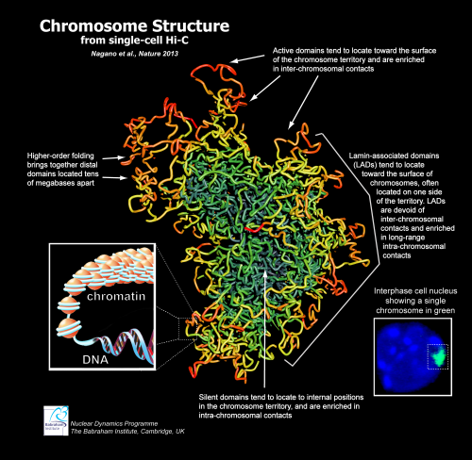

Describe where active domains of DNA are located:

___________________________________________________________________________________________________

X-chromosomes come in two versions: active and Barr Body. Predict what chromosome 1 would look like in a similar diagram:

___________________________________________________________________________________________________

It appears that chromosomes have architecture that is organized into active and inactive domains. Whole domains of DNA can be inactivated by conversion into inactive Heterochromatin nestled towards the interior of the nucleus. Inactive heterochromatin DNA is methylated and tightly wound around acetylated histones.

Recap: Describe an inactive domain of DNA:

_________________________________________________________________________________________________________________________________________________________________________________________________________________________________________________________________________________

This explains one level of gene regulation and why brain cells and kidney cells are different. Elaborate after watching this video: http://learn.genetics.utah.edu/content/epigenetics/intro/

_________________________________________________________________________________________________________________________________________________________________________________________________________________________________________________________________________________

Epigenetics also suggests how offspring could inherit an ACQUIRED phenotype from a parent. Do this activity and then in your own words,define “Epigenetic markers” (http://learn.genetics.utah.edu/content/epigenetics/control/)

Epigenetic changes to global gene regulation is also NOT just restricted to cell differentiation. How about (coordinated but less than global) control of a spectrum of various parallel metabolic pathways? For example, the thrifty phenotype hypothesis suggests that early-life metabolic adaptations help in survival of the organism by selecting an appropriate trajectory of growth in response to environmental cues. That means phenotypic change in response to the environment generate epigenetic changes that prepares the adult organism for better survival in the long term and (this is the important bit) these changes are heritable. In other words, Epigenetic's impact on Evolutionary theory is very important. Watch this and make notes below.http://learn.genetics.utah.edu/content/epigenetics/inheritance/

That idea is mind-boggling…in other words Novo-Lamarckism (not Lamarckism,not Neo-Lamarkism) is back in vogue. In Darwinian terms – isolated individual variants are not always grist for evolution’s mill, rather entire populations can present a new phenotype in response to environmental change that can subsequently respond to Natural Selection by altering gene regulation for the long term.

Think of it this way: some populations have a thrifty phenotype as a default setting – other populations have a spendthrift phenotype as a default setting. Default settings can be switched on and off in response to the environment and these switches are heritable. Eventually populations can change their default settings in response to Natural Selection.

Of course, the next logical question is how entire domains can be activated and inactivated according to cell type. We get a hint by observing the differences between Hinnies and Mules.

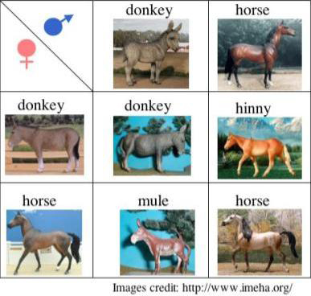
A hinny is the offspring of a male horse and a female donkey. A mule is the offspring of a female horse and a male donkey.

Let’s consider that one more time: From a DNA point of view, there is no difference between a female hinny and a female mule. Both offspring have one set of DNA with the epigenetic changes expected of a horse (from either the mother or the father) and another set of DNA with the epigenetic changes expected of a horse (from either the mother or the father)

So why are hinnies and mules different? Their only difference was the identity of the egg. Horse eggs have different transcription factors than donkey eggs and produce different offspring. It’s not only about the DNA!

Go to this site: https://highered.mheducation.com/sites/9834092339/student_view0/chapter16/control_of_gene_expression_in_eukaryotes.html Watch the video, answer questions on the site. Make notes of any that were incorrect. Questions are also below, so you’ll have them to study:
RNA polymerase binds to the
 |  |  | A) | operator.
 |  |  | B) | promoter.
 |  |  | C) | regulator.
 |  |  | D) | terminator.
 |  |  | E) | enhancer.
2. |  | The most efficient control of eukaryotic gene expression is achieved at the level of
 |  |  | A) | replication.
 |  |  | B) | transcription initiation.
 |  |  | C) | post-transcription.
 |  |  | D) | translation initiation.
 |  |  | E) | post-translation.
3. |  | At which of the following level(s) can gene expression be regulated in eukaryotes?
 |  |  | A) | passage of mRNA through the nuclear membrane
 |  |  | B) | destruction of the mRNA
 |  |  | C) | rate of protein synthesis
 |  |  | D) | A and B
 |  |  | E) | A, B and C
4. |  | The addition of a phosphate to a protein after it is produced is an example of post-transcriptional modification.
 |  |  | A) | True
 |  |  | B) | False
5. |  | The exons of eukaryotic mRNA are removed and the introns are spliced together.
 |  |  | A) | True
 |  |  | B) | False

Let’s move on to transcription factors and enhancers. Open this site: https://highered.mheducation.com/sites/9834092339/student_view0/chapter16/transcription_factors.html

Watch the video, answer questions on the site. Make notes of any that were incorrect. Questions are also below, so you’ll have them to study:
Transcription is carried out by the enzyme
 |  |  | A) | DNA polymerase.
 |  |  | B) | RNA polymerase.
 |  |  | C) | RNAse.
 |  |  | D) | topoisomerase.
 |  |  | E) | reverse transcriptase.
2. |  | Which of the following statement(s) about basal transcription factors is(are) TRUE?
 |  |  | A) | they are essential for transcription
 |  |  | B) | they cannot increase the rate of transcription by themselves
 |  |  | C) | they can decrease the rate of transcription by themselves
 |  |  | D) | A and B
 |  |  | E) | A, B and C
3. |  | The assembly of transcription factors begins
 |  |  | A) | upstream from the transcription start site.
 |  |  | B) | downstream from the transcription start site.
 |  |  | C) | upstream from the translation start site.
 |  |  | D) | downstream from the translation start site.
 |  |  | E) | downstream from the translation stop site.
4. |  | Eukaryotic transcription factors include activators and coactivators.
 |  |  | A) | True
 |  |  | B) | False
5. |  | The various transcription factors bind to the promoter.
 |  |  | A) | True
 |  |  | B) | False

Go to:

https://highered.mheducation.com/sites/9834092339/student_view0/chapter16/transcription_complex_and_enhancers.html

Answer these questions ON THE WEBSITE, as well as below.
1. |  | Assembly of basal transcription factors begins at the ________ sequence in the promoter.
 |  |  | A) | GGCC.
 |  |  | B) | AATT.
 |  |  | C) | ACGT.
 |  |  | D) | GAGA.
 |  |  | E) | TATA.
2. |  | Which of the following statements about basal transcription factors is TRUE?
 |  |  | A) | they are essential for transcription
 |  |  | B) | they cannot increase the rate of transcription by themselves
 |  |  | C) | they can decrease the rate of transcription by themselves
 |  |  | D) | A and B
 |  |  | E) | A, B and C
3. |  | Which of the following statements about enhancers is TRUE?
 |  |  | A) | they are sequences to which activators bind
 |  |  | B) | they are found in the promoter of a gene
 |  |  | C) | they are only found in certain chromosomal locations
 |  |  | D) | A and B
 |  |  | E) | A, B and C
4. |  | The interaction of activators, coactivators and basal transcription factors involves the formation of a loop in the DNA.
 |  |  | A) | True
 |  |  | B) | False
5. |  | Regulatory proteins called repressors can decrease the rate of transcription by binding to the promoter.
 |  |  | A) | True
 |  |  | B) | False

Next, go to: http://bcs.whfreeman.com/hillis1e/#667501__674153__.

If link doesn’t open, try this: http://bcs.whfreeman.com/webpub/biology/pierce5e/animations/14.2%20Overview%20of%20Eukaryotic%20Gene%20Expression/1402_eukary_gene_exp.html *Must download the animation if the last link is used

Where do Transcription factors bind? _________________________________________________

Where do regulator proteins bind? ___________________________________________________

Where do activator proteins bind? ____________________________________________________

Is the default setting of a eukaryotic gene on or off? Explain __________________________________

_____________________________________________________________________________________

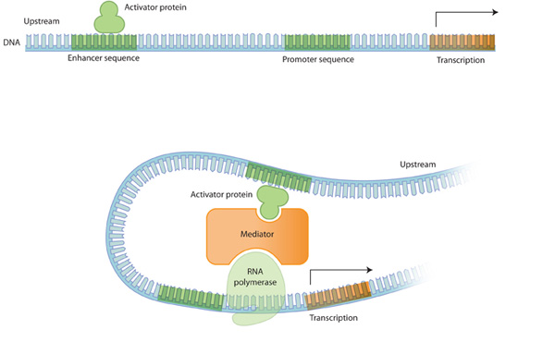
Actually, another level of control is the “Mediator Protein”

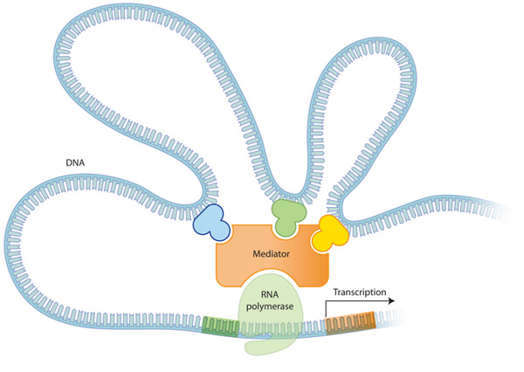
It gets even more complicated. Sometimes more than one enhancer is involved!
Sometimes, enhancers are countermanded by insulators.
Clearly Eukaryotic regulation is more complicated than prokaryotic regulation at the level of transcriptional control.

Of course, there is more to gene regulation than transcriptional control!
Go to: https://highered.mheducation.com/sites/9834092339/student_view0/chapter16/rna_interference.html
Watch video. Answer questions on the site, as well as below:
RNA intereference is a mechanism for silencing gene expression at the
 |  |  | A) | level of replication.
 |  |  | B) | level of transcription.
 |  |  | C) | post-transcriptional but pre-translational level.
 |  |  | D) | level of translation.
 |  |  | E) | post-translational level.
2. |  | The protein ________ acts as an endonuclease in the first step of RNA interference.
 |  |  | A) | interferon
 |  |  | B) | phaser
 |  |  | C) | sizer
 |  |  | D) | dicer
 |  |  | E) | vader
3. |  | RNA interference is stimulated in the presence of ________ in the cell.
 |  |  | A) | single-stranded RNA
 |  |  | B) | double-stranded RNA
 |  |  | C) | single-stranded DNA
 |  |  | D) | double-stranded DNA
 |  |  | E) | proteins
4. |  | RISC is an RNA-protein complex that binds to cellular mRNAs.
 |  |  | A) | True
 |  |  | B) | False
5. |  | Antisense mRNA can be produced during the life cycle of all viruses.
 |  |  | A) | True
 |  |  | B) | False

For a review on RNA splicing and chromatin packing/ remodeling (both on test), Watch these:
https://highered.mheducation.com/sites/9834092339/student_view0/chapter16/rna_splicing.html
https://highered.mheducation.com/sites/9834092339/student_view0/chapter16/chromatin_remodeling.html

Review: Explain the following mechanisms of eukaryotic control, giving an example for each. Use your book and PPt, if needed.

Transcriptional control: _______________________________________________________________________
_________________________________________________________________________________________
__________________________________________________________________________________________
_________________________________________________________________________________________
Post-transcriptional control: (in nucleus- mRNA processing) _________________________________________________________________________________________
_________________________________________________________________________________________
__________________________________________________________________________________________
_________________________________________________________________________________________

Post –transcriptional control (transport in cytoplasm- RNA interference): ________________________________________________________________________________________
_________________________________________________________________________________________ ________________________________________________________________________________________
_________________________________________________________________________________________
Translational control: ________________________________________________________________________
_________________________________________________________________________________________
_________________________________________________________________________________________
_________________________________________________________________________________________
Post-translational control: (Protein processing & degradation) _________________________________________________________________________________________
_________________________________________________________________________________________
__________________________________________________________________________________________
Chromatin packing: _________________________________________________________________________________________________________________________________________________________________________________________________________________________________________________________________________________

Let’s review something mentioned in the earlier worksheet that deserves repetition because it is so important:

The regulation of Operons has significant importance allowing us to understand the regulation of Biological systems in general not to mention cell differentiation and differential gene expression in Eukaryotes.

Take a few minutes & Compare and Contrast Prokaryotic Control with Eukaryotic Control.

This next part will be done with Immune System. Skip this for now and go to HOX genes.

For example, a B Cell does not commit to clonal expansion and antibody production unless the T Cell confirms attack. T Cells themselves meanwhile require redundant confirmation of immune response. Think of an Immune Response as a nuclear warhead launched by an offshore submarine. How does one protect against the possibility of a submarine captain going “rogue” as in the movie “The Hunt for Red October”?

In the case of an Immune response an attack cannot be launched without:

•the Submarine Captain’s key (The B Cell), whose key is necessary to launch an nuclear strike
•a failsafe second key carried by the submarine’s second in command (T Cell) necessary to confirm the attack.

If both B Cells and T Cells go rogue – we can have a problem called an auto-immune response.

To continue the metaphor: in Eukaryotes, a core promoter binds RNA polymerase, but transcription does not proceed until an upstream promoter binds cell-specific binding factors to “confirm” transcription by physically contorting and opening the DNA.

Safety deposit boxes in a bank provide a useful metaphor.

You need two keys to open your bank box:
•your key, (cell-specific transcription factors) whose pattern of notches fits only the lock of the box assigned to you (= the upstream promoter), but which cannot unlock the box unless
•a second key (RNA polymerase II) carried by a bank employee which opens the second lock (= the core promoter) but cannot by itself open any box.

The complexes of hormones with their respective receptors binding to DNA represent one class of transcription factors controlling eukaryotic gene expression.

Bottom Line: Eukaryotes have many layers of redundant gene control.

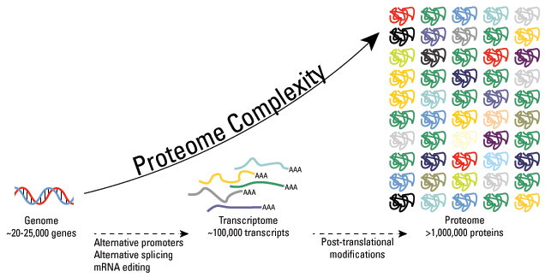
Eukaryotes are more complex than prokaryotes because eukaryotes typically have 100 times as many chemical reactions occurring within their cytoplasm requiring separate chemical reaction chambers known as membrane-bound organelles. So life at its most basic must be considered the cell which is nothing more than a chemical reaction chamber (sometimes with compartments) and all smaller than the size of a grain of sand.

Within the last few decades, scientists have discovered that the human proteome is vastly more complex than the human genome. While it is estimated that the human genome comprises fewer than 25,000 genes, the total number of proteins in the human proteome is estimated at over 1 million. This means that single genes encode multiple proteins.

Genomic recombination, transcription initiation at alternative promoters, differential transcription termination, and alternative splicing of the transcript are mechanisms that generate different mRNA transcripts from a single gene together with post-translational modifications. Some estimates suggest that 5% (approximately 50,000!!!) of the proteome comprises enzymes that alone perform more than 200 types of post-translational modifications on a far larger repertoire of proteins including an ever growing list of enzymes. This crucial 5% includes kinases, phosphatases, transferases and ligases (as well as other kinds of post-translational modifications) which add or remove functional groups, proteins, lipids or sugars to or from amino acid side chains; not to mention proteases, which cleave peptide bonds to remove specific sequences or regulatory subunits. Many proteins can even modify themselves using autocatalytic domains, such as autokinase and autoprotolytic domains. (excellent reference)

HOX genes:
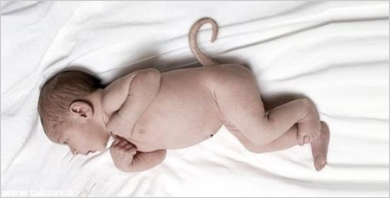
OK, now we can continue with homeobox genes. We already know that homeobox genes control embryonic development. When homeobox genes are inappropriately expressed, fruit flies can grow legs instead of antennae. Humans can grow tails.
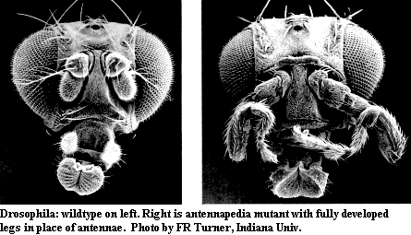

Let’s summarize: We know that genes can mutate. We also know that “regulatory” genes (switches) control the expression of “regular” genes, the genes that code for transcripts and so-called gene products. We also know that regulatory genes are themselves controlled by a higher level of regulatory genes (homeobox genes as just one example). This results in a gene regulatory network or genetic regulatory network (GRN) is a collection of DNA and collaboration of different genes to govern the gene expression levels of mRNA and proteins. Ultimately that is the answer to our old question; what makes a kidney cell different than a brain cell. Check out this link: http://www.pbs.org/wgbh/nova/body/gene-switches.html Check out this video: http://www.pbslearningmedia.org/resource/novat10.sci.life.evo.fruitfly/switching-genes-on-and-off/
The following animation dramatically demonstrates how enhancer binding to transcription factors can affect development. Big changes can occur with very little mutation. See if you can get a fly to grow legs from its head during the following activity.

Follow the steps in the following link and record at least six sets of results.
http://www.pbslearningmedia.org/resource/novat10.sci.life.evo.evodevo/regulating-genes/

Creature | Were spots or appendages affected by the mutation? (How?) | In which part of the chromosome did the mutation occur? | Result in developed creature?
DEFAULT | No mutation in this run. | No mutation in this run | Appendages in middle 1 and  middle 2, spots in middle 1
1
2
3
4
5
6 |  |  | Appendages on head…

What do the small geometric shapes represent (i.e. the stars, triangles etc) _____________________________and what were their origin? ____________________________________

The development of body plans in all animals is controlled by a remarkably small number of genes and those genes are virtually identical in all animals. There appears to be a repeated pattern underlying the differing body structures of animals. Commonalities are observed in the segmented bodies of worms, in the vertebrae of animals with backbones, in the head-thorax-abdomen construction of insects. From a developmental point of view, humans are segmented no differently than earthworms or insect larvae.
These homeobox genes are remarkably common across phyla. Eyeless fruit flies regain functioning compound eyes when rescued with equivalent homeobox eye genes from mice. Homeobox genes and similar genes are often called “the molecular toolkit” or “the genetic toolkit”. You will be hearing about more about Evo-Devo.
http://www.pbs.org/wgbh/nova/evolution/guess-embryo.html
Evolutionary implications are staggering. Check out this cool video: https://www.youtube.com/watch?v=OHR5K2o7uQU
A great quote from a great video:
“Scientists now realize that not all genes are created equal. Some make the stuff of our bodies, and switches are needed to turn many of these stuff genes on and off. The body-plan genes are what throw these switches, which tell the stuff genes what to do and when.

This subtle choreography can have profound effects on how different animal bodies are formed.
And this knowledge is helping us solve perhaps the biggest Darwinian puzzle of all: the mystery of the great transformations.

It all goes back to Darwin's idea of the tree of life, that all life-forms are ultimately related, and from the earliest common ancestor, over billions of years, they have changed and diversified, so that creatures that started out looking the same, evolved to become completely different.

And scientists have made some amazing connections: that dinosaurs share a common ancestor with birds; and that a fish must have been the ancestor of all four-limbed creatures, even us.
Of all his ideas this was probably Darwin's most astonishing.”
Here is the video: http://www.pbs.org/wgbh/nova/evolution/darwin-never-knew.html

