Understanding Evolution: Name ______________________________ # _________
Homology and Analogy
http://evolution.berkeley.edu/evolibrary/article/0_0_0/similarity_ms_01
1. Similarities and differences: understanding homology and analogy
a) Define homology:

b) Define analogy:

c) In the image of the people (the sisters and the Elvis impersonators), which pair represents an analogy and which a homology?

2. What is a tetrapod?

3. What are the six bones found in all tetrapod fore-limbs?

4. Identify these limbs, to what animal do they belong? (label each with both answers)
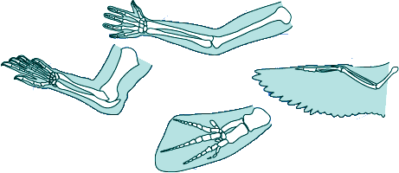
5. What did the common ancestor of all modern tetrapods look like?

6. What Homologous traits do the following organisms have?
Oak & Ginko –
Dragonfly & Butterfly -
Beaver & Elephant -

7. Similar structures that evolved independently are called _________________________.
8. a) How are Thylacosmilus and Smilodon similar?

b) How are they different?

9. Are similarities between sharks and dolphins homologous or analogous? EXPLAIN why you would conclude this.

10. Considering all of the evidence, are the "wings" (actually flaps of skin stretched between the legs) of sugar gliders and flying squirrels homologous or analogous structures? EXPLAIN why you would conclude this.

