Human Pedigree Analysis Problem Sheet Name_____________________ #____ Blk___
There are a number of different types of human pedigrees that you may encounter, however, there are only a few different modes of inheritance that you will need to be familiar. The following pedigrees show you different examples of human traits that can be traced through generations. See if you can identify the modes of inheritance, and answer any questions directly related to each pedigree. While you are working on this, keep the following clues in mind:
Clues for Autosomal Inheritance
Recessive  - individual expressing trait has 2 normal parents  - two affected parents can not have an unaffected child | Dominant  - every affected person has at least one affected parent  - each generation will have affected individuals
Clues for Sex-linked Inheritance
Recessive
- no father-to-son transmission
- predominantly males affected
- trait my skip generations

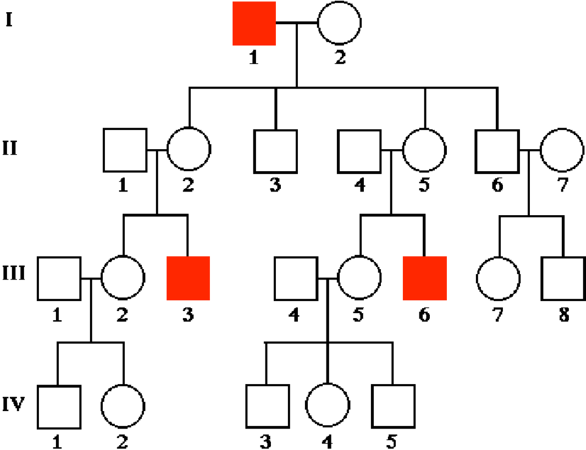
- For each of the pedigrees below, identify the mode of inheritance and provide at least 2 reasons for your choice.

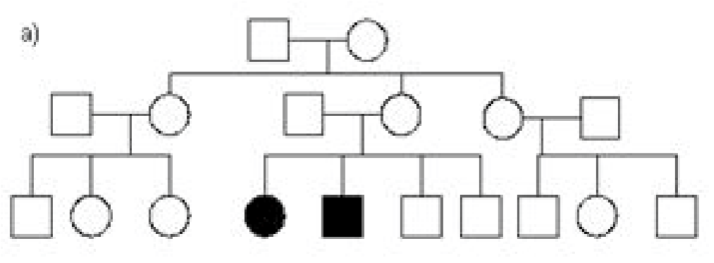 c)

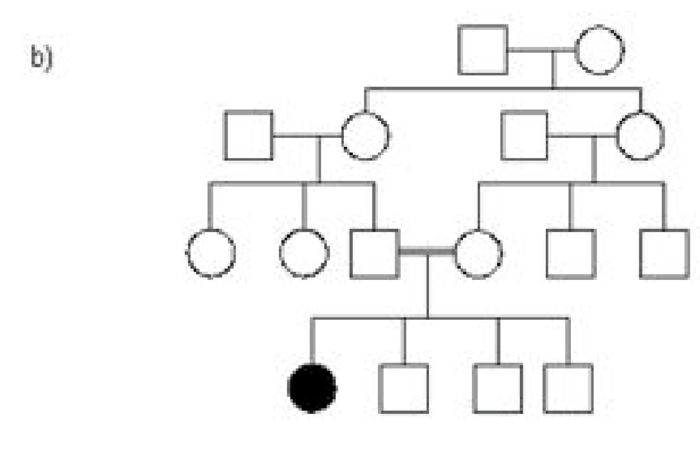
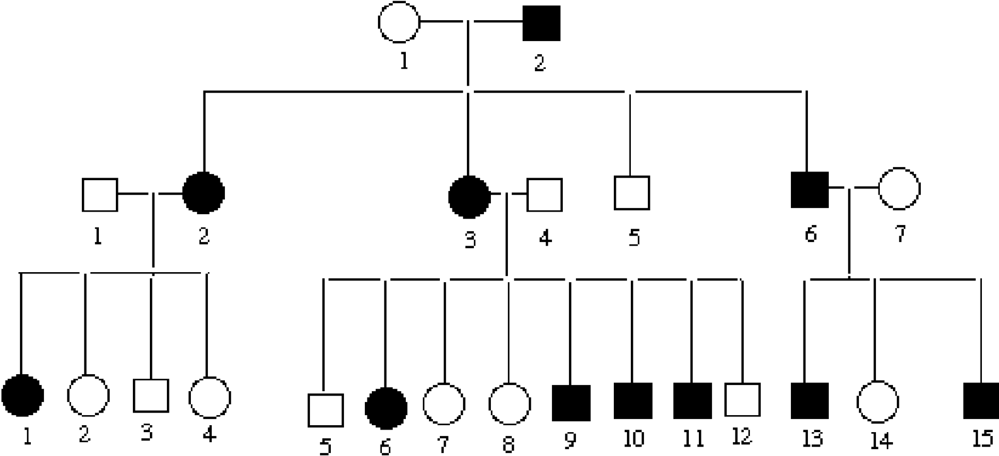
d)

