Name:______________________________________________#:_______________
INTERPRETING ECOLOGICAL DATA

Graph 1: Rabbits Over Time
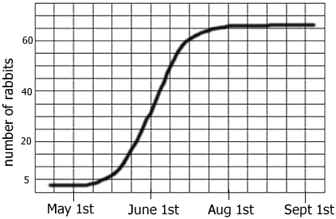
a. The graph shows a _______________ growth curve.
b. The carrying capacity for rabbits is ____________
c. During which month were the rabbits in exponential growth? _______________

Graph 2: Average Toe Length
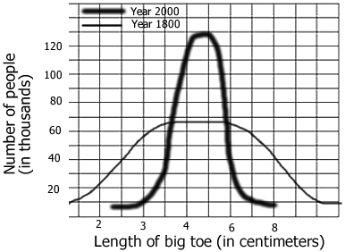
a. In 1800, about how many people surveyed had a 3 cm toe? _____________
How many in 2000? ____________
b. The data shows ____________ selection has occurred (*remember the last unit)
c. In 2000, what is the average toe length? ________ What is the average toe length in 1800? ________

Graph 3: Mexico and US
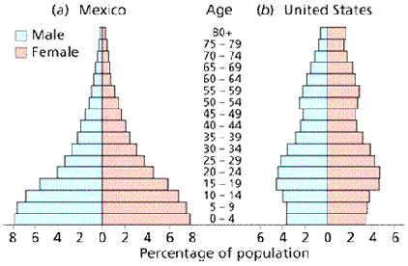
a. In Mexico, what percentage of the population is between 0-4 years of age? _______
In the US? ________
b. Which population is growing the fastest? __________. Explain how you know _________________

____________________________________________________________________________________

____________________________________________________________________________________
c. Which age group has the smallest number in both countries? _________

Chart 4: Trapping Geese
In order to estimate the population of geese in Northern Wisconsin, ecologists marked 10 geese and then released them back into the population. Over a 6 year period, geese were trapped and their numbers recorded.
Year | Geese Trapped | Number with Mark
1980 | 10 | 1
1981 | 15 | 1
1982 | 12 | 1
1983 | 8 | 0
1984 | 5 | 2
1985 | 10 | 1
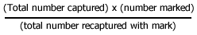
a. Use the formula to calculate the estimated number of geese in the area studied? _____________
b. This technique is called ____________ & ______________ (Refer to PPt)
c. Suppose more of the geese found in the trap had the mark, would the estimated number of geese in the area be greater or lesser? ___________. EXPLAIN BELOW:

Chart 5: Snakes & Mice
Year | Snakes | Mice born | Mice died
1960 | 2 | 1000 | 200
1970 | 10 | 800 | 300
1980 | 30 | 400 | 500
1990 | 15 | 600 | 550
2000 | 14 | 620 | 600
2001 | 15 | 640 | 580
The data shows populations of snake and mice found in an experimental field.

a. During which year was there no mouse population growth? ____________
b. What is the carrying capacity for snakes ? __________
c. Approximately what year was the carrying capacity of mice reached? _________
d. Explain at least 3 reasons why a population cannot continue to grow exponentially & reaches carrying capacity.
1-

2-

3-

Last question: Explain the difference between density dependent and density independent factors. Include a minimum of 2 examples of each.

