Name:______________________________________#:_______________
INTERPRETING ECOLOGICAL DATA
Graph 1: Rabbits Over Time
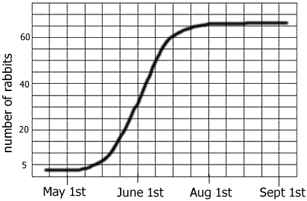
a. The graph shows a __________ growth curve.
b. The carrying capacity for rabbits is ______
c. During which month were the rabbits in exponential growth?
Graph 2: Average Toe Length
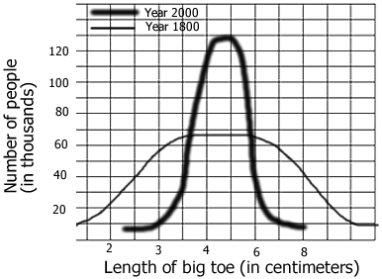
a. In 1800, about how many people surveyed had a 3 cm toe? ______
How many in 2000? _______
b. The data shows the ____________ selection has occurred?
c. In 2000, what is the average toe length? ______ What is the average toe length in 1800 _______

Graph 3: Mexico and US
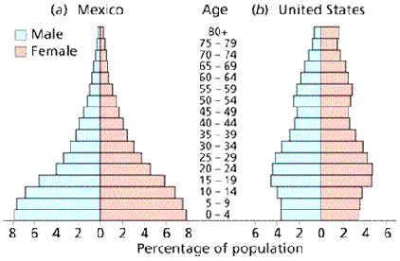
a. In Mexico, what percentage of the population is between 0-4 years of age? _______ In the US? ______
b. Which population is growing the fastest? ________
c. Which age group has the smallest number in both countries? _____
Chart 4: Trapping Geese
In order to estimate the population of geese in Northern Wisconsin, ecologists marked 10 geese and then released them back into the population. Over a 6 year period, geese were trapped and their numbers recorded.
Year | Geese Trapped | Number with Mark
1980 | 10 | 1
1981 | 15 | 1
1982 | 12 | 1
1983 | 8 | 0
1984 | 5 | 2
1985 | 10 | 1
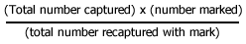
a. Use the formula to calculate the estimated number of geese in the area studied? _____________
b. This technique is called ____________ & ______________
c. Suppose more of the geese found in the trap had the mark, would the estimated number of geese in the area be greater or lesser? _____
Chart 5: Mushroom Plots
Another ecologist uses a different method to estimate the number of mushrooms in a forest. She plots a 10x10 area and randomly chooses 5 spots, where she counts the number of mushrooms in the plots and records them on the grid.
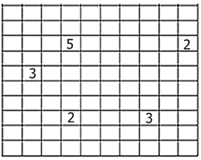
- Calculate the number of mushrooms in the forest based on the grid data: _________
- This technique is called _______________
Chart 6: Snakes & Mice
Year | Snakes | Mice born | Mice died
1960 | 2 | 1000 | 200
1970 | 10 | 800 | 300
1980 | 30 | 400 | 500
1990 | 15 | 600 | 550
2000 | 14 | 620 | 600
2001 | 15 | 640 | 580
The data shows populations of snake and mice found in an experimental field.
a. During which year was the mouse population at zero population growth? ______
b. What is the carrying capacity for snakes ? ______
c. What is the carrying capacity for mice? _____
d. What is the rate of growth (r) for mice during 1970? _____ During 1980? ______

