Name_____________________________ # ____ Blk _____
Lab Bench Activity - Cellular Respiration
Pearson site: go to LabBench ---> go to "Lab 5: Cell Respiration". http://www.phschool.com/science/biology_place/labbench/lab5/intro.html
1. In this lab activity:
a) You will observe __________________________________________________________________
b) You will investigate ________________________________________________________________
2. Write the equation for cellular respiration:

3. What are the three ways in which you can measure the rate of cellular respiration?

4. Sketch a respirometer and label its important features.

5. As the organism inside the respirometer consumes oxygen, what happens to the water? _________________________
6. What happens to the CO2 that the organism produces? ____________________________
7. Experimental Setup (View the graphic)
a) fill out the table
 | Vial 1 | Vial 2 | Vial 3 | Vial 4 | Vial 5 | Vial 6
Contents
Temperature
b) How do you ensure that each vial has an equal volume?
c. What is the purpose of the vial with only glass beads?
8. Analyzing Results
a) What is the equation to determine the rate of respiration?

b) What is X _______________ What is Y _______________
9. Read the respirometers and determine the rate of respiration. Show your calculations
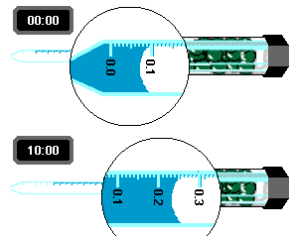
10. Analysis - Self Quiz. Put answers here:
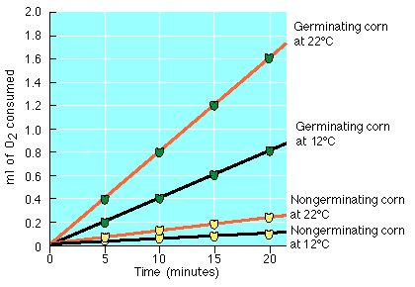
a) Describe the relationship between temperature and consumption of oxygen.

b) Calculate the rate of oxygen consumption for germinating corn at 12 degrees. (Show calculations)

c) Based on the graph, would you conclude that non germinating seeds respire?

11. Extension (You do not need the computer to finish this section, do as homework)

A cricket is placed in a respirometer and data taken at three temperatures. The following table shows the data collected.
 | Temperatures
Time (min) | 10 degrees | 18 degrees | 25 degrees
0 | 0.0 | 0.0 | 0.0
5 | 0.25 | 0.6 | 0.9
10 | 0.5 | 0.9 | 1.4
15 | 0.7 | 1.2 | 1.8
20 | 0.9 | 1.6 | 2.4
a ) Graph the data.

b) Determine the rate of respiration for each of the three temperatures. (Show work)

