Name_________________________________________________ Block _____ # _____
Lab #1 (of 3): Introduction to the Compound Optical Light Microscope
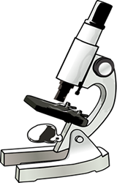
1. Examine your microscope. Familiarize yourself with the parts of the microscope. Lens should always be cleaned with lens paper!
The magnification of the ocular lens (eyepiece) is _____
The magnification of:
the scanning objective _____ x
the low power objective is ______x
the high power objective is ______x
2. The total magnification using the lenses can be determined by multiplying the objective lens with the ocular lens. What is the total magnification of an item viewed with the:
LOW power objective? _____ HIGH POWER? _______ SCANNING? _______
3. Examine the diaphragm (underneath the stage). Turn the lever while looking through the ocular lens. What does the diaphragm regulate?
_________________________________________________________________________________
4. What do you think this is for? _____________________________________________
5. Random Specimen Choose 1 specimen from the box of "common things". Use the scanning objective to view the specimen and use the coarse knob to focus. Then, fine focus.
- While looking through the ocular, use the knobs to move the slide. Move the slide to the right. How does it appear to move? __________________.
- Now, move the slide up. How does it appear to move? _____________.

- Make a drawing (IN PENCIL) of the specimen on scan. Scale your drawing appropriately with the field of view. Before going to low power, make sure your specimen is carefully centered on the slide. Click the low power objective in place. Only use the fine focus knob to focus. Make a drawing on low power, scaled appropriately. C) Finally, switch to high power. Remember at this point, you should ONLY use the FINE adjustment knob. Can you view the entire specimen under high power? _______________________. As you increase magnification, does the field of view become lighter or darker? _____________________. How could you ‘correct’ it? ____________________________________________________________________________

- Return the slide to the box. Repeat the above procedure with a second specimen.

Specimen #1: What slide did you choose? ________________________________________

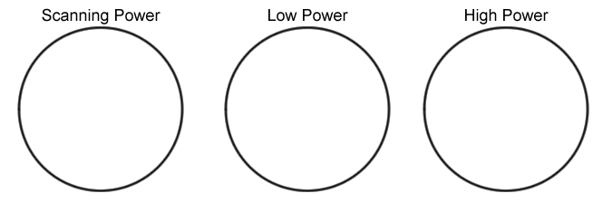

Specimen #2: What slide did you choose? _______________________________________

6. Answer True or False to each of the statements:
__________ On high power, you should use the coarse adjustment knob.
__________ The diaphragm determines how much light shines on the specimen.
__________ The low power objective has a greater magnification than the scanning objective.
__________ The fine focus knob visibly moves the stage up and down.
__________ When the slide is moved to the right, it appears to move left while viewing through the ocular lens of the microscope.
__________ If a slide is thick, only parts of the specimen may come into focus.
__________ The type of microscope you are using is a scanning microscope.
__________ For viewing, microscope slides should be placed on the objective.
__________ In order to switch from low to high power, you must rotate the revolving nosepiece.
__________ The total magnification of a microscope is determined by adding the ocular lens power to the objective lens power.

