MAGNET BIOLOGY Name _____________________________ # _______
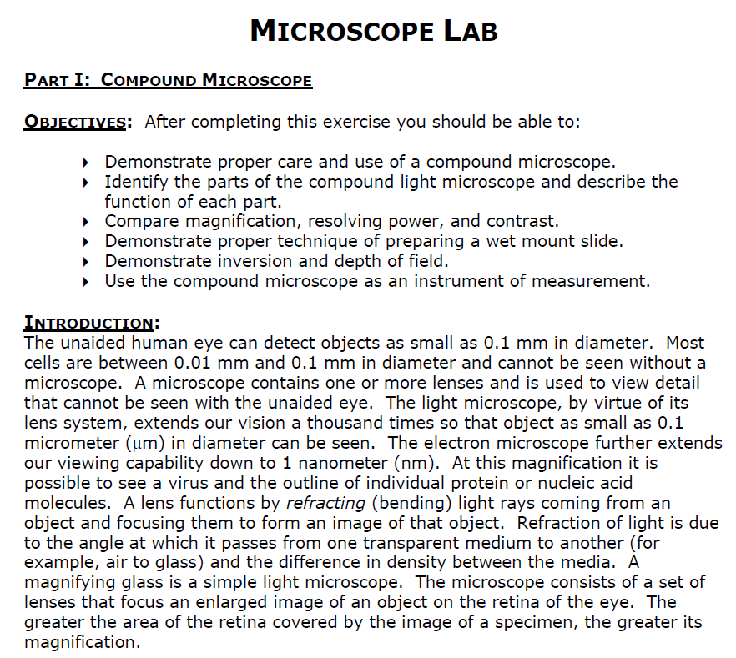
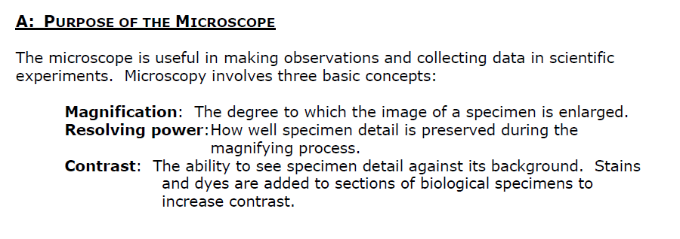
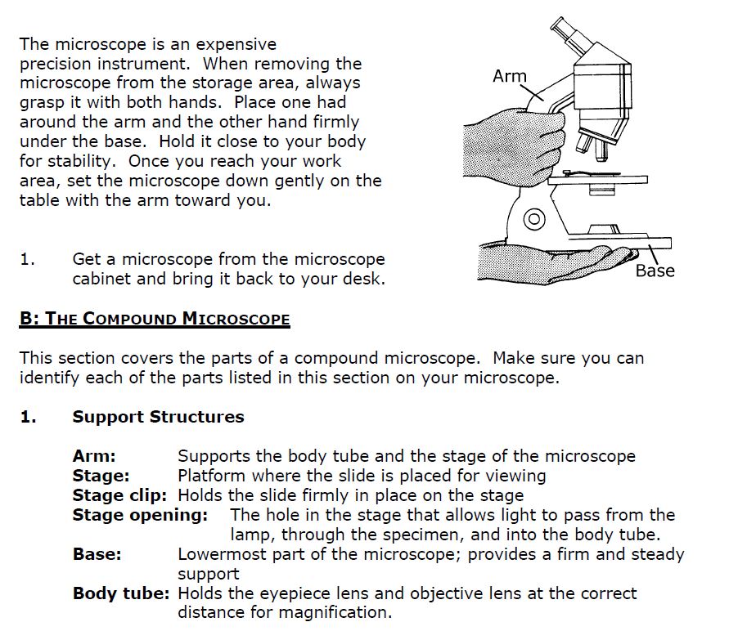
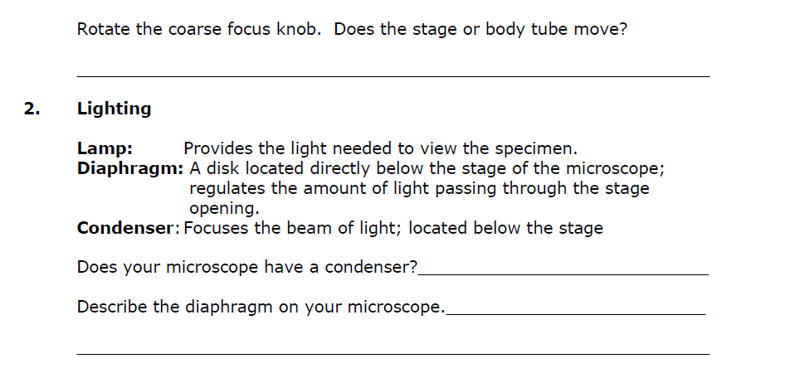
*NOTE: Our microscopes have Iris Diaphragms (not Disk Diaphragms)
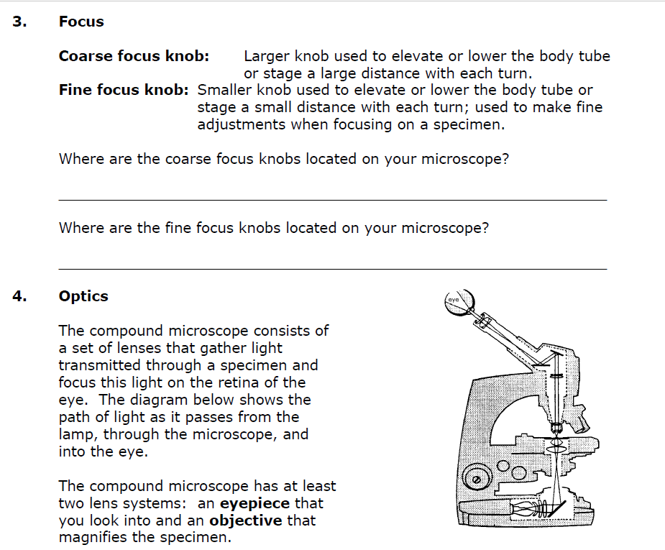
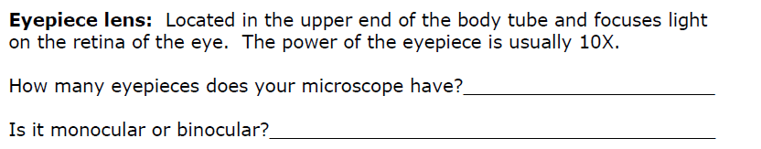
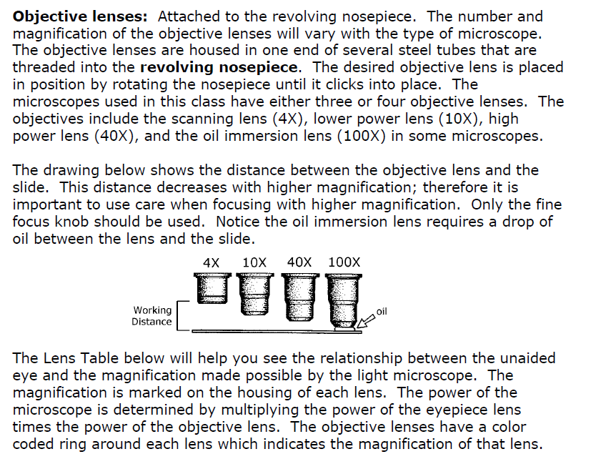
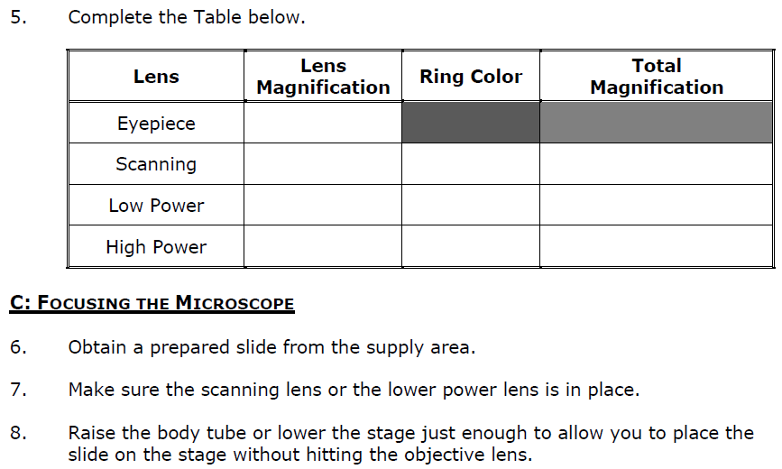
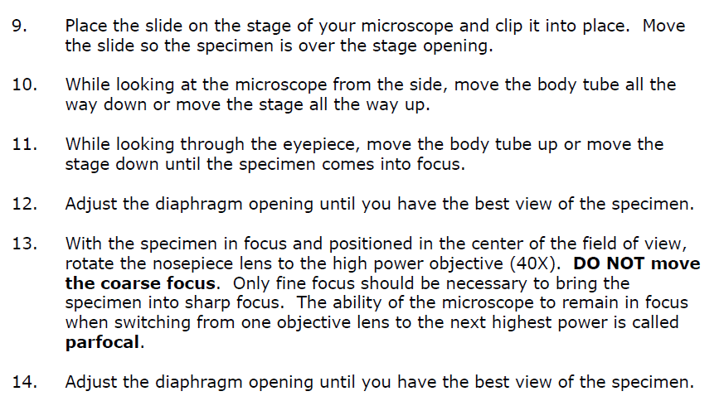
15-17:
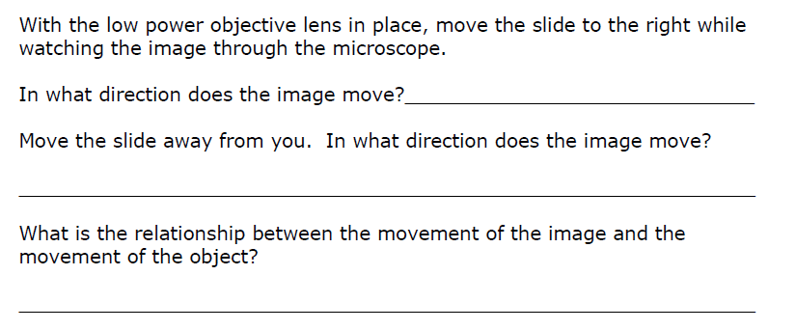
Return the slide to the Slide Box.
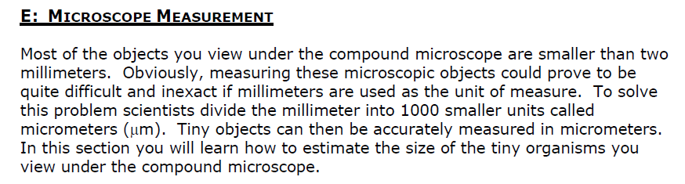

Questions 18-20: *You may use sig figs to estimate the last digit.
Here’s an example to remember sig figs: 2.7 um: the 2 was measured and the remainder (.7) is estimated.
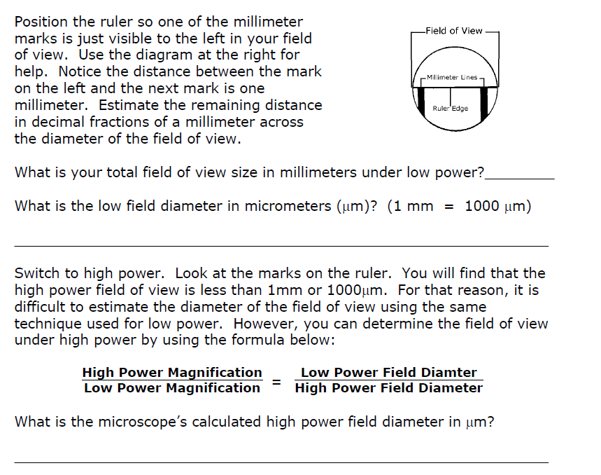
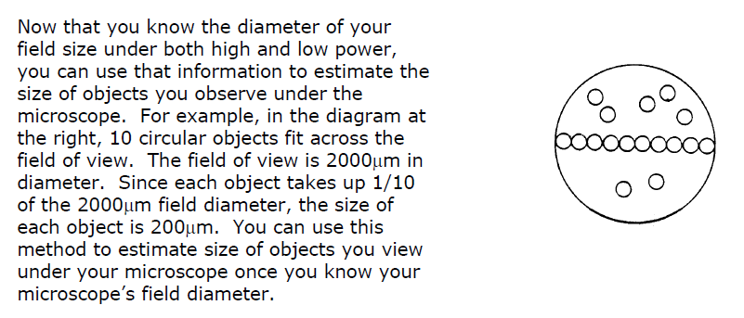

Each group will use 4 slides to complete the below chart, HOWEVER, EACH GROUP CAN ONLY CHECK OUT ONE SLIDE AT A TIME. YOU MUST RETURN A SLIDE BEFORE YOU PICK UP THE NEXT SLIDE. One of the 4 slides must have an object LARGER than the field of view. The second slide must have an object SMALLER than the field of view. Slides 3 and 4 may either be larger or smaller (your lab group has the choice).
Depending on the slides chosen, you may use either LOW or HIGH power to determine object size. Indicate which power was used in the table, below. Refer to the calculations you did on the previous slide to determine the size of the object (use sig figs to estimate the last digit).
Another example of using sig figs: 5700: the 5 (meaning 5000) is measured and the 7 (700) is estimated
*Helpful tip: If the object used is LARGER than the field of view, the group will estimate the size based on the % of the object viewed. Ex: If only ~ 50% of the object was in the field of view, the # of specimen in the field of view would be 0.5

Name of SPECIMEN | Indicate which Power was used (Low or High) | Field Diameter (value will depend on power used) | # of specimen that are in within the field of view | Estimated Specimen Size (microns- um)

ADDITIONAL QUESTIONS:
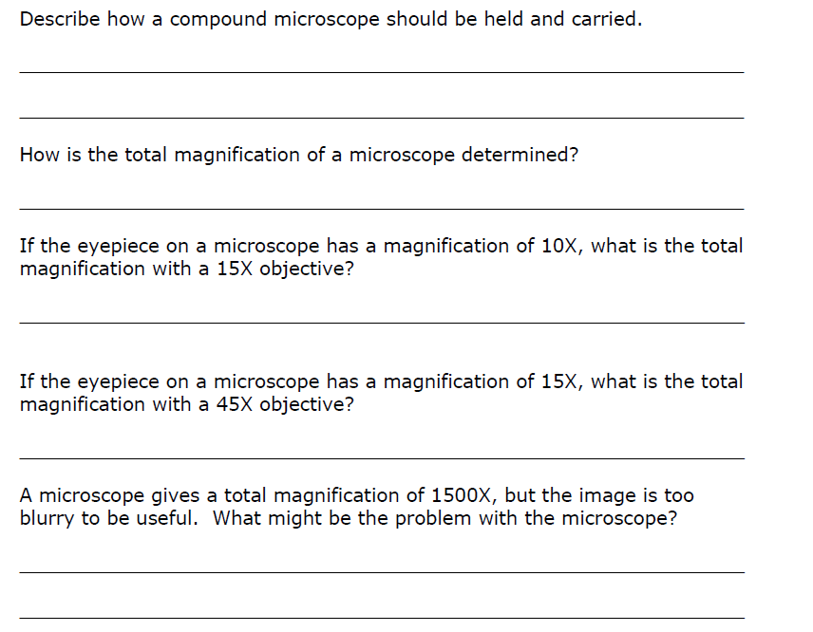
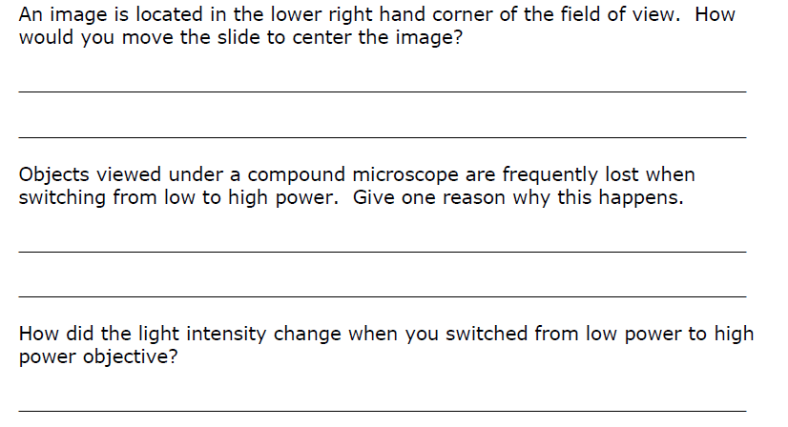

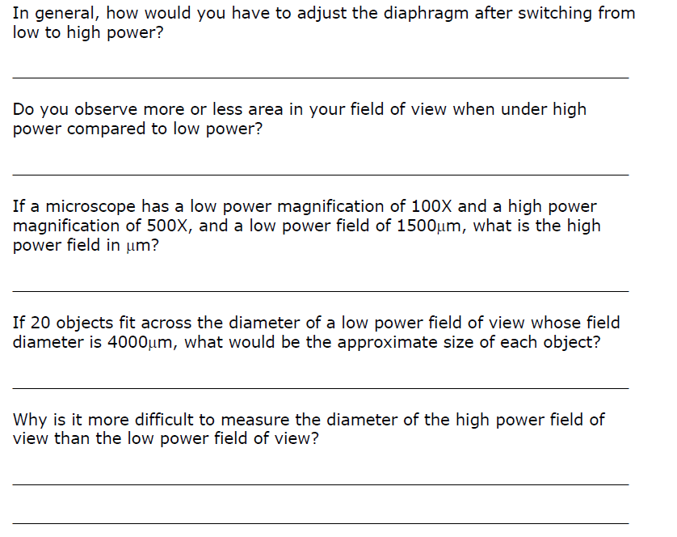
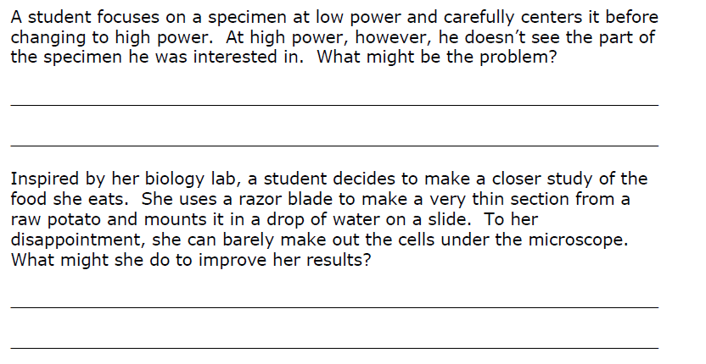
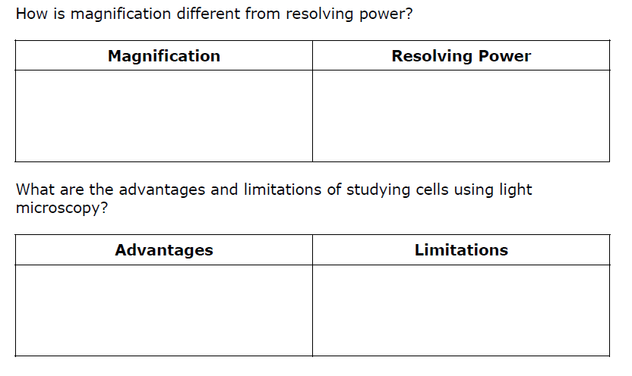
Use the PPt given in class to answer the next 2 questions:
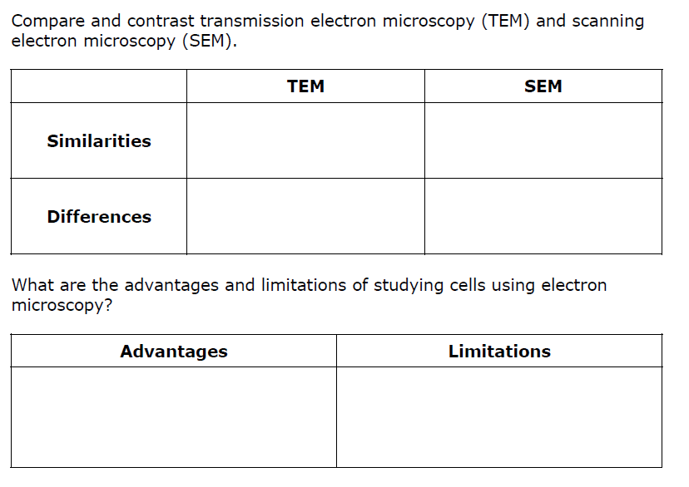
Next, the teacher will demonstrate how to do a PROPER DRAWING of specimen viewed under the light microscope. You will make drawings for the Cell Lab(s). Remember these RULES: 1) Pencil must be used. 2) The specimen drawn must be PROPORTIONAL to the field of view. 3) STRAIGHT lines USING A RULER must be used to label structures (or receive a DEDUCTION). 4) Write the name of the structure at the END of the line (not on the line). 5) Magnification must be indicated; 6) Each drawing needs a title.
You will also learn how to prepare a wet mount, as well as staining cells, before the next lab.

