More Graphing- AP Bio Name______________________________ Blk _____ # ______
Box and Whisker plot- more complex because they display more detail. A box and whisker plot is a way of summarizing a set of data measured on an interval scale. It is often used in explanatory data analysis. This type of graph is used to show the shape of the distribution, its central value, and its variability.
In a box and whisker plot:
- the ends of the box are the upper and lower quartiles, so the box spans the interquartile range
- the median is marked by a vertical line inside the box
- the whiskers are the two lines outside the box that extend to the highest and lowest observations.
Although it’s not likely you will have to construct one of these on an exam (or AP Exam) from a given set of data, it is likely there will be question(s) in which you will have to analyze data when given a B & W graph.
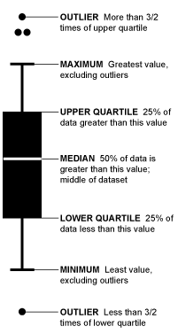
Before you begin, watch this video: https://www.youtube.com/watch?v=b2C9I8HuCe4
There are more good videos on youtube, if needed.
This site also explains it well: http://www.purplemath.com/modules/boxwhisk.htm
*See back of page for questions

Example of a B&W graph and representative questions:
The below graph displays data of temperatures throughout a ~ 50-year time span.
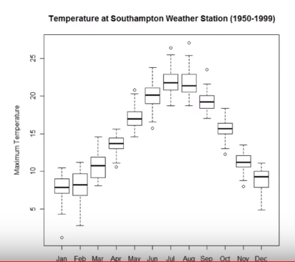
For the following questions, use a ruler and give ‘approximate’ values (*do not use more than 2 sig figs for any answer).
What is the median temperature in July?
What are the outlier temperatures in the month of December?
What is the temperature range of the 1st quartile in May?
What is the temperature range of the 3rd quartile in February?
Is the data from this graph discrete or continuous?
Explain the difference between median and mean. *Use data from this graph to justify your response.

What is a vital piece of information that is not given in this graph? (Hint- think units)
How would interval(s) need to be modified to give answers with the appropriate # of sig figs?

