Name ______________________________________ # _______
Multiple Alleles Practice Problems
1.
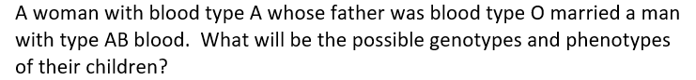

2.

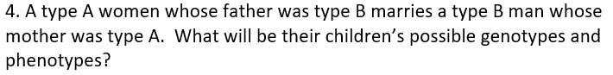

5.

