Nitrogen Cycle Worksheet Name__________________________ # _____

Introduction:
- Animals are able to obtain nitrogen through eating plants and animals.
- Plants have much harder time obtaining nitrogen as they can only absorb nitrogen when it is mixed with oxygen or hydrogen.
- Nitrogen is mixed with oxygen or hydrogen through a process called nitrogen fixation.
- There are two ways nitrogen can be fixated:
1. Lightening
2. Bacteria in the soil or bacteria found in nodules of legumes
- Nitrogen is a necessary component of life as plants need it to grow and animals need it to create DNA.
- The speed of decomposition is the key to keeping the nitrogen cycle moving as the majority of fixated nitrogen comes from bacteria breaking down dead matter and feces.
- The warmer an area is the faster decomposition will occur.

Processes in the Nitrogen Cycle
- Fixation - Fixation is the first step in the process of making nitrogen usable by plants. Here bacteria change nitrogen into ammonium.
- Nitrification - this is the process by which ammonium gets changed into nitrates by bacteria. Nitrates are what the plants can then absorb.
- Assimilation - This is how plants get nitrogen. They absorb nitrates from the soil into their roots. Then the nitrogen gets used in amino acids, nucleic acids, and chlorophyll.
- Ammonification - This is part of the decaying process. When a plant or animal dies, decomposers like fungi and bacteria turn the nitrogen back in ammonium so it can reenter the nitrogen cycle.
- Denitrification - Extra nitrogen in the soil gets put back out into the air. There are special bacteria that perform this task as well.
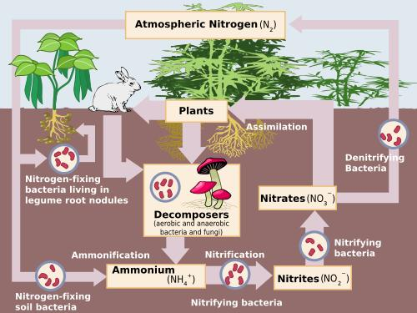

Questions:

- Explain why bacteria are the most important part of the nitrogen cycle.

- 2. If nearly 79% of the atmosphere is made of nitrogen, how could there be a shortage of nitrogen in soil?

- How do animals obtain usable nitrogen? Why is it important?

- Give the two ways nitrogen can be fixated so plants can use it to grow.

- Explain the problem if too much nitrogen enters an aquatic ecosystem.

- Explain the statement “Nutrients do not flow in one direction in the ecosystem, they recycle through the ecosystem.”

