Name:_____________________________________ # ______ Block: ______

AP Biology - Investigation: Photosynthesis

Background and Pre-Lab
Photosynthesis fuels ecosystems and replenishes the Earth's atmosphere with oxygen. Like all enzyme-driven reactions, the rate of photosynthesis can be measured by either the disappearance of substrate, or the accumulation of products. The equation for photosynthesis is:
6CO₂ + 6H₂O ------light--------> C₆H₁₂O₆ + 6O₂ + H₂0
What could you measure to determine the rate of photosynthesis?
1) The production of oxygen, which is released as photosynthesis occurs
2) The consumption of carbon dioxide

Leaf Structure and Function
In this investigation, you will use a system that measures the accumulation of oxygen in the leaf. Consider the anatomy of the leaf as shown below.
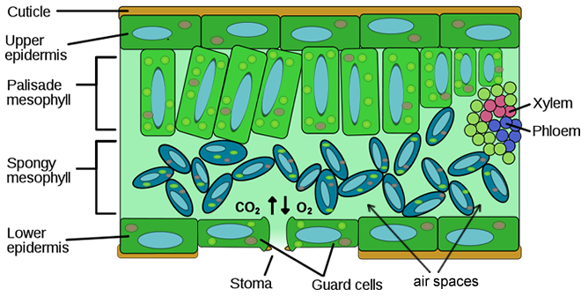
The leaf is composed of layers of cells. The spongy mesophyll layer is normally infused with gases, oxygen and carbon dioxide. Leaves (or disks cut from leaves) will normally float in water because of these gases. If you draw the gases out from the spaces, then the leaves will sink because they become more dense than water. If this leaf disk is placed in a solution with an alternate source of carbon dioxide in the form of bicarbonate ions, then photosynthesis can occur in a sunken leaf disk. As photosynthesis proceeds, oxygen accumulates in the air spaces of the spongy mesophyll and the leaf becomes buoyant and floats. Oxygen and carbon dioxide are exchanged through openings in the leaf called stoma.
While this is going on, the leaf is also carrying out cellular respiration. This respiration will consume the oxygen that has accumulated and possibly cause the plant disks to sink. The measurement tool that can be used to observe these counteracting processes is the floating (or sinking) of the plant disks. In other words, the buoyancy of the leaf disks is actually an indirect measurement of the net rate of photosynthesis occurring in the leaf tissue.

Learning Objectives:
1) To design and conduct an experiment to explore factors that affect photosynthesis.
2) To connect and apply concepts, including the relationship between cell structure and function, strategies for capture and stores of energy, and the diffusion of gases across membranes.
PreLab Questions - these should be completed BEFORE the scheduled lab
1. How can the rate of photosynthesis be measured?

2. What is the function of the stoma?

3. Where in the cells of the leaf do you find air spaces?

3. What will happen if you remove the air from these spaces?

4. How will air return to these spaces?

5. Instead of carbon dioxide, what will be used as the reactant in this lab?

6. List any factors that you think may affect the rate of photosynthesis. Consider environmental factors that you could manipulate during the lab.

7. Watch the video that shows the set-up for the floating leaf disk lab at Bozeman Science. (Search for "bozeman leaf disk lab" or use QR code)
a) What is the ratio of water to baking soda you will need for your solution?

b) What is the purpose of the syringe?

c) Why did Mr. Anderson put a ‘heat sink’ with water on top of the beaker?

d) How will you know when photosynthesis is occurring in your leaf disks?

Part 1: Basic Procedure for Measuring the Rate of Photosynthesis
Materials: baking soda, liquid soap, plastic syringes, leaves (spinach or ivy), hole punch, cups or beakers, timer, light source, heat sink, ring stand
- *See step 10 before starting the lab. CONTROL set up- May want to do it simultaneously to save time. IMPORTANT- For running the control, make these modifications to the apparatus: Use a 250 ml beaker (and 200 ml of liquid/sol’n) and a smaller heat sink. You may have to use the same light source as the experimental group, if I don’t have enough equipment for each group to use 2 lamps. For the control, infiltrate leaf disks with a solution of only deI-water with a drop of soap and no bicarbonate.

1. Collect leaf disks by punching holes in the leaf (try to get them between the veins), you will need 20 leaf circles.
2. Using a 400 ml beaker, make a solution of sodium bicarbonate by mixing 300 ml of deionized (d) H2O to a pinch of baking soda (Ratio: 100 ml to 1g).
3. Make a dilute solution of liquid detergent in 100 ml beaker (OR PLASTIC CUP) by adding 3 drops of dish soap to 70 ml of dH20. Don’t make suds! *Ask if already prepped
4. Add one SMALL drop of this dilute soap solution to your 300 ml bicarbonate solution. Swirl or stir gently to avoid making suds.
5. Place 10 leaf disks into the barrel of the syringe (labeled w/ CO2).
6. Carefully replace the plunger and push out most of the air (leave about 10 ml of volume), but do not crush your leaves.
7. Pull in a small volume (~3 ml) of NaHCO3 into the syringe. Tap and gently swirl the syringe to suspend the disks into solution. Place the syringe tip cap on the syringe (or cover the tip with your finger). Then, draw back on the plunger and create a vacuum. Hold 10 seconds. While holding, swirl the syringe gently to keep them suspended in solution.
8. Release the vacuum so that the solution will enter the air pockets disks. It may take a several repeats to get the disks to sink. You may need to gently tap the syringe to dislodge discs from the sides. If the disks do not sink after 3 tries, add a VERY small drop (use a microtip) of soap to the NaHCO3 sol’n and repeat steps 6-8.
9. Once they have sunk, you can put them back into the sodium bicarbonate solution and expose the disks to a light source (HAVE THIS READY BEFOREHAND. You may need a ring stand to attach the lamp). Use a heat sink (PREPARED AHEAD) the same way as the Bozeman video. Start a timer and record how many of the disks are floating at 1 minute intervals. (See data table.) At the end of each minute, you may quickly swirl the disks if any are stuck on the side of the beaker/cup.
10. CONTROL: Repeat your set-up from above, but this time do not place baking soda in the beaker (only distilled H20). This is your control (label the syringe). May want to run both the control and bicarb experiment simultaneously to save time. Record data in notebook and/or data table *IMPORTANT- For running the control, you may have to make these modifications to the apparatus set up (if we only have small heat sinks left): Use a 250 ml beaker (and 200 ml of deI-water) with the smaller heat sink. You may have to use the same light source as the experimental group, if we are running low on lamps.
11. Both the experimental group and the control should run until all the discs are floating (hopefully, this is within 15 minutes).
12. On day 2: each group will repeat this experiment with another variable (see Part 2, below the graph). You must get my approval before you begin, so start brainstorming now (and remember, you will also have to run a control).

Data Table
Time (min) | # of floating disks  (bicarbonate, water, + soap) | # of floating disks (control)  ( only water + soap)
1
2
3
4
5
6
7
8
9
10
11
12
13
14
15
16

Analyzing Data
To make comparisons between experiments, a standard point of reference is needed. Repeated testing of this procedure has shown that the point at which 50% of the disks are floating (the median or ET₅₀) is a reliable and repeatable point of reference. In this case, the disks floating are counted at the end of each time interval. The median is chosen over the mean as the summary statistic. The median will generally provide a better estimate of the central tendency of the data because, on occasion, a disk fails to rise or takes a very long time to do so. A term coined by G. L Steucek and R. J Hill (1985) for this relationship is ET50, the estimated time for 50% of the disks to rise. That is, rate is a change in a variable over time. The time required for 50% of the leaf disks to float is represented as Effective Time = ET₅₀.
Graph data for the Day 2 experimental group. Make a title and a legend. Determine the ET₅₀ for your leaf disks and determine the ET₅₀ for your data. Show your calculation below and indicate on the graph.

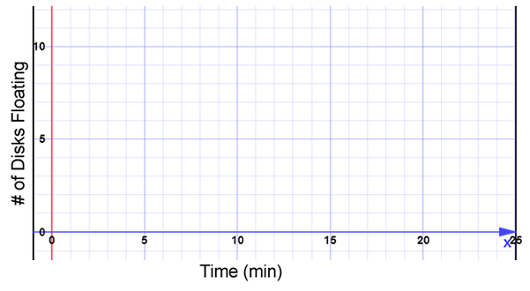

Part 2: Design and Conduct Your Own Investigation
Now that you have mastered the floating disk technique, you will design an experiment to test another variable that may affect the rate of photosynthesis. You will collect data, analyze data and present your findings in the form of a LAB REPORT (see next page). As you conduct your investigation, you may want to take photos to include in your report. Choose from the list of variables below to investigate. (If you have another variable that you would like to try, check with your instructor first.)

Suggested variables:
light intensity or distance from the light; amount of sodium bicarbonate;
water temperature; size of leaf disks or shape of leaf disks; food coloring or filters

Lab Report: We will either do a formal lab report or a mini-poster (ask me). If it’s a mini-poster, I will give separate handouts with directions, although many of the sections for the Formal Report (below) will still be applicable.

Formal Lab Report Guidelines- Use APA format. Include a title page. Refer to “Lab Report’ Handout. This is a shortened version of the sections required for this lab:
1) Hypothesis/ Prediction/ Purpose - stating the problem or question you will be investigating, your predicted outcomes (hypothesis)

2) Methods (Procedure) - describe how your experiment was set up, include materials (summarize, do not copy procedures from a lab guide)
3) Data Tables and Graphs - present your data in an easy-to read format, include graphs and indicate the ET₅₀ of your treatments.
4) Discussion/ Analysis (of data) - Thoroughly explain the data in paragraph form. (Refer to handout given previously in class)

5) Conclusions - did your experiment answer your question, what did you learn, how could your experiment be improved upon? If the experiment did not go as expected, offer an explanation, as well as how the lab could be improved.

