Name _________________________________ Block ____ # _____
Photosynthesis Worksheet- #2
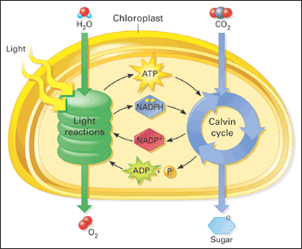
You must know this diagram!
Using the PPt and the Chloroplast diagram, answer these general overall questions regarding photosynthesis:
- What is the overall reaction for photosynthesis?

- How does this compare to the overall reaction for cellular respiration? EXPLAIN.

- Where does the energy for photosynthesis come from?

- What plant pigments are involved in photosynthesis?

- Explain why plants appears green to us, in terms of the different wavelengths of light (BE SPECIFIC)

- Which colors of light are most effective for photosynthesis?

- What are the two stages of photosynthesis? Which one does not require light?

- In which part of the chloroplast does each stage occur?

- What happens to water molecules in the light reactions?

- What photosynthesis waste product is formed in the light reaction and released?

- What two products of the light reactions are taken to the Calvin cycle to produce glucose?

- Besides the products from the light reactions, what other substance diffuses into the stroma that is critical for the Calvin cycle?

- Explain the role of NADPH in the light reactions and Calvin Cycle.

- What happens to carbon dioxide molecules in the Calvin cycle reactions?

- How can cells store sugar that is produced in photosynthesis?

- Label the diagram below to summarize the 2 stages of photosynthesis. Use the word bank to help you. Then check your answers using the diagram on the 1st page.
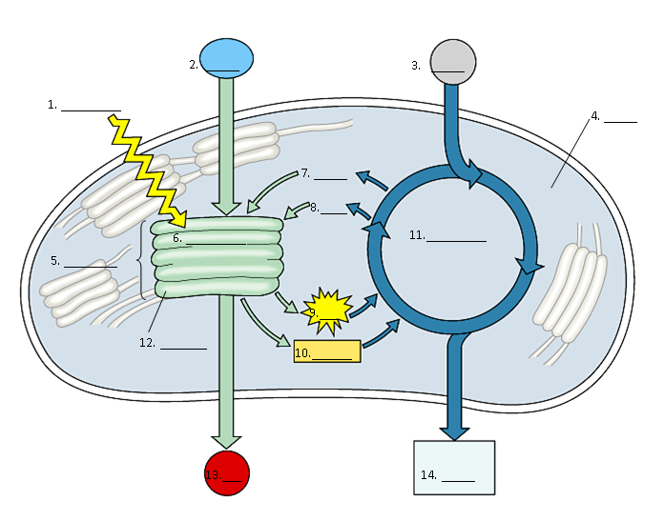

Word list:

thylakoids Calvin cycle CO₂ NADP⁺
granum light NADPH O₂
stroma H₂O ATP ADP + P
light reactions sugar

