Constructing Phylogenetic Trees Name_____________________________________ # ____
Construct trees for the following:
1.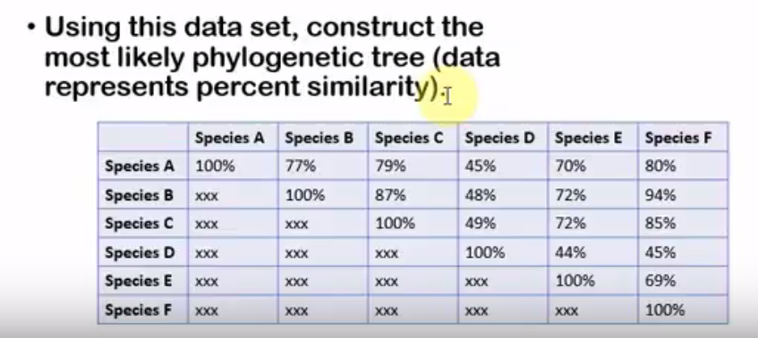

2. 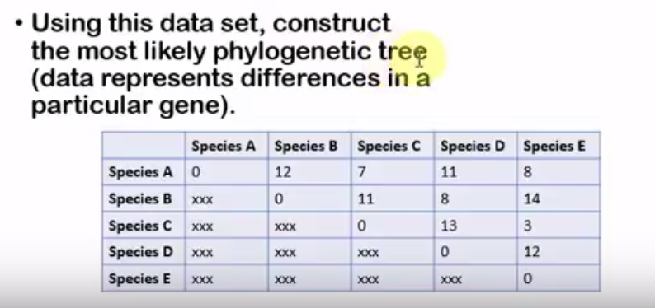
*SEE BACK OF SHEET FOR #3

3. 