PROTEIN MODELING Name _________________________ Block ____ #_____

FORM determines FUNCTION in the world of proteins. Proteins are involved in many reactions within the body. Some of the protein functions include: movement, enzymes in reactions, hormones, cell receptors, carrying oxygen, antibodies to fight infection.
The shape of the protein is determined by the order of amino acids and the interaction of these amino acids in the polypeptide chain.

The basics of protein folding:
A. Levels of protein structure
Primary: order of amino acids
Secondary: hydrogen bonds created between the elements in the backbone
Tertiary: interactions between side chains
Quaternary: interaction of 2 or more polypeptide chains
B. Reasons for tertiary structure
- Polarity and hydrophobicity:
-Hydrophobic (water fearing) are non-polar amino acids; they try to get to the inside of the protein because of the mostly aqueous (water) environment surrounding proteins
-Hydrophilic (water loving) are polar amino acids; try to get to the surface and away from the center of the protein. They are attracted to the aqueous environment
- Charge:
Positive (basic), Negative (acidic) or Neutral
-Oppositely charged amino acids attract and ‘move’ toward each other
-Same charged amino acids do not attract and move away from each other
-Neutral atoms do not move when coming in contact with other amino acids
- Disulfide bridges
-Covalent bond between 2 cysteine’s (contain sulfur)

Diagrams of the 20 amino acids are given at the end of this document. Determine which amino acids are:
- Hydrophilic & Neutral
- Hydrophobic & Neutral
- Hydrophilic & Negative (acidic)
- Hydrophilic and Positive (basic)
Label each amino acid with the correct designation (properties) in each of the squares.

Next, List those properties in Table 1 on the following page. *In the ‘CHARGE’ column, designate as +, - or N (neutral). Under ‘HYDROPHOBICITY’, write ‘Phobic’ or ‘Philic’

TABLE 1: AMINO ACID PROPERTIES
AMINO ACID | CODE | CODE | CHARGE | HYDROPHOBICITY | AMINO ACID | CODE | CODE | CHARGE | HYDROPHOBICITY
Alanine | Ala | A |  |  | Leucine | Leu | L
Arginine | Arg | R |  |  | Lysine | Lys | K
Asparagine | Asn | N |  |  | Methionine | Met | M
Aspartic Acid | Asp | D |  |  | Phenylalanine | Phe | F
Cysteine | Cys | C |  |  | Proline | Pro | P
Glutamine | Glu | Q |  |  | Serine | Ser | S
Glutamic Acid | Gln | E |  |  | Threonine | Thr | T
Glycine | Gly | G |  |  | Tryptophan | Trp | W
Histidine | His | H |  |  | Tyrosine | Tyr | Y
Isoleucine | Ile | I |  |  | Valine | Val | V

The following colored beads will represent the amino acids with the above properties:

Medium Blue: Hydrophobic & Neutral (Navy may be substituted, if needed)
Yellow: Hydrophilic & Neutral (only those that DO contain Sulfur)
Orange: Hydrophilic & Neutral (all that do NOT contain sulfur)
Light Blue: Hydrophilic & + (basic)
Green: Hydrophilic & - (acidic)

ACTIVITY: Part 1
- Pick up any 2 pipe cleaners (of the same color) and twist them together, end to end.
- Using the information given above, pick up the beads (put in cup or baggie) needed to construct a partial sequence of the ‘Traskase’ enzyme:
Met, Lys, His, Val, Ser, Leu, Asp, Glu, Cys, Asn, Tyr, Val, Cys, Phe, Trp, Pro, Ser

- Place the beads, in order, on the pipe cleaner(s). Leave some space (1-2 cm) between them (cut small pieces of straw, if needed). Which level of protein structure does this represent? __________________

- Now, let’s fold! See the last page of this handout for help.
Things to remember about tertiary interactions:
Strongest = disulfide bridges created between cysteine amino acids
Ionic interactions= oppositely charged regions
Hydrophilic ones will orient toward water (meaning toward the surface/outside)
Hydrophobic interactions = weak; nonpolar (hydrophobic) amino acids ‘group’ together and will orient away from water (inside)

- You may use spacers or he small rubber bands to ‘stabilize’ the tertiary interactions, if needed.

- Draw your tertiary structure below, in pencil (or colored pencils). Label the tertiary interactions (use a ruler). Also, take a picture of your Traskase protein:

PART 2:
- Create your own protein. Put the beads back in the baggie/cup. Pick up any 3 additional colored beads and also place them in the container (20 total). Create a new primary structure of your own choosing. Write the sequence of the amino acids, below:

- Fold your protein, as before. Draw and Label the tertiary level interactions. Take another picture (we will share on google docs. Include your names and block. susan.phillips@wheelermagnet.com

- Each person: Explain (in your OWN words) each of the interactions of your protein. BE CLEAR and CONCISE. Also include: would your protein more likely be structurally fibrous or globular? Give an example of how it would most likely function (do some research). Write in paragraph form (like a FRQ). Use additional paper & staple behind this doc, if needed.

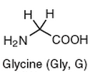 | 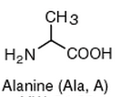
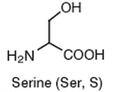 | 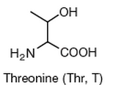
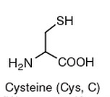 | 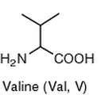
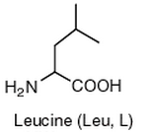 | 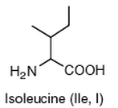
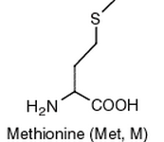 | 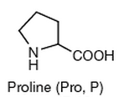
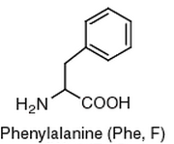 | 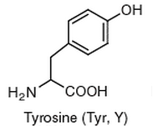
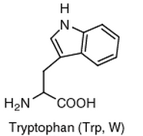 | 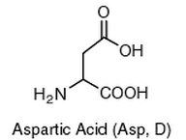
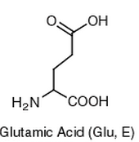 | 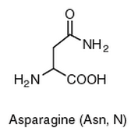
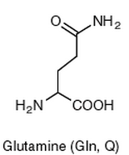 | 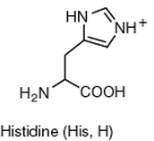
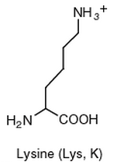 | 