Cladogram Relatedness:
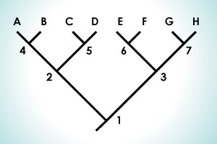

Questions:
1. What is the most recent CA of:
a. C & D?
b. A & D?
c. C & H?
2. Which of these pairs are least related? Most related?
a. A & D
b. F & D
c. D & H
d. E & F

Don’t look at the next page until you’ve answered the questions yourself!

1a. 5
1b. 2
1c. 1
2. Most related- E & F; followed by A & D. The other 2 pairs are both equally least related, based on the info given here. Cladogram branch lengths do not correspond with the length of time that has passed (only phylogenetic trees do…and we’re doing that AFTER the quiz. BUT, farther down on the overall diagram means it was longer ago than lineages (speciation divergence) higher up on the cladogram
NOW GO TO SLEEP! I won’t ask anything harder than that on this quiz

