NAME: Block: #:
NATURAL SELECTION AND EVOLUTION OF ROCK POCKET MOUSE POPULATIONS

INTRODUCTION
The rock pocket mouse, Chaetodipus intermedius, a small, nocturnal animal, is found in the deserts of the southwestern United States. Most of these mice have a sandy, light-colored coat that enables them to blend in with the light-colored desert rocks and sand on which they live. However, populations of primarily dark-colored rock pocket mice have been found living in areas where a dark rock called basalt covers the ground. The basalt formed from cooling lava flows thousands of years ago. Scientists have collected data from a population of primarily dark-colored mice living in an area of basalt in Arizona called the Pinacate lava flow, as well as from a nearby light-colored population. Researchers analyzed the data from these two populations in search of the genetic mutation responsible for the dark color. Their analyses led to their discovery of a mutation in the Mc1r gene, which is involved in coat-color determination.
MATERIALS
genetic code chart (see page 4 or any biology textbook)

PROCEDURE
1. Read the following excerpt from an article published in Smithsonian magazine by Dr. Sean Carroll, a leading evolutionary biologist and Howard Hughes Medical Institute investigator:
“One of the most widespread phenomena in the animal kingdom is the occurrence of darkly pigmented varieties within species. All sorts of moths, beetles, butterflies, snakes, lizards and birds have forms that are all or mostly black. . . .
All of these so-called “melanic” forms result from increased production of the pigment melanin in the skin, fur, scales, or feathers. Melanic pigmentation can serve many roles. Melanin protects us and other animals from the ultraviolet rays of the sun; it can help animals in colder climates or higher altitudes warm their bodies more quickly, and . . . black pigment does conceal some animals from predators.
In the deserts of the southwestern United States, for instance, there are outcrops of very dark rocks that were produced by lava flows over the past two million years. Among these rocks lives the rock pocket mouse, which occurs in dark black and a light, sandy color. Naturalists in the 1930s observed that mice found on the lava rocks were typically melanic, while those on the surrounding sand-colored granite rocks were usually light-colored. This colormatching between fur color and habitat background appears to be an adaptation against predators, particularly owls. Mice that are color-matched to their surroundings have a survival advantage over mismatched mice in each of the two habitats. . . .
The gene involved in the origin of melanism in [some] rock pocket mice is called melanocortin receptor 1, or MC1R for short. That is not a very interesting nugget of information, until I tell you that the melanic forms of jaguars, snow geese, arctic fox, fairy wrens, banaquits, golden lion tamarins, arctic skua, two kinds of lizards, and of domestic cows, sheep, and chickens are caused by mutations in this very same gene. In some species, precisely the same mutations have occurred independently in the origin of their dark forms. These discoveries reveal that the evolution of melanism is not some incredibly rare accident, but a common, repeatable process. Evolution can and does repeat itself. “ (Carroll, Sean B. Evolution in Black and White. Smithsonian.com, February 10, 2009).
- Watch the short film titled The Making of the Fittest: Natural Selection and Adaptation.
- Using a genetic code chart, such as the one on page 4, and the messenger RNA (mRNA) codons provided in the table below, fill in the appropriate amino acids in the boxes left blank. The columns from the Pinacate light-colored and darkcolored rock pocket mouse populations studied in the film have been filled in for you.

www.BioInteractive.org

Published March 2012
Revised October 2013
Page 1 of 4
Natural
Selection and Evolution of Rock Pocket Mouse Populations

Mc1r Gene Mutations in Different Rock Pocket Mouse Populations

Mc1r Gene Missense Mutation Amino Acid Positions |  | Pinacate  Light Mouse Population | Pinacate  Dark Mouse Population | Kenzin Dark  Mouse  Population | Armendaris  Dark Mouse Population | Carrizozo  Dark Mouse Population
018 | mRNA | CGC | UGC | CGC | CGC | CGC
 | Amino acid | Arg | Cys
109 | mRNA | CGG | UGG | CGG | CGG | CGG
 | Amino acid | Arg | Trp
160 | mRNA | CGG | UGG | CGG | CGG | CGG
 | Amino acid | Arg | Trp
233 | mRNA | CAA | CAC | CAA | CAA | CAA
 | Amino acid | Gln | His

4. Answer the questions below.

QUESTIONS
- Most rock pocket mouse populations have sandy-colored fur, which is consistent with the light color of the desert rocks and sand on which they live. On the other hand, dark-colored rock pocket mouse populations have been found living on black, basaltic rock formations caused by geologic lava flows. What is the best explanation for these facts? Discuss both.
____________________________________________________________________________________
____________________________________________________________________________________
____________________________________________________________________________________
- The Mc1r gene encodes a protein called melanocortin 1 receptor (MC1R). This receptor plays a role in the coat color of the rock pocket mouse. When the normal Mc1r gene is present, melanocytes, which are melanin-producing skin cells, decrease the production of the dark-colored pigment called eumelanin and increase the production of the light-colored pigment, pheomelanin. The mutated version of the Mc1r gene results in an increase in the production of eumelanin by melanocytes, resulting in the dark coat-color phenotype.
  - In the data provided in Step 3 of the procedure, the MC1R protein in the dark rock pocket mouse population from the Pinacate lava flow contains how many mutations?
____________________________________________________________________________________

  - Compare the amino acid data of dark-colored mice from the other three populations to that of the wild-type (light-colored) mice in the Pinacate region. What do you notice?
____________________________________________________________________________________
____________________________________________________________________________________
____________________________________________________________________________________
  - Use the information in the excerpt on page 1 to explain the evolutionary significance of MC1R protein variations in the different mouse populations.
____________________________________________________________________________________
____________________________________________________________________________________
____________________________________________________________________________________
- Charles Darwin proposed the mechanism of evolution called natural selection. Explain the theory of natural selection.
____________________________________________________________________________________
____________________________________________________________________________________
____________________________________________________________________________________
____________________________________________________________________________________
- Natural selection is just one mechanism of evolution. What are the others? Use your textbook or other Internet resources if necessary.
____________________________________________________________________________________
____________________________________________________________________________________
____________________________________________________________________________________
____________________________________________________________________________________
- If two of the lava flows in New Mexico were near each other and included spans of rocky outcrops between them, what would be a possible mechanism, other than new mutations, to drive the decrease in the light coat-color gene frequency and the increase in the dark coat-color gene frequency in these rock pocket mouse populations? Explain your answer.
____________________________________________________________________________________
____________________________________________________________________________________
____________________________________________________________________________________
____________________________________________________________________________________
____________________________________________________________________________________

GENETIC CODE CHART
Below is the standard genetic code: mRNA → amino acid. The inner circle represents the first letter of the codon, and the remaining letters follow in the second and third rings. Find the corresponding amino acid in the outer circle.

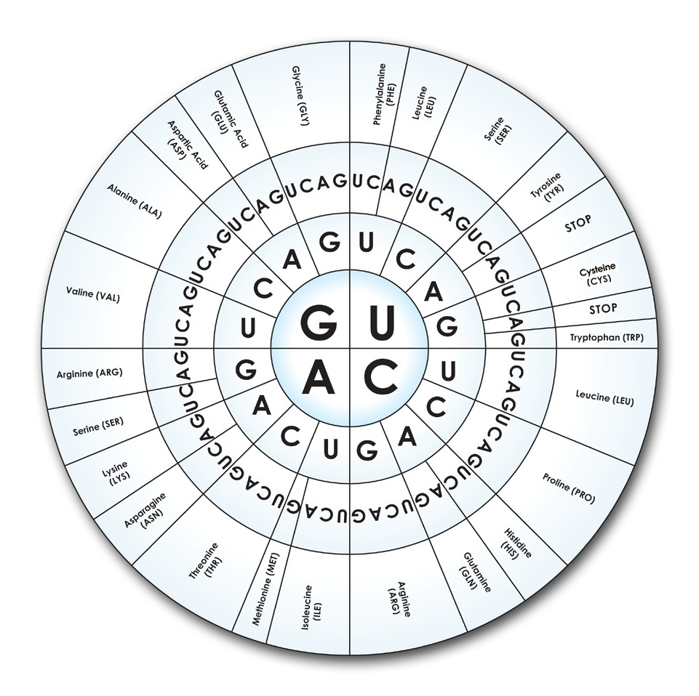

AUTHOR
Ann Brokaw, Rocky River High School, Ohio

