Name:___________________________________________ #__________ Block______________
Biotechnology: DNA Extraction and Electrophoresis
Scroll down to the tab for "Virtual Labs" at http://learn.genetics.utah.edu/
You will be doing the DNA extraction and the Gel Electrophoresis. Complete this worksheet as you walk through the steps of the labs.
DNA Extraction
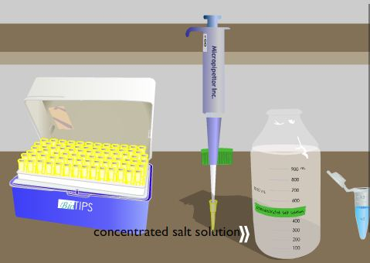
1. List three reasons for extracting DNA from a human subject:
1) ________________________________________________________
2) _________________________________________________________
3) __________________________________________________________
2. Where is DNA found in the cell? _____________________
3. From where do we obtain the cells of our test subject? ___________________________
4. List the four steps needed to extract DNA:
1) ________________________________________________________
2) _________________________________________________________
3) __________________________________________________________
4) __________________________________________________________

5. The lysis solution contains detergent, what will this do to the cell? ________________________________
It also contains proteinase K, what does this do to the cell? ________________________________________
6. What does the salt do to the cellular mixture? _________________________________
7. Why do you need to place a second tube into the centrifuge? ______________________________
After the tube is removed from the centrifuge, what equipment is used to remove the top liquid from the tube? _____________________________________________
What is in this liquid? ____________________________________
8. Isopropyl alcohol causes DNA to do what? _________________________________

Gel Electrophoresis
We will practice loading gels in class. Answer the following regarding what we did. Then, continue your virtual lab at http://learn.genetics.utah.edu/

- What metric unit was used for loading the gel?
- Why must gloves be used?

- Why do the tips need to be changed?

- How are the used tips discarded and why?

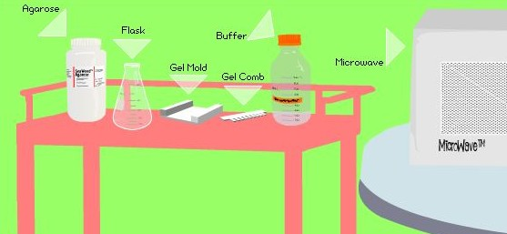

- Gel electrophoresis is used to sort DNA strands according to their __________________
Where do you place the DNA samples on the gel? _______________________________
What makes the DNA move? _____________________
Short strands move [ faster / slower ] than longer strands.

- Place the steps in the correct order (number them 1-5):

______ Load DNA sample into the gel
______ Stain the Gel and analyze results
______ Make the gel
______ Hook up the electrical current
______ Set up gel apparatus

3. In the "Gel Electrophoresis Laboratory", follow the steps to make your own gel, answer the questions as you go.
a) What is agarose made from? ___________________________________
b) Melted agarose is poured into a ___________________________________
c) What is the purpose of the comb? ___________________________________________
d) The black end generates a ______________ charge, the red end a _______________ charge.
e) Which electrode does the DNA migrate toward and why?________________________________________________________________________
f) The bubbles in the electrophoresis indicate what? _________________________________
g) Staining the DNA will make it show up under a ____________________________________ light.

- In the space at right, draw your gel
- Write your size estimates below:

  - Strand 1___________________

  - Strand 2 ___________________

  - Strand 3 ___________________

- Give one reason why a Gel electrophoresis would be used on someone and explain your answer.

