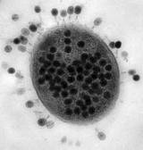
Name: __________________________
#: ______________
AP Biology: Virus Webquest!
- Go to http://www.etymonline.com/index.php?term=virus
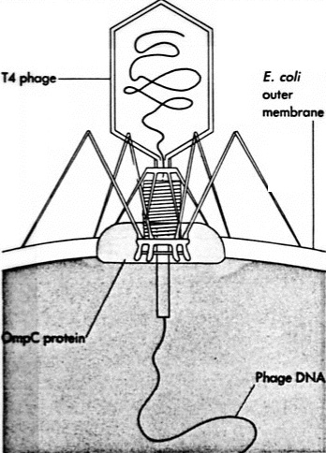
Virus is derived from the Latin word for what? ________________________

- Go to http://micro.magnet.fsu.edu/cells/virus.html

What are the 3 main parts of a virus?
  - _________________________
  - _________________________
  - (and sometimes) ________________________

Label the parts of a bacteriophage: ----------------------------------

- Watch: http://highered.mheducation.com/olc/dl/120078/bio39.swf
Briefly describe the 4 methods of producing a vaccine:
a. ______________________________________________________________________________________________ ________________________________________________________________________________________________
b. ______________________________________________________________________________________________ ________________________________________________________________________________________________
c. _____________________________________________________________________________________________
d. _____________________________________________________________________________________________
Watch: http://highered.mheducation.com/sites/0072556781/student_view0/chapter18/animation_quiz_1.html
Take quiz. Put answers here:
Retroviruses: HIV infection and replication. Go to http://highered.mheducation.com/olc/dl/120088/micro41.swf
or http://highered.mheducation.com/sites/0072556781/student_view0/chapter18/animation_quiz_1.html
- Watch the above animation, take quiz. Answers: Summarize/list the steps that HIV takes to infect a cell and eventually to reproduce. May use back of page.

