Name: ________________________________ # _________

Chapter 2B: Water
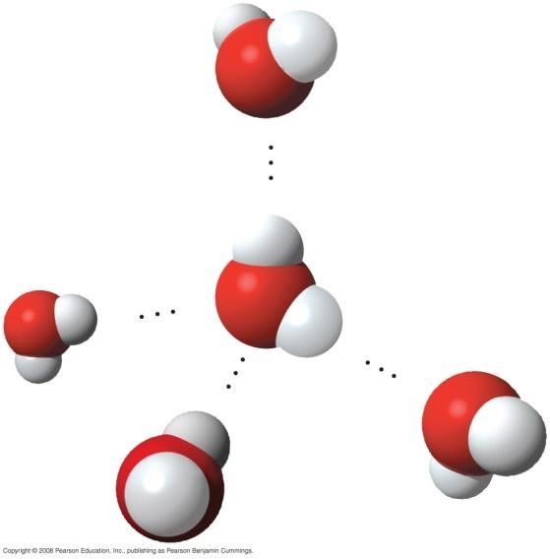
2.5 Hydrogen bonding gives water properties that help make life possible on Earth

1. Study the water molecules at the right. On the central molecule, label oxygen (O) and hydrogen (H).

2. What is a polar molecule? Why is water considered polar?

3. Now, add + and – signs to indicate the charged regions of each molecule. Then, indicate the hydrogen bonds.

4. Explain hydrogen bonding. How many hydrogen bonds can a single water molecule form?

Hydrogen bonding accounts for the unique properties of water. Let’s look at several.

Cohesion
5. Distinguish between cohesion and adhesion.

6. What is demonstrated when you see beads of water on a waxed car hood?

7. Which property explains the ability of a water strider to walk on water?

Moderation of Temperature
9. Water has high specific heat. What does this mean? How does water’s specific heat compare to iron’s?

10. Explain how hydrogen bonding contributes to water’s high specific heat.

11. Summarize how water’s high specific heat contributes to the moderation of temperature. How is this property important to life?

Expansion upon Freezing
13. Ice floats! So what? Consider what would happen if ponds and other bodies of water accumulated ice at the bottom. Describe why this property of water is important.

14. Review and define these terms:
solvent

solution

solute

15. Consider coffee to which you have added sugar. Which is the solvent? The solute?

16. Explain why water is such a fine solvent.

17. Define hydrophobic and hydrophilic.

18. You already know that some materials, such as olive oil, will not dissolve in water. In fact, oil will float on top of water. Explain this property in terms of hydrogen bonding.

Concept 2.6 Acidic and basic conditions affect living organisms

19. What two ions form when water dissociates?

You should have answered “hydronium (H3O+) and hydroxide ions (OH–)” in the preceding question. However, by convention, we will represent the hydronium ion as H+.

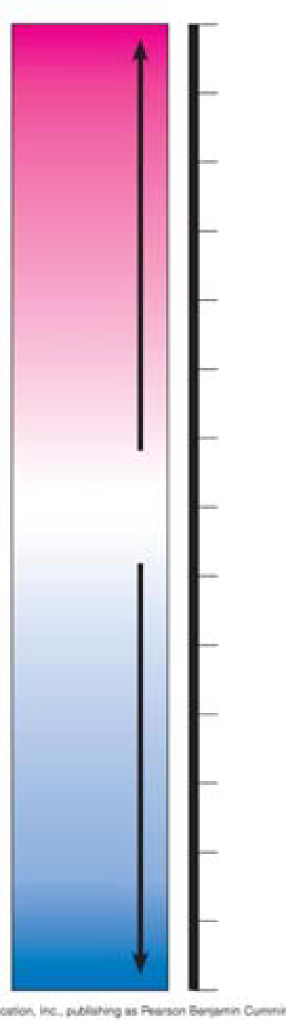
Water, which is neutral with a pH of 7, has an equal number of H+ and OH– ions. Now, define
acid

base

20. On the pH chart, label pH 0–14. Label neutral, acid, base. Indicate the locations of pure water, urine, gastric juice, and bleach.

21. Even a slight change in pH can be harmful! How do buffers moderate pH change?

22. Exercise will result in the production of CO2, which will acidify the blood. Explain the buffering system that minimizes blood pH changes.

