AP Biology – Part 1: Study Guide for Final Exam
(*while this should suffice in preparing for my final exam, it does not include all of the info needed to prepare for AP Exam)
Math Equations on Formula Sheet- *these won’t be emphasized for my final
- Standard Error (Standard Error of the Mean) - (would not have to calculate but need to know how to interpret it and place it on a graph)
- Mean, Median, Mode, Range
- Standard Deviation (would not have to calculate but need to know how to interpret it and place it on a graph)
- Chi-Square
- Law of Addition for 2 events occurring together that are mutually exclusive
- Law of Multiplication for independent events occurring together
- Rate
- Primary Productivity
- Surface Area to volume ratio
- Gibb’s Free Energy
- pH (and calculating H+ or OH- concentrations)
- Water Potential
Intro (Chap 1), Biochemistry and Cells Review
- Levels of life’s organization (listed from largest to smallest)
  - Biosphere – All environments on Earth that support life (Basically, the Earth and the sky above it that has living things occupying it.)
  - Biomes – A group of ecosystems that have similar climates and communities
  - Ecosystem – all living organisms in a particular area as well as the nonliving, physical components they interact with (ex. Sunlight, water, etc.)
  - Community – All living things in an area
  - Population – Single species living in a single area
  - Organism – Single individual
  - Organ System – group of organs working together for a certain function
  - Organ – 1 part of an organ system
  - Tissue – group of similar cells that do a particular function for an organ
  - Cell – Smallest unit of life (All living things are made up of one or more cells) (Can perform all 7 characteristics of MRS. GOCH)
  - Organelle – “organ” of a cell
  - Molecule – cluster of atoms held together by chemical bonds (called a molecule when it’s atoms of the same element, i.e. O2, and a compound when it’s atoms of a different element, i.e. H2O)
  - Atom - basic unit of matter made of dense nucleus (protons and neutrons) with electron cloud around it
    - Subatomic particles = proton (+ charge, in nucleus), neutron (neutral, in nucleus), electron (- charge, in motion outside of the nucleus)
      - For living things, electrons are responsible for the storage and transfer of energy.
- Energy of living organisms
  - Potential energy = energy stored in chemical bonds
  - Kinetic energy = energy involved with the movement of electrons
  - Valence shell = outer electron shell
  - Electronegativity = the desire for electrons
    - Everything wants to have 8 valence electrons (to become a noble gas / stable). The closer an element becomes to getting 8 electrons, the more its desire is to gain an extra electron.
    - Oxygen is the most electronegative biological element (so it is the most reactive element)
- Types of bonds
  - Covalent = sharing of electrons (strongest bond).
    - Polar = unequal sharing of electrons between elements with differing electronegativities
    - Nonpolar = equal sharing of electrons between elements with the same electronegativity
  - Ionic = attraction between cation (positively charged) and anion (negatively charged)
    - Occurs between elements with extremely different electronegativities (generally elements in the 1st and 7th columns)
  - Hydrogen bonds = weak attraction between the partially positive charged hydrogen of one polar molecule to a partially negatively charged element of another polar molecule
    - These are the most biologically important bonds.
    - These bonds are INTERMOLECULAR while the others are INTRAMOLECULAR
  - Van Der Waals Forces = momentary attraction of nonpolar molecules (very weak)
- Water
  - Polar – show using water model
  - 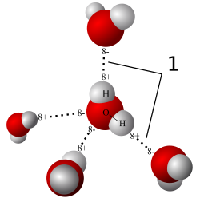
  - All of the following are caused by hydrogen bonds
    - Cohesion - attraction of water to itself
      - Surface tension – strength of water’s surface because separate water molecules are attracted by hydrogen bonds
    - Adhesion - attraction of water to another polar molecule
    - Capillary action – the ability of water to “climb” a thin tube; caused by a combination of cohesion and adhesion
  - Temperature Regulation – water can absorb and store large amounts of heat before a change in temperature due to the breaking and reforming of hydrogen bonds
  - Evaporative cooling (as water leaves, it takes heat with it. Surface left behind is cooler)
  - Liquid water vs. ice (density)
  - Universal solvent
    - Solvent – liquid doing the dissolving
    - Solute – solid being dissolved
    - Solution – Solute dissolved in a solvent
  - Hydrophilic vs. hydrophobic
    - Hydrophilic = polar molecules have charges so they can mix with water (their charges will attract to those on water). This means they will DISSOLVE in water.
    - Hydrophobic = nonpolar molecules have no charges so they cannot mix with water. This means they will NOT dissolve in water.
- Chemistry terminology
  - Mole
  - Molarity (Concentration)
  - Disassociation (will use for “i” in solute potential for water potential – will be 1 for sugars because they don’t disassociate and 2 for ions because they do).
  - Buffer
- Organic chemistry - carbon containing molecules
  - All living things are made of carbon
  - Carbon has 4 valence electrons so is very versatile in the types of bonds it can form
  - Hydrocarbons – composed of only carbon and hydrogen
    - Nonpolar
  - Functional Groups
    - 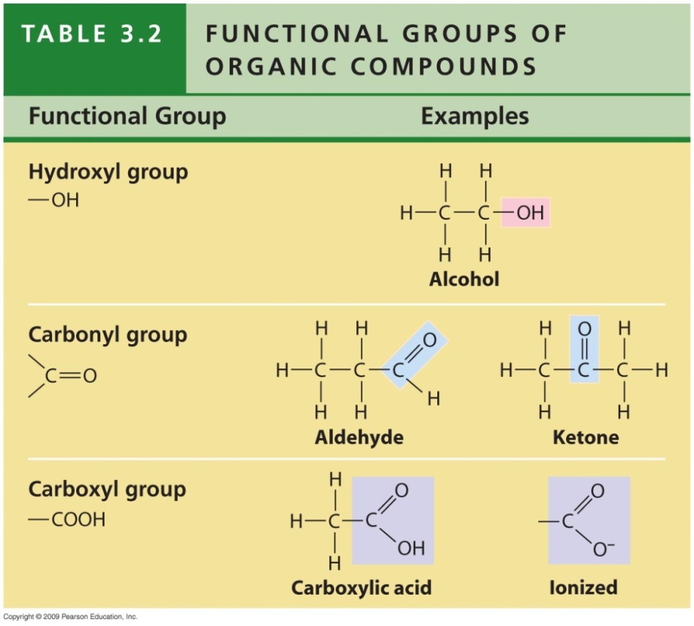
    - 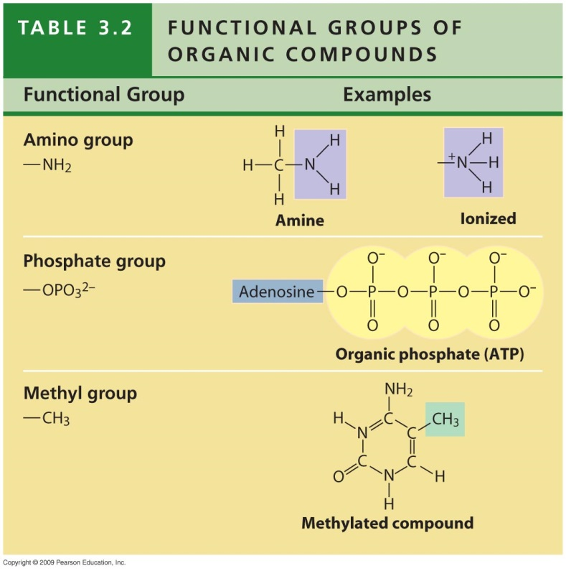
  - Macromolecules – built by dehydration and broken down by hydrolysis
    - Carbohydrates (General formula = CH2O)
      - Carbo (C) Hydrate (H2O)
      - Used for immediate energy (these are our primary energy source)
      - Most end in –ose

    - Lipids
      - All lipids are nonpolar (hydrophobic)
      - Stored energy (because there are many hydrogens that are willing to donate their electrons)
      - Types: Triglycerides (fats – unsaturated vs. saturated), phospholipids, oils, waxes
    - Protein
      - Go over: Levels of protein structure
        - Denaturation – protein loses shape / lose function due to temperature, pH, etc.
          - Primary structure is not broken because covalent bonds are strong
      - Workhorse of cell – perform basically all functions in cell (or make the thing that does)
      - Coded for by DNA
    - Nucleic Acids
      - DNA and RNA – carriers of hereditary information
        - Sequence codes for proteins
        - Pyrimidine vs. Purine bases
          - Purines = Adenine and Guanine (Purines Are Good)
          - Pyrimidines = Cytosine and Thymine (DNA); Cytosine and Uracil (RNA)
    - Monomers
      - Carbs = monosaccharide
      - Proteins = amino acids
      - 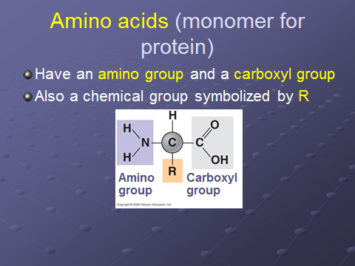
      - Nucleic acids = nucleotide
      - Lipids = no true monomer because all lipids are different. Grouped together because they’re all nonpolar/hydrophobic
- Cells – the smallest thing that can perform all of the processes of life (MRS. GOCH)
  - Metabolism
  - Reproduction
  - Stimulus (Response to)
  - Growth and Development (growing from an infant to adult)
  - Organization of cells
  - Change over time (evolution)
  - Homeostasis
- Open vs. closed system
  - Open systems exchange energy and matter with the environment while closed systems do not (we are open systems as we exchange heat, oxygen, water, food, etc.)
- Prokaryotic Cells (pro = before and kary = nucleus so these are cells with no nucleus)
  - Unicellular
  - Cellular components
    - DNA in nucleoid region
    - Cell membrane, ribosomes, proteins, cytoplasm, cell wall, capsule, pili
      - 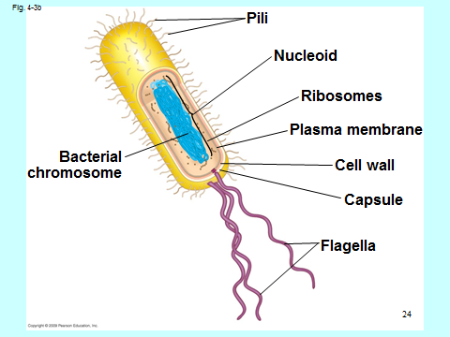
  - Shapes
    - Cocci = round
    - Bacilli = rod
    - Helical = spiral
  - Gram stain = used to tell the differentiate between different types of bacteria
- Eukaryotic cells (eu=true and kary=nucleus so these are cells with a nucleus)
  - Cell components
    - Nucleus, Nucleolus, ribosome (free in cytoplasm and bound to RER), ER (smooth and rough), Golgi apparatus, lysosome, peroxisome, vacuole, vesicle, mitochondria, chloroplast (plants), cytoskeleton (microfilaments, intermediate filaments, and microtubules), cell wall (plants, fungi), extracellular matrix
    - The endomembrane system is composed of the different membranes that are suspended in the cytoplasm within a eukaryotic cell. These membranes divide the cell into functional and structural compartments, or organelles.
    - Differences in animal and plant cells
      - Plants have chloroplast, cell wall, and central vacuole
    - Animal cell (next page)
    - 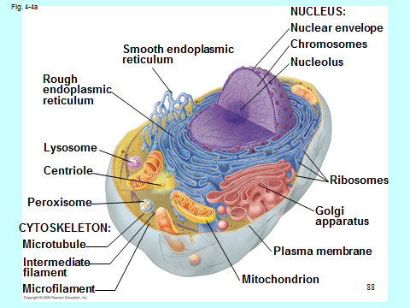
    - Plant cell
    - 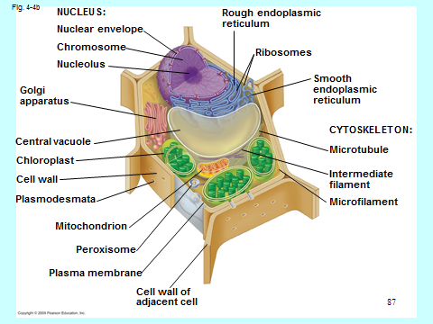

- Endosymbiosis – evolution of eukaryotes from prokaryotes
- 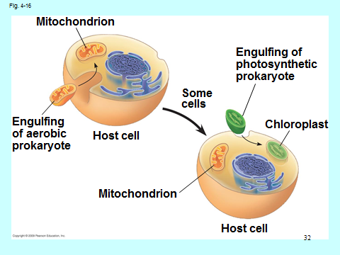
- Cell Membranes – surround the outside of the cell; controls what comes in and out – use model to demonstrate structure
  - Phospholipids, proteins, cholesterol
  - 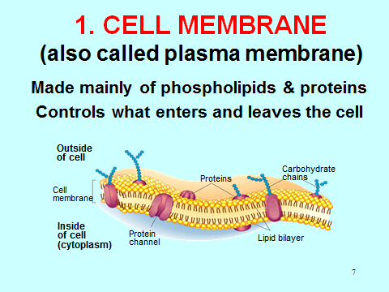
  - Transport across a cell membrane
    - Diffusion – no energy, movement of small/nonpolar molecules down their concentration gradient directly across the phospholipid bilayer
    - Facilitated diffusion – no energy, movement of large/polar molecules down their concentration gradient with the help of a transport protein
    - Osmosis – the diffusion of water
      - Hyper, Hypo, and Isotonic
        - Water flows from hypo to hyper
      - Turgid, Flaccid, Plasmolysis
      - Water potential – discuss and calculate
        - Likelihood of water to leave something and do work (kinetic energy through movement)
        - Water moves from high water potential to low WP
    - Active Transport – the movement of molecules against their concentration gradient with the aid of transport proteins using ATP
      - Bulk transport (vesicular transport)
        - Exocytosis
        - Endocytosis (phago- and pino-)
        - Receptor mediated endocytosis
  - Membrane potential – potential energy across a cell membrane created by a difference in charge (due to a difference in ion concentration)
    - Voltage gradient
    - Examples
      - H+ pump in cell respiration and photosynthesis
      - Na+/K+ pump in neurons
  - SA:V ratio (SA = membrane and V = cytoplasm)
    - Cells want large SA to volume ratio so that they can efficiently diffuse needed materials into the cell and waste out of the cell
    - Cells maintain a high SA:V ratio by being smaller and having folds
    - Calculating SA:V ratio (formula sheet)

Bioenergetics
- Metabolism – chemical conversions in your body (breaking down food for energy and using the materials from that food to build up yourself)
  - Catabolism (digestion)
    - Hydrolysis – putting in water to break covalent bonds
    - Exergonic – releases energy (exit energy); This means there is a negative DeltaG
    - Spontaneous
    - Break down like a CAT
  - Anabolism (building up from your food)
    - dehydration – taking out water to make covalent bonds (think anabolic steroids)
    - endergonic – requires energy (enter energy); This means there is a positive DeltaG
    - Non-spontaneous
    - build up like an ANT
- Thermodynamics
  - 1st law – conservation of energy
  - 2nd law – entropy (disorder) constantly increasing as high quality sunlight energy is taken in by plants and low quality heat is given off (also animals taking in high quality energy in food and releasing heat)

- Gibb’s Free energy
  - Energy available to do work
  - DeltaG = free energy (so the energy that is released to do work), DeltaH=Enthalpy (stored, organized energy – can’t be used because it is still ordered and stored – think of a cheeseburger), DeltaS = entropy (disorder – as this increases there is more energy that is escaping that can be captured to do work – think of the cheeseburger as it comes out your back end {in other words, you’ve already taken the energy to use it})
  - DeltaG = DeltaH – T*DeltaS
    - T in Kelvin (C + 273)
  - (+) DeltaG = NONspontaneous BECAUSE PUTTING ENERGY IN
    - This means that Enthalpy is HIGHER than Entropy (so energy is still stored – In other words, you still have a cheeseburger setting there so you haven’t used it for anything)
  - (-) DeltaG= spontaneous because energy is being release
    - This means Enthalpy is LOWER than Entropy (so energy is released – In other words, you have eaten the cheeseburger, and you can use the energy.)

- ATP = adenosine triphosphate
- 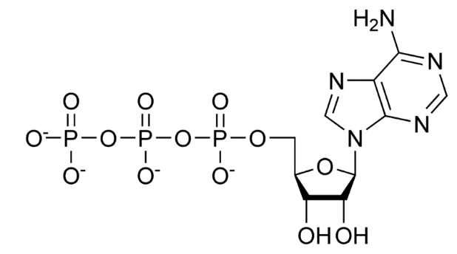
  - 3 phosphate groups are negative – They are bonded together, but their negative charges repel each other (so the bond is very unstable). The phosphate-phosphate bonds is why this is the UNIVERSAL energy source (because it can be broken very quickly and releases lots of energy). Remember though, glucose has much more energy than ATP (1 glucose = 36 ATP). It’s just the glucose would take too long to break down to use immediately.
  - Phosphorylation – Removing of phosphate from ATP (hydrolysis, exergonic) and using this energy to stick this phosphate to another molecule. The negative charge on the phosphate causes a shape change in the phosphorylated molecule, making it more likely to do work.
  - Kinase = Enzyme that turns things ON by PHOSPHORYLATING them
  - Phosphatase = Enzyme that turns things OFF by DEPHOSPHORYLATING them
- Enzymes (mainly proteins) – biological catalysts (speed up reactions)
  - Structure – active site, allosteric site
  - Substrate – molecule being worked on by the enzyme
  - Induced fit model - Each enzyme is shaped to fit a single substrate. Once they have bound together, the enzyme is INDUCED to change it shape so that it FITS the substrate perfectly. This causes a strain on the bonds of the substrate make it easier for hydrolysis to occur.
    - The bonds between enzymes / substrates must be weak so they can be separated once the reaction is over. This means that the bonds holding the 2 will be ionic, hydrogen, or Van Der Waals.
    - 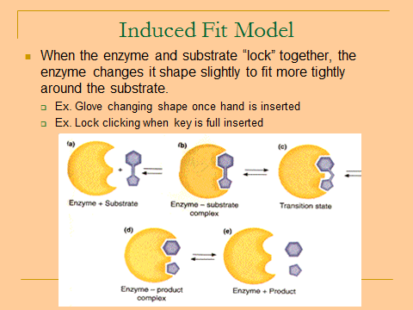
  - Resuable
  - End in –ase and the first of the name tells you what it works on. (Ex. Lipase is an enzymes that breaks down lipids)
  - Lowers activation energy (the energy needed for a reaction to occur).
    - Does so by orienting molecules so it is easier for the reaction to occur (grab-grab-pair or grab-grab-tear)
    - 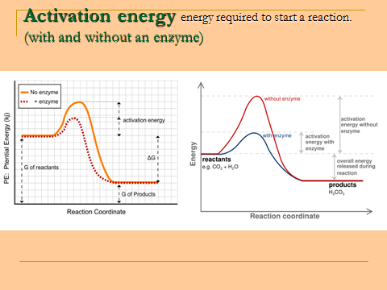
  - Environmental factors that affect enzyme’s optimal rate
    - Temperature, pH, salt concentration
    - 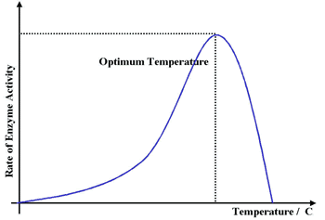
    - 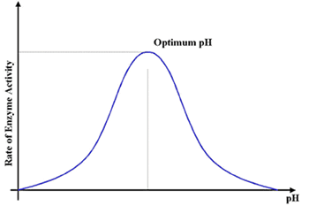
  - Substrate and Enzyme concentration also affect the rate of the reaction
    - This graph is saying at the amount of substrate increases, the reaction goes faster as the enzymes works faster (enzymes are reusable). Eventually, the rate levels off because the enzyme is constantly working (no lag time between binding to a new substrate) so the reaction won’t go faster even if you add more substrate for the enzyme to work on. The rate levels off at 0.3 which is the max rate for this reaction (vmax)
    - 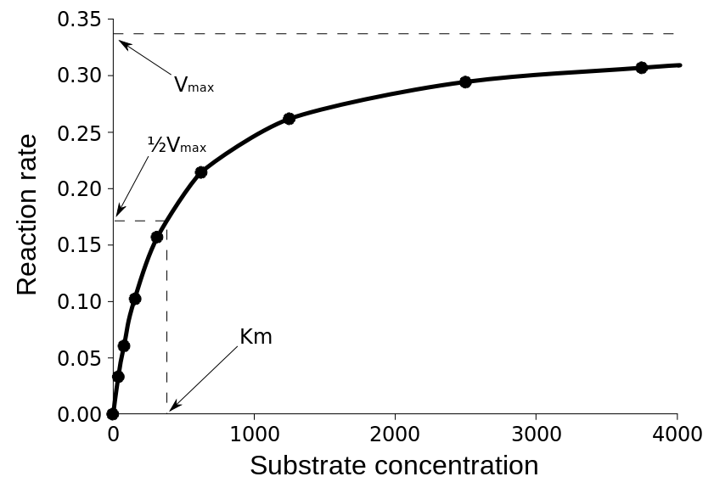
    - This graph looks like it says the same thing, but you must look at the labels on the axis to see the difference. Here the graph shows the amount of product formed vs. time. Here, the rate becomes 0 as no product is being formed after about 160 seconds. This is because all of the substrate available has already been converted to product and there is nothing for the enzyme to work on.
    - 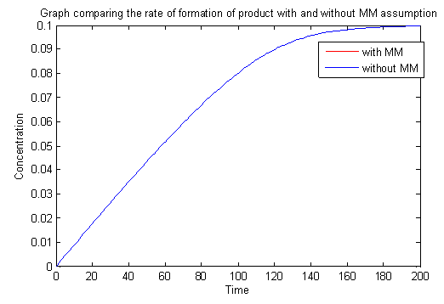
    - Inhibitors
      - Competitive inhibitor – shaped like the substrate, compete for the active site, slow down a reaction
      - Non-competitive (allosteric) inhibitor – not shaped like the substrate, binds at the allosteric site and changes the shape of the active site of the enzyme, stops a reaction
    - Feedback inhibition
      - Negative feedback loop. Often, the product made by an enzymatic reaction is a noncompetitive inhibitor of the reaction itself. The product will bind to the enzyme and shut it down because you do not need any more of the product at that time. When you use it all up, you will break down the product attached to the enzyme which turns it back on to make more.
- Photosynthesis – Converting sunlight (electromagnetic energy) to chemical energy (glucose) – Remember the 1st law of thermodynamics. Plants cannot create energy, only convert it.
  - Autotroph vs. heterotroph
  - Chloroplast structure
  - 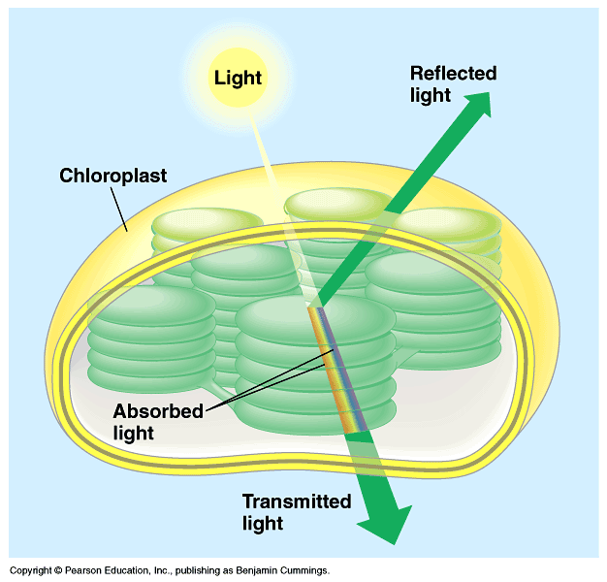
  - Overall equation
  - 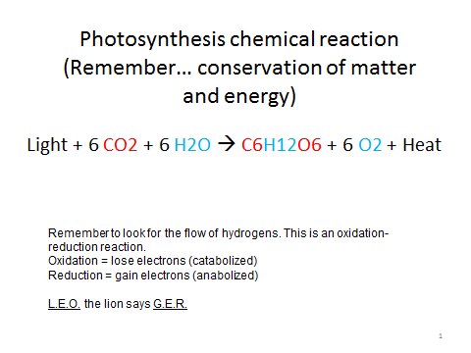
  - 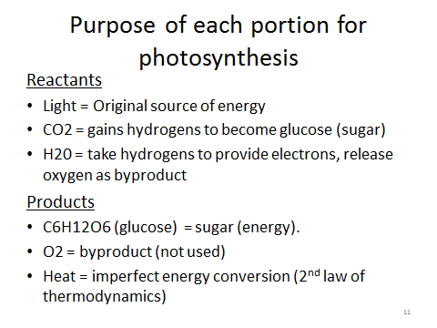
  - Absorbed vs. reflected light
    - Photosystems purpose
    - Pigments
      - Chlorophyll A- just know this one
      - Chlorophyll B
      - Carotenoids
  - 2 parts of photosynthesis: 1) light reactions and 2) Calvin Cycle
    - Light reactions
      - Non-cyclic vs. cyclic electron flow
      - 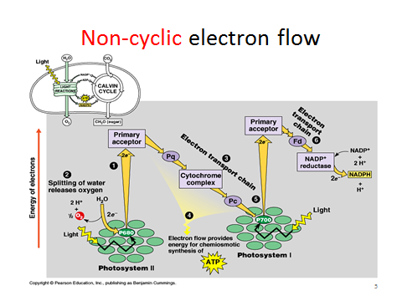
        - Water in stroma hit by sun (breaks into H+[+ because give off electrons] and O2[waste product]
        - 2 electrons are given to Mg of Chlorophyll A in photosystem 2 (all other pigments in the photosystem bounce light to chlorophyll A)
        - electrons of chlorophyll A now become excited, escape, and mow down the Electron transport chain (a series of REDOX reactions)
          - movement of electrons used to power cytochromes to pump H+ (that was provided by water) into confined thylakoid space.
            - This creates membrane potential due to the voltage gradient created
        - H+ comes back into stroma through ATP synthase to make ATP
          - This is an example of energy coupling. Kinetic energy of H+ moving through ATP synthase powers the anabolic creation of ATP from ADP and a phosphate.
        - Electrons accepted by Mg of chlorphyll A in photosystem I.
        - Electrons excited again. They can go back through the first electron transport chain (cyclic flow) or continue through a new electron transport chain that ends at NADP+ to make NADPH (electron carrier)
        - End product of light reactions = ATP and NADPH to power the Calvin cycle
      - 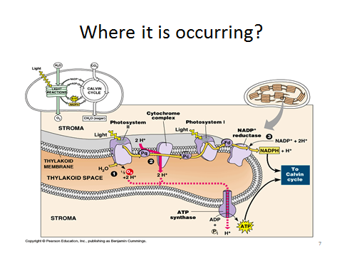
    - Calvin cycle
      - Rubisco combines3 CO2 w/ 3 RuBP (5 carbon chain)
      - This 3 6-carbon molecules are unstable so they break into 6 3-C molecules
      - Use 6 ATP and 6 NADPH to bend twice to make G3P
      - Take 1 G3P out and recycle other to recreate 3 RuBPs
        - Takes 3 extra ATP
      - Do cycle twice to take out 2 G3P. Combine to make 1 glucose
      - Called “dark reactions” or “light independent reactions” because it doesn’t directly require light. Even so, it also occurs during the day because it must have the products (ATP and NADPH) made by the light reactions during the day.
- Photorespiration – using O2 instead of CO2 during Calvin Cycle (no glucose produced)
  - Rubisco uses O2 instead of CO2
    - Rubisco evolved very early on. There was no oxygen early in Earth’s history because there were no photosynthetic plants to make it; therefore, there would have been no evolutionary selection to make Rubisco not be capable of binding with oxygen.
  - C3 plants – normal plants
    - In hot, dry places they start running out of water due to transpiration through their stomata. They have to close their stomata so they can’t bring in more CO2.
    - Rubisco begins to use O2 instead because it is in higher concentration. Remember O2 is a waste product of photosynthesis so plants are always making it. If the stomata are closed, the O2 can’t leave.
    - Plant eventually starves to death because it can’t make more glucose.
  - C4 plants – Do photosynthesis in a different location (bundle sheath)
    - Like dry climates
    - O2 can’t enter here so Rubisco always uses CO2 even if there is much more O2 in the plant
  - CAM (Crassulacean acid metabolism) plants – open stomata at a different time
    - desert plants
    - open stomata at night so don’t lose H2O to transpiration
    - Store CO2 as crassulacean acid (This is because CO2 would eventually start diffusing back out of the plant otherwise. Remember diffusion occurs from high to low concentration. If the concentration got high in the plant, it would diffuse out).
      - Crassulacean acid is too large to diffuse back out of stomata so carbon source stays in leaf
    - Break down Crassulacean acid to CO2 during day when stomata close and light is available to make ATP and NADPH through light reactions
- Cell respiration
  - Equation is reverse of photosynthesis (photosynthesis is making the food and cell respiration is breaking it down)
  - 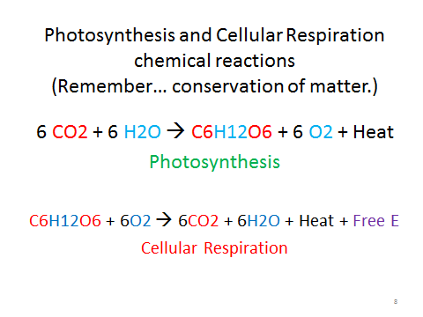
  - Catabolism of stored energy (carbs/fat) to make ATP
    - This is an example of energy coupling
  - Steps if oxygen is present in eukaryotes:
    - Glycolysis – breaking glucose down to Pyruvate
      - All organisms do this for energy because it happens in the cytoplasm
      - Makes some NADH and ATP (through substrate level phosphorylation) but main purpose is to provide pyruvate
      - PHOSPHOFRUCTOKINASE = important enzyme involved in glycolysis. This is the enzyme that makes the “committed step”. In other words, it essential in the breakdown of glucose. ALL organisms have this because ALL organisms do glycolysis.
    - Kreb’s (Citric Acid Cycle) – makes NADH and FADH2 (electron carriers)
      - Only occurs if O2 is present. If so, pyruvate will be converted to Acetyl CoA, taken into the inner mitochondrial space, and broken down entirely to CO2 (notice the H’s are being pulled off because these are what give up their electrons)
      - Makes some NADH (like NADPH for photosynthesis – think “P” for photoynsthesis {even though it actually stands for phosphate})and ATP (through substrate level phosphorylation - EXPLAIN) but main purpose is to provide electron carriers for oxidative phosphorylation
    - Oxidative phosphorylation (electron transport chain)
      - occurs on inner mitochondrial membrane using cytochromes
        - All E.T.C.’s occur on a membrane because they all involve using the energy released during REDOX reactions to pump H+ into a confined space.
        - In this case, the confined space is the intermitochondrial space (in chloroplast it was the thylakoid space)
      - O2 is at the end of the ETC because it is the most electronegative.
        - This allows the chain to go longer, more kinetic energy to be released during the movement of electrons, and more pumping of H+ into a confined space to create a greater voltage gradient (so more ATP made)
  - Steps if no O2 present:
    - Fermentation
      - Alcohol fermentation (yeasts)
        - converting pyruvate to ethanol
      - Lactic acid fermentation (mammals)
        - converting pyruvate to lactic acid
    - No oxygen so pyruvate not converted to Acetyl CoA and brought into the mitochondria.
    - In both cases, pyruvate is converted so that the electrons can be pulled off of NADH to regenerate the electron carrier (to restart the process)

(Cell Cycle / Communication)
- Cell Cycle
  - DNA is more stable than RNA (so it is the principle organic molecule used for inheritance)
    - RNA does not have as many proofreading mechanisms; therefore, there are many more mutations
  - All cells do the same 3 basic functions to reproduce:
    - Replicate DNA so that both new cells have the code to make proteins
    - Replicate cytoplasmic contents so that both new cells have everything they need to operate
    - Divide cytoplasm / cell membrane to create 2 new cells
  - Prokaryotes
    - Reproduce by binary fission (basically splitting in 2 to make clones)
    - Their 1 circular chromosome is copied
  - Eukaryotes
    - Eukaryotes are much more complex (nucleus, multiple chromosomes, membrane-bound organelles) so their process of division is more complex
    - DNA forms
      - Chromatin – DNA is loosely associated with histones (not wrapped around them). It can be used to copy itself or to make proteins in this format but not divided evenly. Looks like a bowl of spaghetti.
      - Chromosome – DNA is tightly wrapped histone proteins. It cannot be used but can be divided easily.
        - Differences in prokaryotic and eukaryotic chromosome
          - Prokaryotic = 1 circular chromosome, no histone proteins
          - Eukaryotic = multiple, linear chromosomes
            - Parts = sister chromatids, centromere, telomere, histone, nucleosome, kinetochore
    - 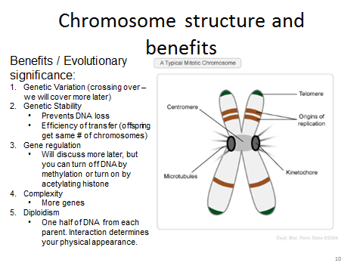
    - Genome – all of the genes of an organism
    - Somatic vs. germ cells
      - Somatic cells = body cells
        - These are diploid (have both members of homologous pair from mother and father).
      - Germ cells = will divide to create gametes (sex cells)
        - These are haploid (have only one member of a homologous pair)
  - Stages of cell cycle
    - Interphase (inter means in between so in between cell divisions)
      - Substages
        - G1 = normal growth and activity
        - S = synthesis of new DNA
        - G2 = preparation for division
      - DNA in chromatin form
      - Most cells spend the majority (approximately 90%) of the time in this phase
    - Mitosis – nuclear division (PMAT). DNA in chromosome form.
      - Explain each stage orally using the terms centriole, kinetochore, spindle apparatus, metaphase plate, centromere, motor proteins:
        - Prophase
        - Metaphase
        - Anaphase
        - Telophase
      - Cytokinesis – division of the cytoplasm
        - Cleavage furrow = pinching of cell membrane in animals
        - Cell plate = creation of a new cell wall between cells in a plant
      - G0 = stage whenever a cell is not going to divide but rather stay in interphase forever (does not go to S phase)
    - Regulating the cell cycle
      - Checkpoints
        - 1st = In between G1 and S phase. Check to make sure DNA is okay. Point of no return.
        - 2nd = In between G2 and Mitosis. Check to make sure you have 2 of everything and are ready to divide.
        - 3rd = End of metaphase. Make sure all chromosomes are attached to a spindle fiber and that the chromosomes are at the metaphase plate ready to be divided. “Kinetochore signal”
      - Checkpoints are managed through the production of cyclin.
        - Cyclin binds to cyclin-dependent kinase (remember kinase is an enzyme that phosphorylates things). This particular kinase is typically inactive. Cyclin binds to its allosteric site to change it to its active form.
        - The combination of CDK and cyclin is called MPF (mitosis promoting factor or maturation promoting factor). MPF will phosphorylate things to cause the changes that occur from interphase to mitosis (breaking down the nucleus, building spindle fibers, DNA coiling around histones to create chromosomes, etc.)
        - CDK is an enzyme so it’s always present (it is reusable). Process is turned on or off because cyclin is only made from S phase to Anaphase. It is made starting at S phase because we have passed the checkpoint of no return and we know we are going to divide. It is no longer made after anaphase because the DNA is separated, and we are ready to go back to being normal cells. To end cell division, cyclin must be degraded in order to turn off MPF (to remove cyclin from CDK).
    - Density dependent inhibition and anchorage dependence
    - 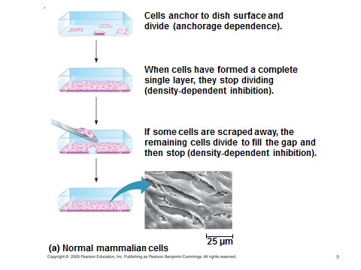
    - Cancer – abnormal growth, no checkpoints
    - Benign vs. malignant tumor
    - 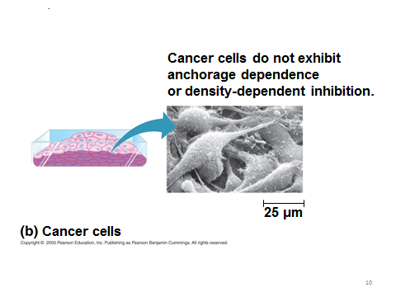
- Cell communication
  - Types
    - Direct
    - 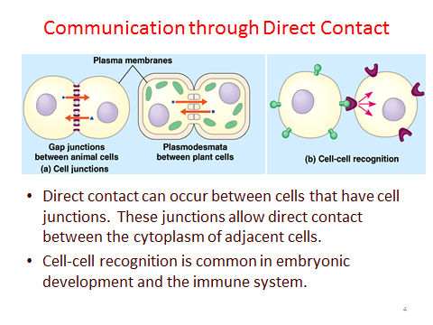
    - Local (paracrine)
    - 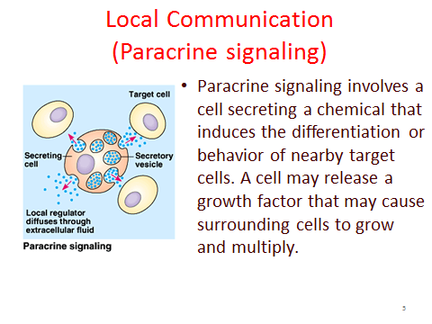
    - Long distance
      - Hormones
      - 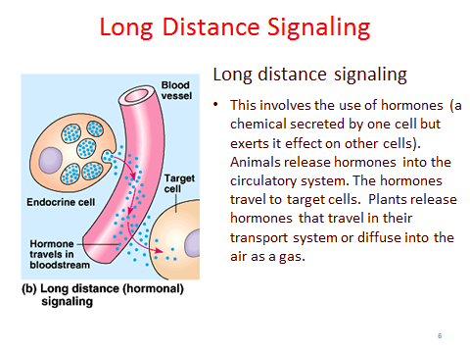
      - Pheromones
  - Signal transduction pathway
    - 1. Reception
      - Ligand binds to receptor (1 ligand goes to 1 type of receptor)
      - Causes conformational shape change in receptor
      - Types of Receptors.
        - G-Protein Linked Receptor (most common)
          - Ligand attaches to G-Protein linked receptor which changes shape
          - Shape change causes phosphorylation of GDP to GTP on G-protein (similar to ADP to ATP) which activates G-protein
          - Activated G-protein travels and turns on the appropriate enzyme or protein
        - Tyrosine-Kinase receptor (remember that kinase = enzyme that phosphorylates something)
          - Works in growth and emergency repair because it phosphorylates 6 things at once (so works faster)
          - Ligand binds to two separate tyrosine kinase receptors. They join to form a dimer.
          - This timer is phosphorylated by 6 different ATP.
          - This receptor acts directly as an enzyme (which is different than a G-protein linked receptor which simply turned on the G-protein)
        - Ion Channels / receptors
          - ligand gated means ligand binds to causes shape change in receptor
          - voltage gated is that the difference in voltage
          - allow for flow of ions in or out of cell through facilitated diffusion
            - Ex. Na+ and K+ channels in neurons
        - Intracellular receptors
          - Other 3 are membrane receptors for polar ligands
          - These are for nonpolar ligands that travel through the phospholipid bilayers.
          - Usually transcription factors (cause mRNA to be made from DNA)
            - remember transcription is DNA to mRNA
    - 2. Transduction – changing of information received by receptor to something the cell can understand
      - changing shape of receptor starts a SERIES of reactions in the cytoplasm.
      - Purpose
        - amplify signal (if you turn on several enzymes that continually work over and over then the binding of 1 signal can be repeated thousands of time)
        - multiplicity = 1 ligand can bind to 1 receptor but cause many different responses
          - This depends upon the proteins that are turned on in the transduction pathway within the cell
        - control = there are several checkpoints along that way where the signal can be assessed to make sure it is working properly
      - Second messengers
        - Relay message in the cytoplasm (turn on the transduction pathway)
        - Cyclic AMP (cAMP)
        - Ca2+ and IP3 (involved in muscle contraction)
      - Protein Kinase Cascade
        - Kinases are enzymes that turn on processes through phosphorylation.
        - Many transduction pathways use these (and would be turned on by secondary messengers)
      - Protein Phosphatase
        - Turn off processes by de-phosphorylating molecules (opposite of kinase)
    - 3. Response = Action performed by cell because of transduction pathway
      - If it is a polar ligand accepted by a membrane bound receptor protein, it usually turn on/off a process by activation or deactivation of an enzyme
      - If it is nonpolar ligand accepted by a intracellular receptor protein, it usually is a transcription factor that will turn on or off gene expression (the making of mRNA from DNA)

(Genetics)
- Mitosis vs. Meiosis
