Name________________ # ____ Biology Exploration & Study Guide
Cell Metabolism: Cellular Respiration

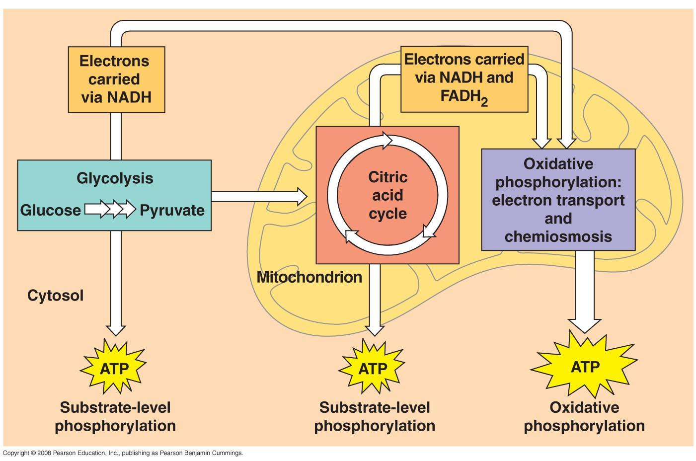
Key Concepts:
- Catabolic pathways yield energy by oxidizing organic fuels
- Glycolysis harvests chemical energy by oxidizing glucose to pyruvate (pyruvic acid)
- After pyruvate is oxidized, the citric acid cycle (Kreb’s cycle) completes the energy-yielding oxidation of organic molecules
- During oxidative phosphorylation, chemiosmosis couples electron transport to ATP synthesis

Read:
- Chapter 9

Key Terms: Here is a list of key terms and concepts you will hear about and see during the chapter readings. Get to know them!

Cellular respiration | NAD⁺ / NADH | Acetyl CoA | Phosphofructokinase
Aerobic respiration | FADH / FADH₂ | Citric Acid (Kreb’s) Cycle | Allosteric feedback
Fermentation (anaerobic) | Oxidative phosphorylation | Electron Transport Chain
Redox reactions | Substrate-level phosphorylation | Chemiosmosis
Oxidation | Glycolysis | ATP synthase
Reduction | Pyruvate (pyruvic acid) | Proton-motive force

Exploration and STUDY Questions:

The Principles of Energy Harvest
- In general terms, distinguish between fermentation and cellular respiration.
- Define oxidation and reduction.
- Use either the equation for photosynthesis or cellular respiration to illustrate how redox reactions are coupled together. Create a diagram to support your answer.
- The processes of oxidation and reduction are critical to the success of metabolic processes such as cellular respiration and photosynthesis. Explain where oxidation and reduction occur during the three major stages of cellular respiration:
  - Glycolysis
  - Krebs Cycle
  - Oxidative phosphorylation
- Describe the role of NAD⁺ in cellular respiration.
- Why do hydrogen atoms accompany electrons as they are transferred in biological systems?
- In fermentation, pyruvate becomes reduced. Explain why this is necessary.
- How is respiration regulated via feedback mechanisms?

Overview of Cellular Respiration
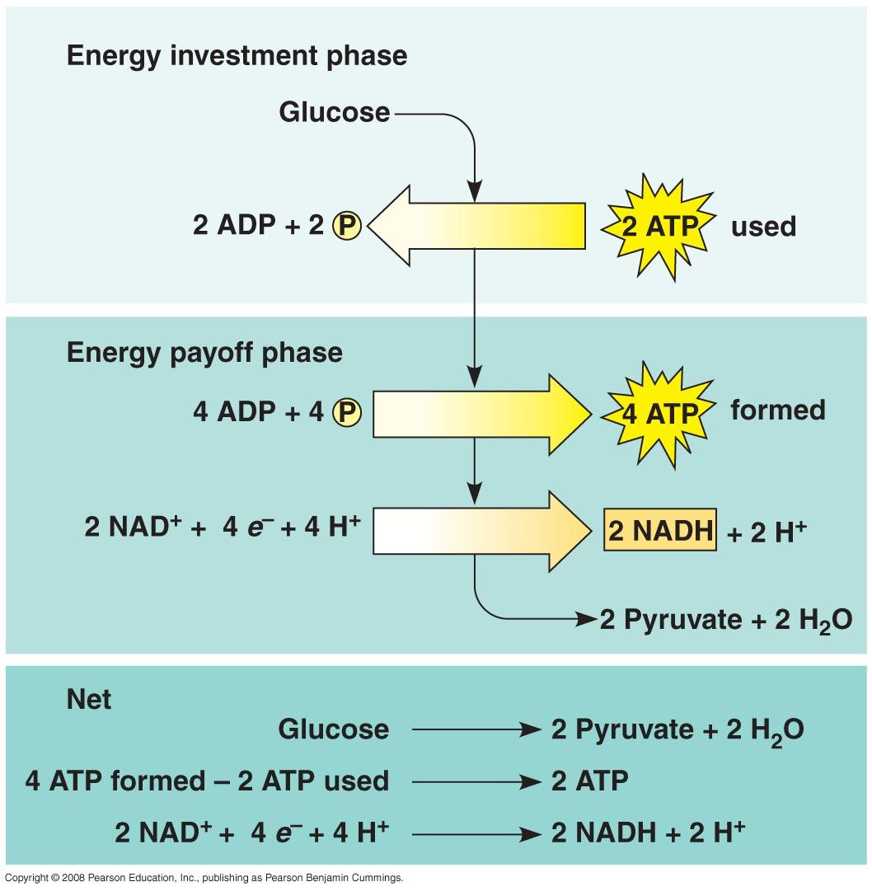
- Name the three stages of cellular respiration and state the region of the eukaryotic cell where each stage occurs.
- Sketch a ‘typical’ mitochondria and label the following parts: outer membrane, inner membrane, cristae, inner membrane space, matrix. On your drawing indicate where the Citric Acid Cycle and the Electron Transport Chain operate in the mitochondria.

Glycolysis
- The process of glycolysis does not require oxygen in order to occur. Explain what this tells us about the evolutionary history of this metabolic process.
- List the reactants and products and their quantities for glycloysis.
- State the net gain of ATP from glycolysis and explain how you arrived at that number.

Intermediate Step
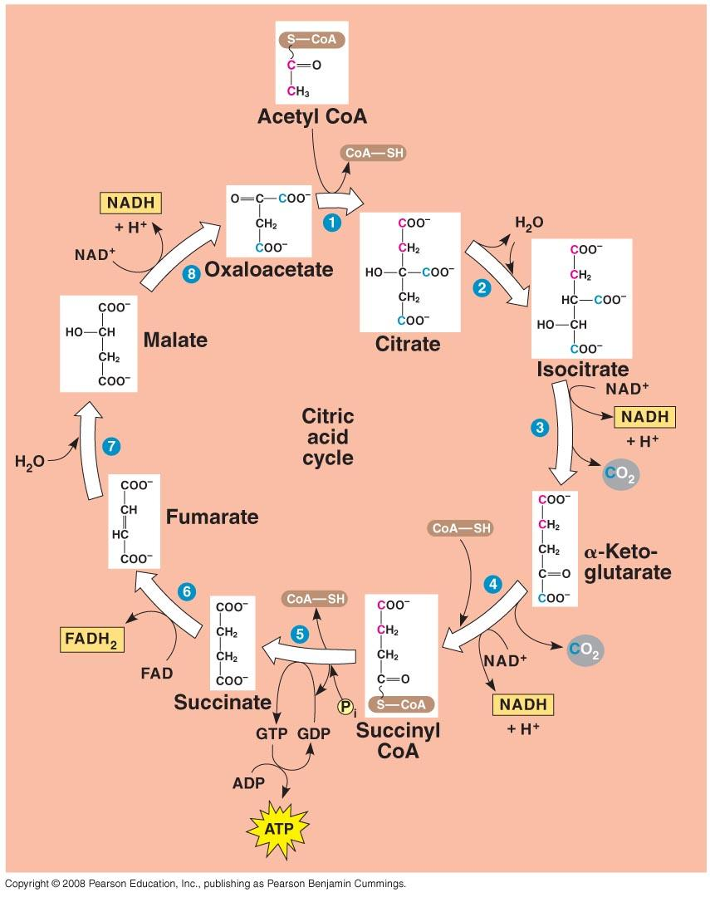
- Describe where pyruvate (pyruvic acid) is oxidized to acetyl CoA, what molecules are produced, and how this process links glycolysis to the citric acid cycle.

Citric Acid Cycle
- List the products and their quantities for one “turn” of the citric acid (Krebs) cycle.
  - Products = ____ ATP, ____ CO₂, ____ NADH, ____ FADH₂
  - Explain why it is called a cycle.
  - How many “turns” does the cycle take for each glucose molecule? Explain.
- At the end of the citric acid cycle, explain what has happened to the carbon atoms from the original glucose molecule.

Electron Transport Chain

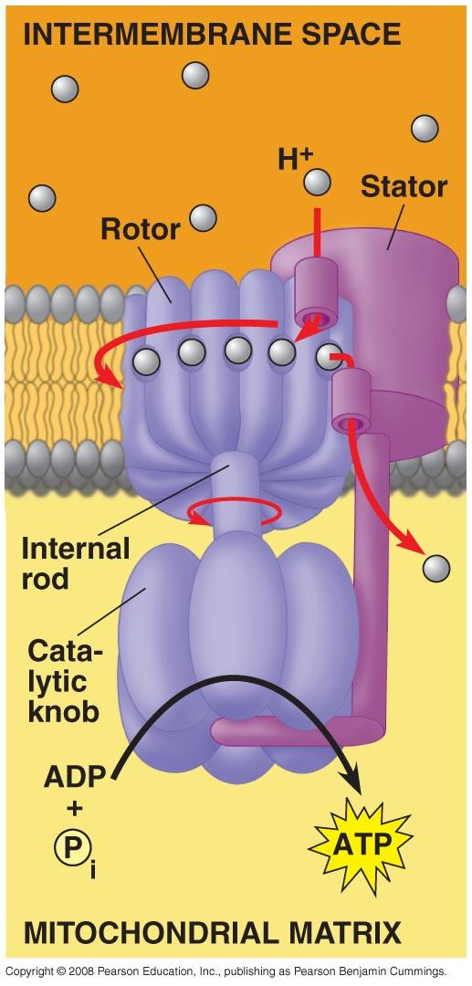
- Identify what delivers the electrons for the electron transport chain.
- Identify the final electron acceptor for cellular respiration. Explain what happens if this final electron acceptor is absent.
- List the two final products of the electron transport chain.
- As the electrons take an exergonic “slide” down the electron transport chain they produce a proton gradient in the inner membrane space of the mitochondria. Explain how this proton gradient is created and why it leads to a buildup of potential energy.
- Cut out Figure #1 at the end of this handout and paste it into your notebook. Fill in the diagram AND summarize, in your own words, how oxidative phosphorylation uses chemiosmosis coupled with the electron transport chain to produce ATP.
- Cut out Figure #2 at the end of this handout and paste it into your notebook. Fill in the diagram AND summarize, in your own words, aerobic respiration and the net ATP yield from the oxidation of a glucose molecule.
- Estimate the efficiency of aerobic cellular respiration of a molecule of glucose:
- Energy of formation of ATP from ADP: ~ + 57 KJ/Mol (~ + 7.3 kcal)
- Energy of combustion of glucose: ~ - 2805 KJ/Mol (~ - 686 kcal)
**The Campbell 11th edition estimates somewhat less ATP is generated per molecule of glucose than has been stated in previous editions. Don’t worry…no one will ask you to give an exact value!

Figure #1 (Cut and paste onto your line paper) for question #21

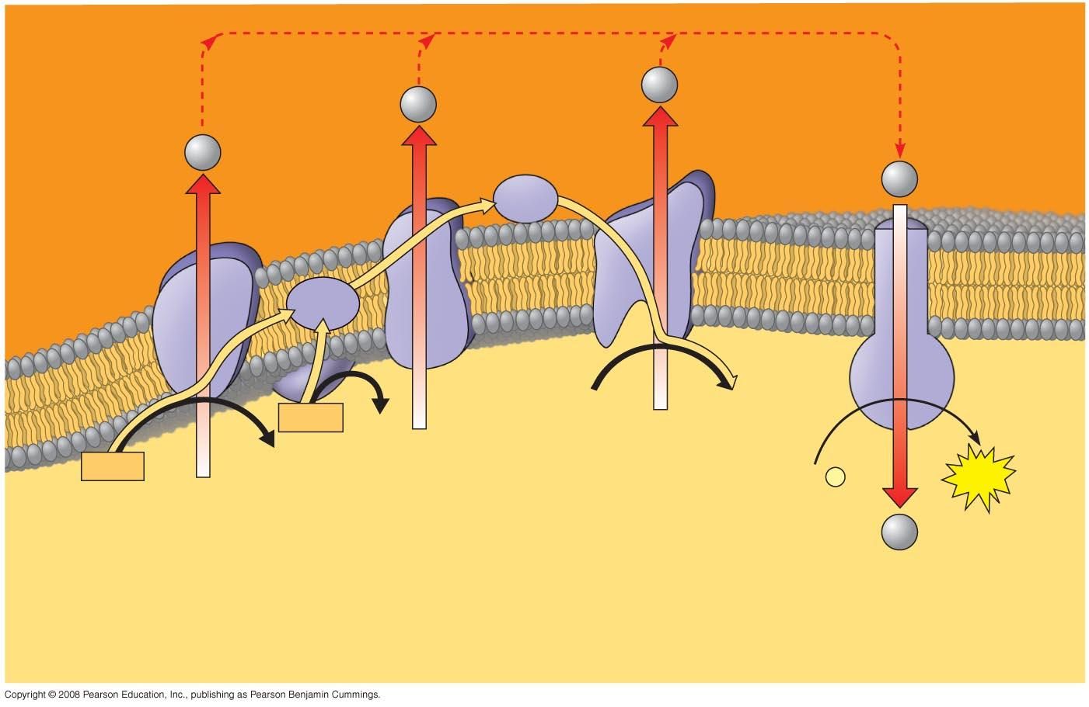

Figure #2 (Cut and paste onto your line paper) for question #22
