Name ____________________________ # ______ Biology Exploration Guide: Cell Metabolism:
Fermentation

Key Concepts:
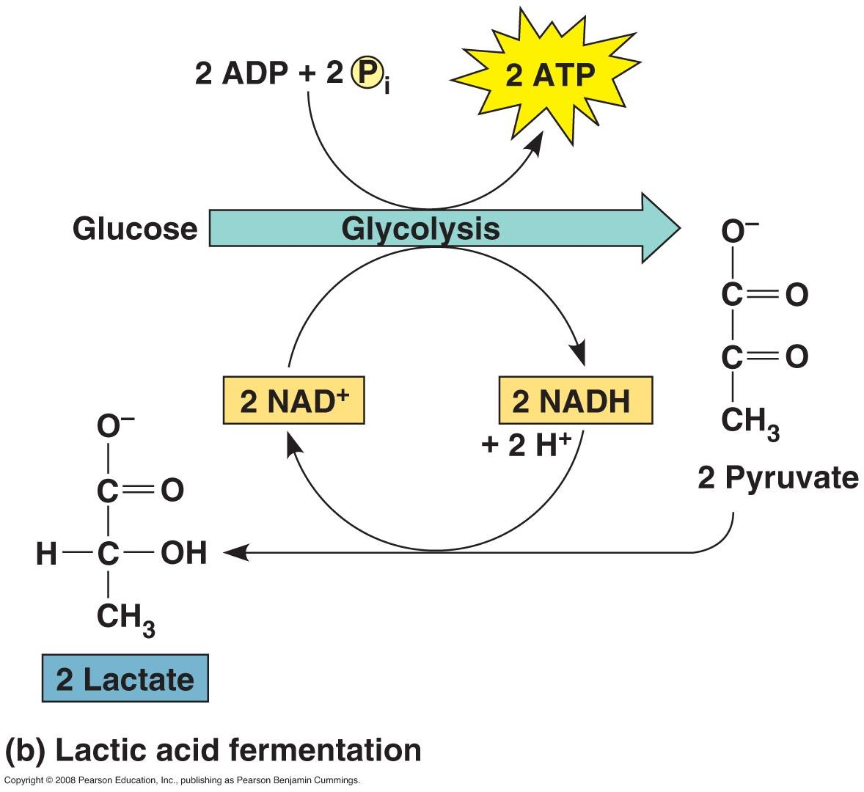
- Fermentation and anaerobic respiration enable cells to produce ATP without the use of oxygen
- Glycolysis and the citric acid cycle connect to many other metabolic pathways

Read:
- Chapter 9

Key Terms: Here is a list of key terms and concepts you will hear about and see during the chapter readings. Get to know them!

Alcohol fermentation
Lactic acid fermentation
Obligate anaerobes
Facultative anaerobes
Exploration Questions:

Fermentation / Anaerobic Respiration
- State the basic function of fermentation.
- Consider the NADH formed during glycolysis. What is the final acceptor for its electrons during fermentation? What is the final acceptor for its electrons during aerobic respiration?
- Explain why it is necessary to regenerate NAD⁺ during fermentation.
- Compare the fate of pyruvate in alcohol fermentation and lactic acid fermentation.
- Compare the production of ATP in fermentation and cellular respiration.
- Discuss the concept of oxygen debt in the human body and how it relates to lactic acid fermentation.
- Describe the impact of lactic acid on the human body and explain how its effects can be reversed.

Alternative Metabolic Pathways
- Carbohydrates are the primary energy source for many cells, but proteins and lipids can also be used. Describe where these alternative energy sources enter the process of cell respiration.

