Name____________________________ # _______ Biology Exploration Guide: Cell Metabolism #6
Photosynthesis
Key Concepts:
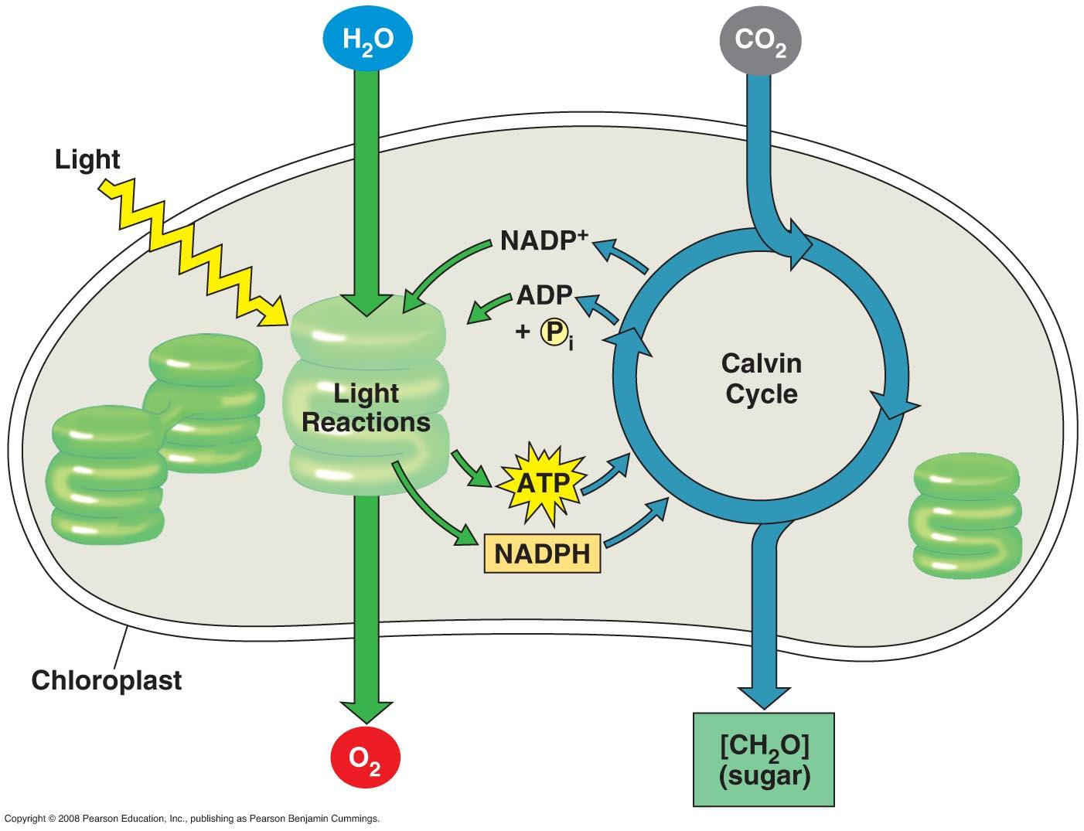
- Photosynthesis converts light energy to the chemical energy of food
- The light reactions convert solar energy to the chemical energy of ATP and NADPH
- The Calvin cycle uses ATP and NADPH to convert CO₂ to sugar
- Alternative mechanisms of carbon fixation have evolved in hot, arid climates

Read:
- Chapter 10

Key Terms: Here is a list of key terms and concepts you will hear about and see during the chapter readings. Get to know them!

Photosynthesis | Stroma | Electromagnetic spectrum | Photosystem I and II
Autotroph | Thylakoids | Wavelength | Reaction-center complex
Heterotroph | Light reactions | Visible light | Light-harvesting complex
Chlorophyll | Calvin cycle | photons | Rubisco
Mesophyll | NADP⁺ / NADPH | Absorption spectrum | Glyceralhehyde-3-phophate (G3P)  Photorespiration
Stomata | Photophosphorylation | Action spectrum | C₃ and C₄ plants
Guard cells | Carbon fixation | Carotenoids | CAM plants+

Exploration Questions:

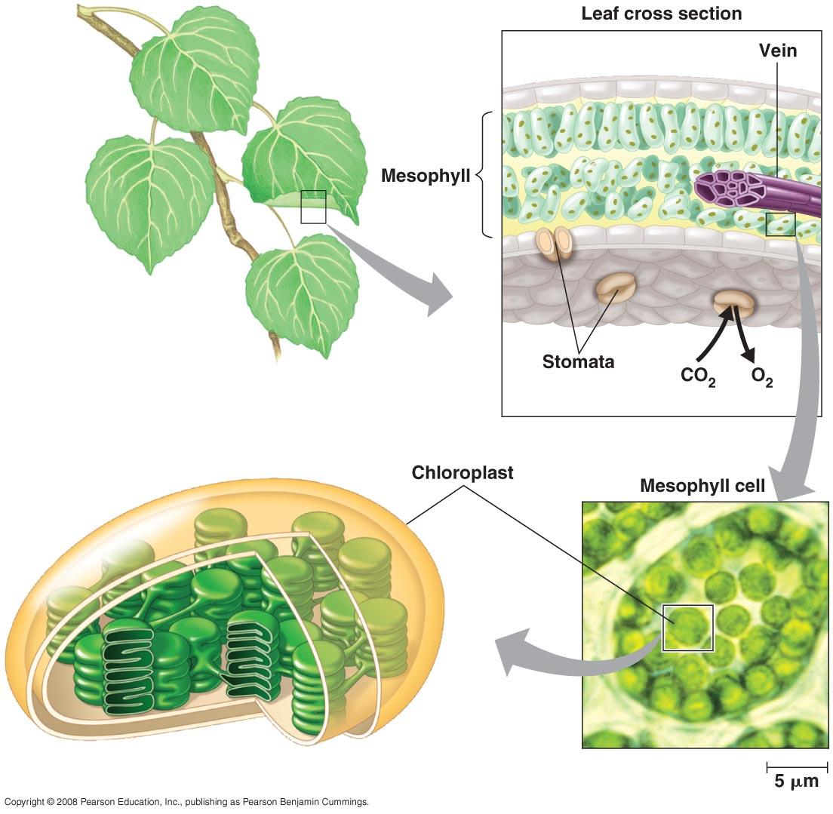
The Process that Feeds the Biosphere
- Identify where most chloroplast are located in a plant. Be specific.
- Sketch the structure of a chloroplast, listing all membranes and compartments: outer membrane, inner membrane, inner membrane space, stroma, chlorophyll, thylakoids, grana, thylakoid lumen
- State what a stomata is, identify where you find them, and explain what their role is.
- How do the reactant molecules of photosynthesis reach the chloroplasts in leaves?
- Write a summary equation for photosynthesis. Label and use arrows to indicate what is being oxidized and what is being reduced.

Overview of Photosynthesis
- Explain why photosynthesis is considered an anabolic, endergonic process.
- Describe the two main stages of photosynthesis in general terms. light-dependent reactions and the Calvin cycle (light-independent reactions)

Light Reactions
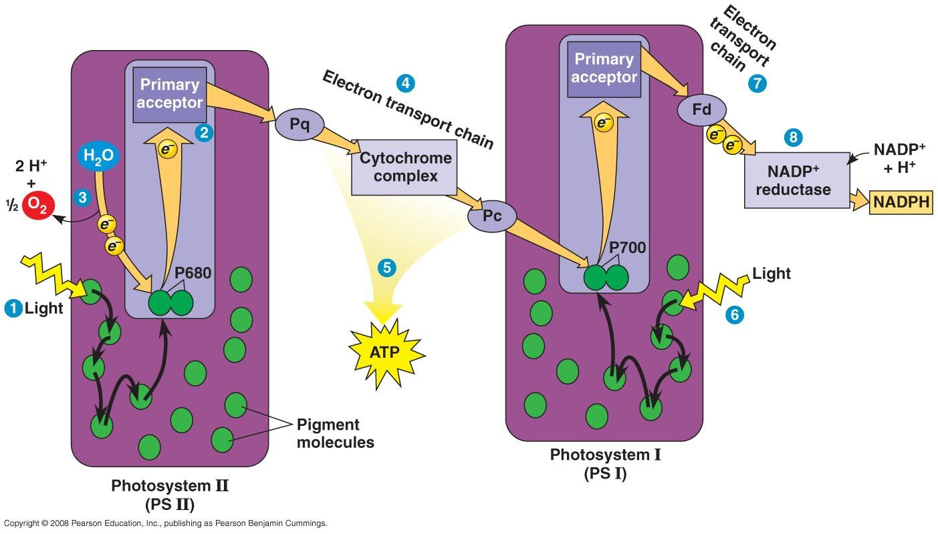
- Describe the relationship between an action spectrum and an absorption spectrum.
- What color of light is least effective in driving photosynthesis? Explain.
- Thylakoid membranes contain two different photosystems – photosystem I and photosystem II. Distinguish between these two photosystems.
- Cut out Figure #1 and paste in your notebook. Write, in your own words, descriptive captions for each of the numbered SIX steps in the linear flow of electrons via the photosystems. Use the following terms in your description: photosystem II, water, oxygen, electrons, excited, electron transport chain, proton gradient, chemiosmosis, ATP, photosystem I, NAP⁺, NADPH
- In the light reactions, what is the initial electron donor? At the end of the light reactions, where are the electrons?
- Identify the TWO products of linear electron flow that are passed on to the Calvin cycle.
- Why is oxygen produced during the light reactions?
- Compare and contrast the electron transport chains of photosynthesis to those in cellular respiration. Provide at least one similarity and three differences.

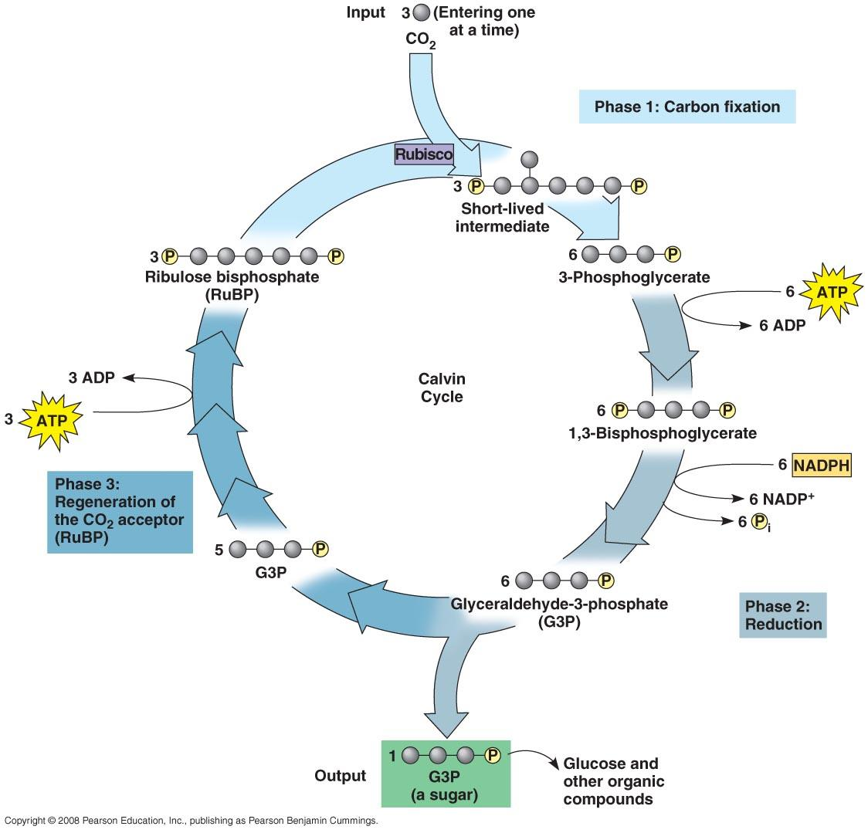
Calvin Cycle
- Cut out Figure 2 and paste in notebook. Write descriptive captions, in your own words, to explain the THREE key phases of the Calvin cycle. Include the following terms in your description: CO₂, RuBP, carbon fixation, ATP, NADPH, and glyceraldehyde-3-phosphate (G3P)
- Create a t-chart that describes the similarities and differences between the Calvin cycle and the citric acid (Kreb’s) cycle.
- Identify the following amounts:
  - In order to net ONE molecule of G3P, the Calvin cycle must go through how many rotations and use how much CO₂?
  - How much ATP from the light reactions is consumed in the generation of ONE G3P?
  - How much NADPH from the light reaction is consumed in the generation of ONE G3P?
  - How many of every SIX G3P molecules made by the Calvin cycle will be used for biosynthesis or the energy needs of the cell?
  - What happens to FIVE of every SIX G3P molecule?
  - How many G3P does it take to form ONE glucose molecule?

Alternative Mechanisms of Carbon Fixation
- Describe the problems faced by C₃ plants on hot dry days.
- Describe the major consequences of photorespiration.
- Describe how C₄ plants use a photosynthetic adaptation of structure separation to help minimize photorespiration.
- Describe how CAM plants use a photosynthetic adaptation of temporal separation to help minimize photorespiration.

Figure #1

Figure #2

