Name_____________________________ # ______ Biology Exploration Guide: Cell Metabolism #7
Transport of Water and Sugar in Plants
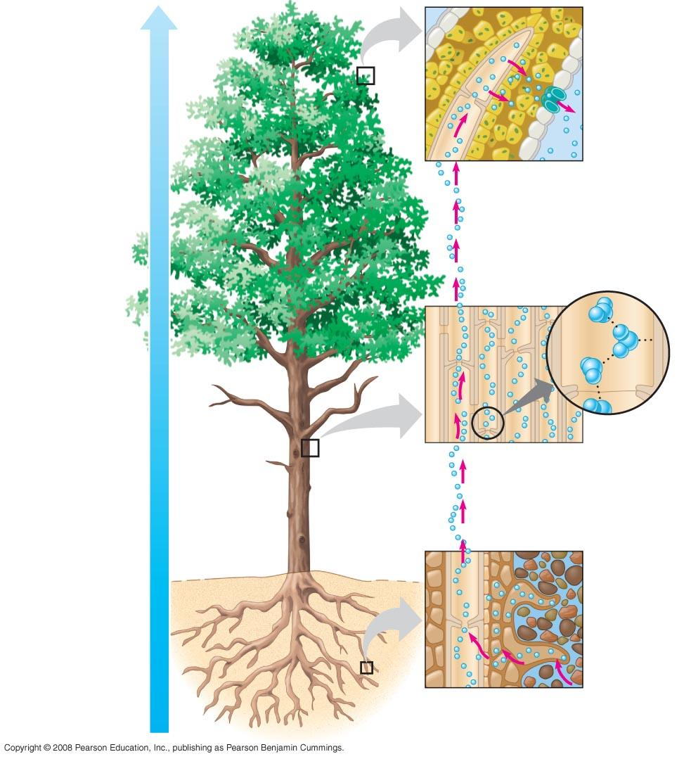
Key Concepts:
- Transpiration drives the transport of water and minerals from roots to shoots via the xylem
- The rate of transpiration is regulated by stomata
- Sugars are transported from sources to sinks via the phloem

Read:
- Chapter 36.3-36.5

Key Terms: Here is a list of key terms and concepts you will hear about and see during the chapter readings. Get to know them!

Xylem | Casparian strip | Transpirational pull | Unloading
Phloem | Root pressure | Translocation | Source
 |  | Loading | Sink

Plant Transport of Xylem Sap (Water & Dissolved Minerals)
- Discuss the effects of root pressure on moving xylem sap (water and dissolved minerals).
- How does the Casparian strip force water and minerals to pass through the plasma membranes of endodermal cells?
- Use Diagram #1 at the end of this packet. In your own words, explain how transpirational pull moves xylem sap up from the root tips to the leaves. Explain why this is considered negative pressure. (Relate this back to water potential.)
- Use Diagram #1 at the end of this packet. Label the diagram and use it to discuss, in your own words, how transpiration takes advantage of water’s properties of cohesion and adhesion.

The Control of Transpiration
- Discuss what two factors stomata are constantly trying to balance.
- Describe the mechanisms of stomatal opening and closing. Include the following terminology in your description: potassium (K+), water potential, turgor pressure, guard cells
- Describe THREE cues that trigger stomatal opening at dawn.

Translocation of Phloem Sap
- Use Diagram #2 at the end of this packet. Label the diagram and use it to describe, in your own words, the process of translocation. Trace the path of phloem sap from a primary sugar source to a sugar sink. Include a discussion of sugar loading and unloading and the influence of positive pressure flow.

Figure #1 – Cut out and paste in your Notebook for question #3 and 4

Figure #2 – Cut out and paste in your Notebook for question #8

