Beyond Mendel – Codominance, Lethal Genes, Multiple Alleles, and Polygenic Traits
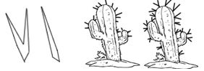
1. In a certain cactus, prickly spines can be two pronged or one pronged. If a true breeding one-pronged cactus is crossed with a true breeding two-pronged cactus, the F1 generation has a mixture of spines, some are two-pronged, some are one-pronged.
a. Is this an example of codominance or incomplete dominance?
b. Show the F2 generation (a cross between the two F1's). What are the phenotypes of the offspring and in what proportion?

2. In this same cactus, if you cross a plant that has red flowers to one that has yellow flowers, you produce a plant that has orange flowers. Is this codominance or incomplete dominance? Show the cross of an orange flowered plant to a red flowered plant.

3. A red flowered, two-pronged cactus is crossed with a yellow flowered one-pronged cactus. What are the resulting offspring and in what proportion?

4. Show the cross of a cactus that is heterozygous for both traits crossed with one that has red flowers and one-pronged spikes.

5. A man with type A blood is married to a woman with type O blood. What are ALL of the possible blood types of their children.

6. A man with type AB blood is married to a woman with type O blood. What are all the possible blood types of their children?

7. Dwarfism in humans is a domininat trait that is also lethal if an individual inherits two copies. Show the genotypes of a family wear both parents are dwarfs and they have 2 children, where one is a dwarf and the other is not.

8. Guinnea pigs can have curly or straight hair, where the curly gene is recessive. Guinnea pigs can also have a condition called bowlegged, where their legs curve noticeably outward. Bowleggedness is a dominant lethal allele if an individual inherits two copies of it (BB). Show the cross between a curly haired, bowlegged guinnes pig and a heterozygous straight haired pig that is also bowlegged. How many of their offspring would you expect to be normal with curly hair?

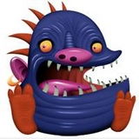
9. In Snarlymonsters, the number of teeth is polygenic. The recessive condition (aabbcc) results in a toothless Snarlymonster, and the dominant condition (AABBCC) results in a Snarlymonster with 6 teeth. There are 5 other possible variations.
How many teeth would a AaBbCc Snarlymonster have? ______

10. List the phenotypic ratios (how many teeth) of all the potential offspring for the cross AABBCc x AAbbcc .

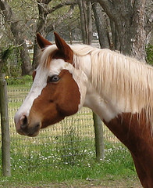
11. Lethal white overo syndrome is an autosomal recessive gene which if fatal 100% of the time and occurs in horses. Death of OLWS foals occurs within a few days of birth. If heterozygous, the animal has a multicolored patterned appearance, sometimes called a "paint". This pattern indicates the horse is heteroyzogous. If two of these horses were bred, what percentage of their offspring would be frame and what percentage would die from OLWS?

