CARBON CYCLE
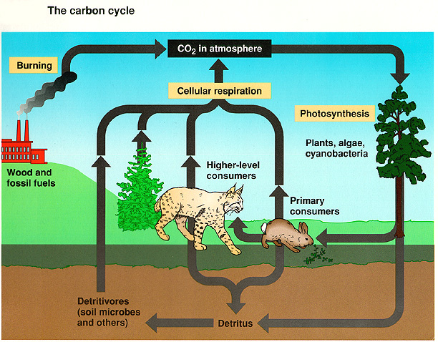
1. Photosynthesis/Respiration link
2. Carbon cycles fast (plants have high demand)
3. Decomposition recycles carbon to atmosphere
4. Fossil fuels (Coal, oil, natural gas)
5. In aquatic environments: dissolved CO₂ reacts with water to form carbonic acid, which reacts with limestone to form bicarbonates and carbonate ions
• Reservoirs: atmosphere (CO₂); fossil fuels, organic material
• Assimilation: photosynthesis; animal consumption
• Release: respiration; decomposition; combustion

NITROGEN CYCLE-
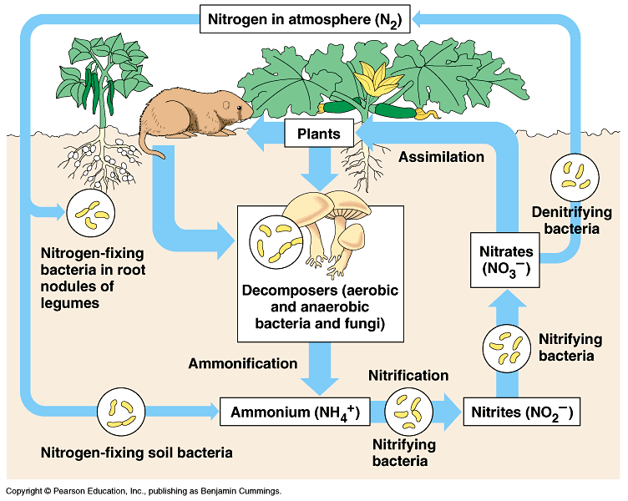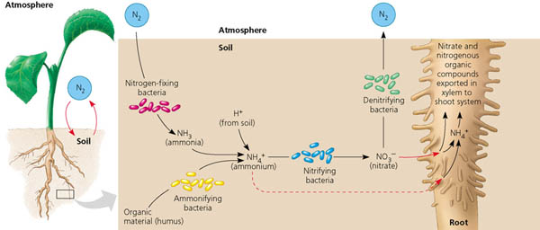
The atmosphere is about 80% nitrogen, but not in a usable form
1. Nitrogen Fixation
A. reduces atmospheric nitrogen to ammonia (NH₃)
B. prokaryotes (Rhizobium bacteria; cyanobacteria)
C. also by lightening (small amounts)
d. eventually, all organisms depend on this process for nitrogen
2. Nitrification
A. oxidation of ammonia (NH₃) to nitrite (NO₂⁻) (toxic to most plants);
then to nitrate (NO₃⁻)
(form that can move into plant roots; responsible for many algal blooms)
B. plants assimilate NO₃⁻ and convert it to amino acids and proteins
3. Denitrification
A. returns nitrogen to the atmosphere by converting NO₃⁻ to N₂
4. Ammonification
A. decomposition of organic nitrogen back into ammonium ion
B. carried out by bacteria and fungi
C. recycles large amounts of nitrogen to the soil
• Reservoirs: atmosphere; soil
• Assimilation: plant absorption; animal consumption
• Release: denitrification; detrivorous bacteria (ammonification); animal excretion
WATER CYCLE –
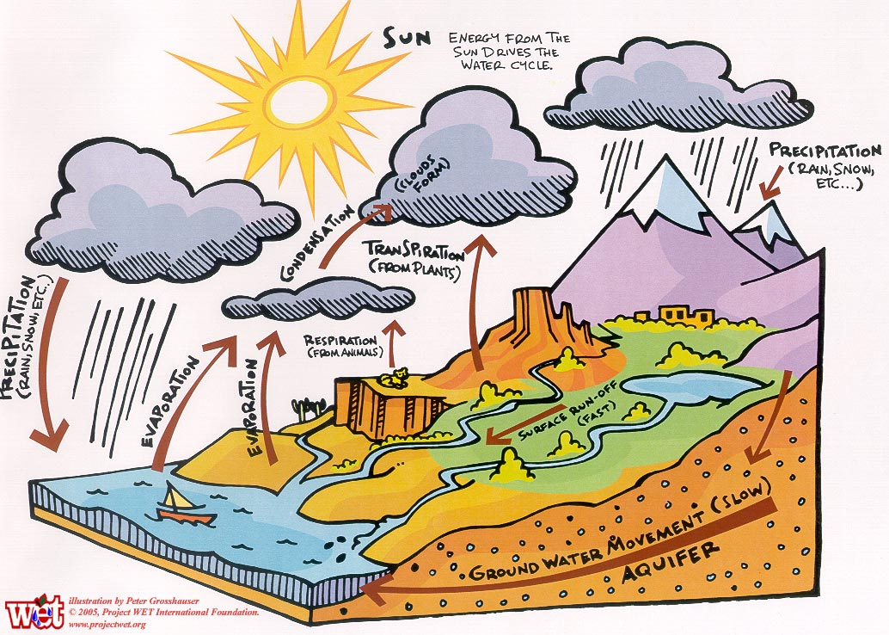
All water now is the same amount as 4 billion years ago- only changes form
Runoff from water cycle connects other cycles
a. evaporation (liquid → gas)
B. condensation (gas → liquid)
C. precipitation (rain, snow, sleet, hail)
D. transpiration (liquid → gas off leaf surface)
• Reservoirs: oceans, air, groundwater, glaciers
• Assimilation: plants from soil, animals eat other organisms; drink water
• Release: transpiration; animal/plant decomposition
PHOSPHORUS CYCLE – only cycle that doesn’t pass through atmosphere
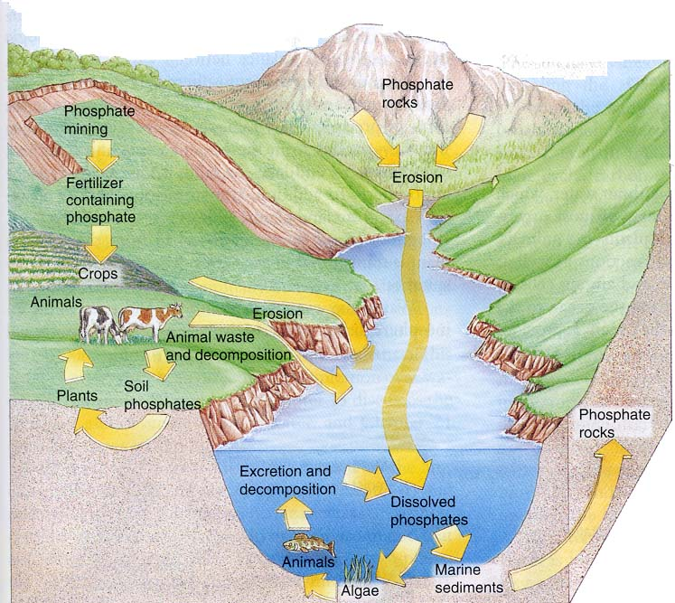

1. Occurs only as an inorganic, phosphate
A. weathering of rock adds phosphate to soil
B. absorbed by plants into molecules
C. transferred to consumers
D. added back to soil by excretion and decomposition
2. Also leaches into water table over time
• Reservoirs: rocks
• Assimilation: plants from soil; animals eating plants
• Release: decomposition; excretion

Modified from Mark Adame

