Name______________________________ #________ Block_________

What is biological magnification?
Biological magnification occurs by increasing the toxicity of poisonous substances as those substances move up the food chain. An example of biological magnification and its dangers is any small fish that eats plankton that has been tainted with mercury. Hundreds of small fish might then contain just few parts of the mercury, not enough to cause major harm. On the image, the amount of mercury is measured in ppm, which means “parts per million.”
A bird then might eat hundreds of the small fish, so that now instead of 200 ppm in a single fish, that bird has much higher levels of mercury. The toxin amplifies as it moves up the food chain.
Biological magnification caused a crisis with eagles, where DDT was used to control mosquitoes and other pests. Birds would accumulate toxic levels of DDT in their bodies which would cause their eggs to become fragile and break. The eagle almost became extinct, but lawmakers banned DDT and the eagle is now in recovery.
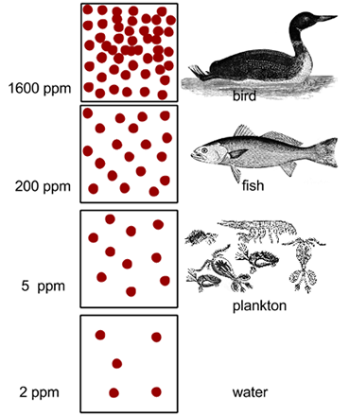
A. Finding Information: Scan the article for answers to specific questions.
1. What does PPM mean? ______________________________________
2. What chemical caused the decline of the eagle population? ______________
3. What does amplify mean?
4. What does accumulate mean?

